MPhil / PhD Project
Ref: input.doc

Supervisor(s) | Dr Hussain A Khalid & Dr Z Yang | Suitable for  (MPhil, MPhil/PhD, PhD) | MPhil/PhD
Project Title | Modelling asphalt damage due to fatigue cracking

Project Description
This project aims to study resistance to crack propagation of different asphalt mixtures under the influence of a number of variables using repeated and monotonic loading tests. The study also aims to investigate asphalt’s fatigue fracture resistance by numerical modelling adopting computational fracture mechanics principles. An existing cohesive crack model will be extended to consider a number of parameters, including visco-elasticity, temperature and possibly material heterogeneity.
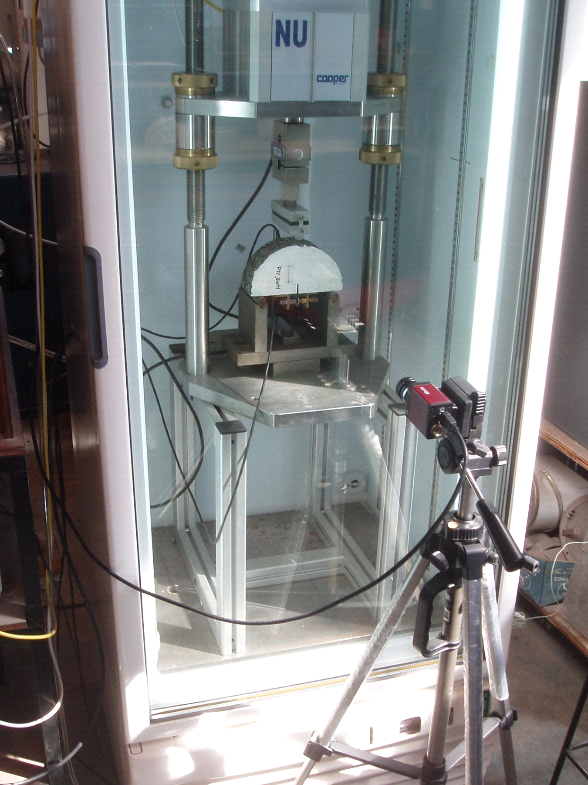
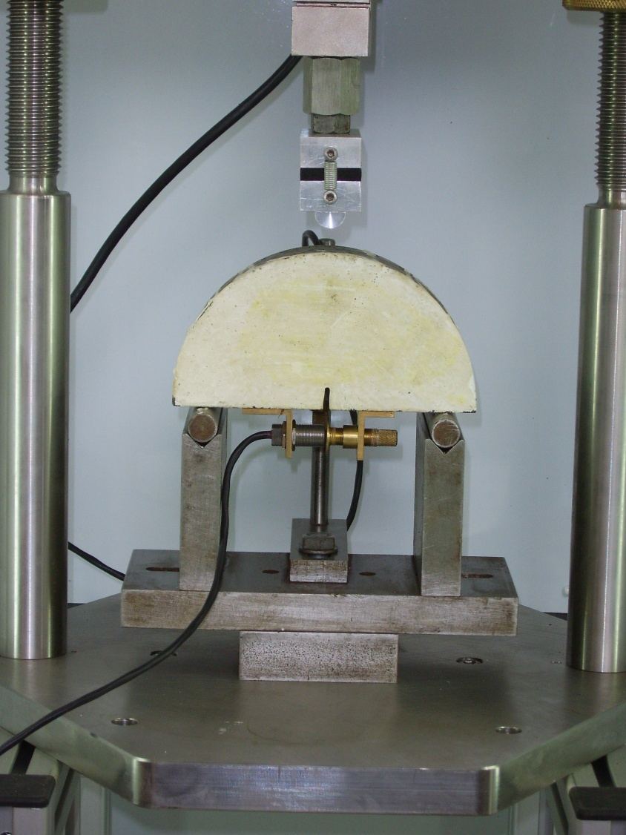

Funding
Source | None |  | Secured? (yes/no) | No
Funding details |  | -

Request for support by Departmental EPSRC funds? (yes/ no) | Yes

Candidate: special qualities/background required (e.g. 1st degree must include fluids)
Good first degree in any engineering or science discipline.

Submitted by | Dr Khalid | Date | 20 March 2009

