MPhil / PhD Project
Ref: input.doc

Supervisor(s) | Dr Hussain A Khalid & Prof D Chen | Suitable for  (MPhil, MPhil/PhD, PhD) | MPhil/PhD
Project Title | Characterising leaching potential of waste and by-product material in road foundations

Project Description
This project uses a lysimeter, see figure below, to study the leaching properties of waste, recycled and by-product materials used as road foundation layers. Road foundation layers can be constructed in the lysimeter in a way that reproduces in-situ conditions. The project aims to model the infiltration of harmful substances into aquifers and groundwater using diffusion, advection and sorption theories.
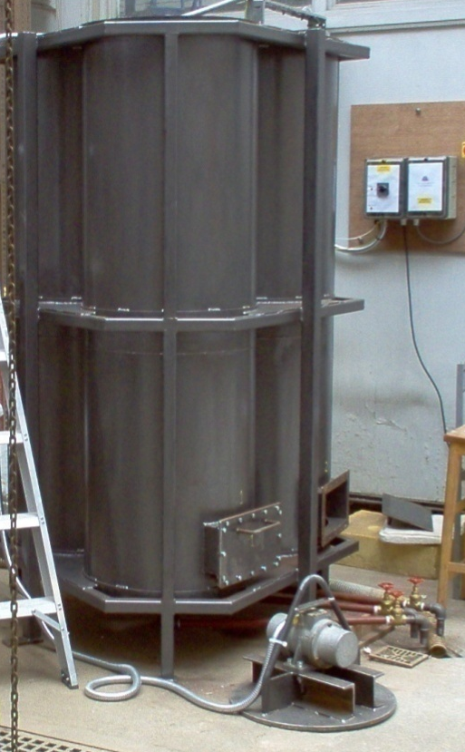

Funding
Source | None |  | Secured? (yes/no) | No
Funding details |  | -

Request for support by Departmental EPSRC funds? (yes/ no) | Yes

Candidate: special qualities/background required (e.g. 1st degree must include fluids)
Good first degree in any engineering or science discipline.

Submitted by | Dr Khalid | Date | 20 March 2009

