MPhil / PhD Project
Ref: input.doc

Supervisor(s) | Dr Hussain A Khalid | Suitable for  (MPhil, MPhil/PhD, PhD) | MPhil/PhD
Project Title | Hydraulically bound materials including recycled waste as road bases and foundation layers in flexible pavements

Project Description
Fundamental research work has been carried out to study the properties of Slag bound materials and other pozzolanic products as road layers in flexible pavement construction. Hydraulically bound materials’ properties are more akin to soils than bound materials, especially during the early stages of service. This renders applicable relevant soil mechanics theory and testing techniques. The scope of the programme centres on the use of the cyclic triaxial test to characterise HBMs with special emphasis on their early life behaviour. Modelling of the behaviour is aimed at following different theoretical principles and the influence of a number of parameters is addressed. The research also includes the use of construction and demolition and other types of waste.
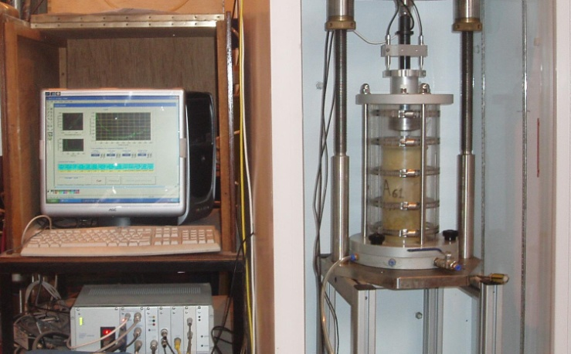
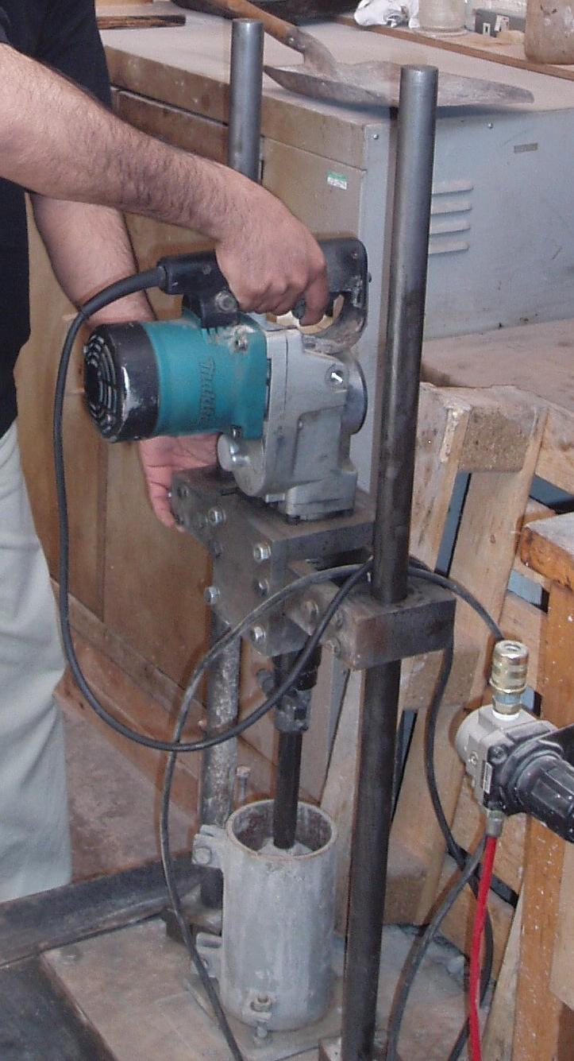

Funding
Source | None |  | Secured? (yes/no)
Funding details

Request for support by Departmental EPSRC funds? (yes/ no) | Yes

Candidate: special qualities/background required (e.g. 1st degree must include fluids)
Good first degree in any engineering or science discipline.

Submitted by | Dr Khalid | Date | 20 March 2009

