MPhil / PhD Project
Ref: input.doc

Supervisor(s) | Dr Hussain A Khalid | Suitable for  (MPhil, MPhil/PhD, PhD) | MPhil/PhD
Project Title | Higher usage of incinerator bottom ash aggregates (IBAA) in road base layers

Project Description
There is a major industrial interest in this project. It aims to enhance the structural support value of bitumen-IBAA mixtures by studying the fundamental properties of different formulations, including a cold-applied applied variety. The project centres on the study of leaching potential, permanent deformation and resistance to crack propagation of coated aggregate blends with partial IBAA replacement.
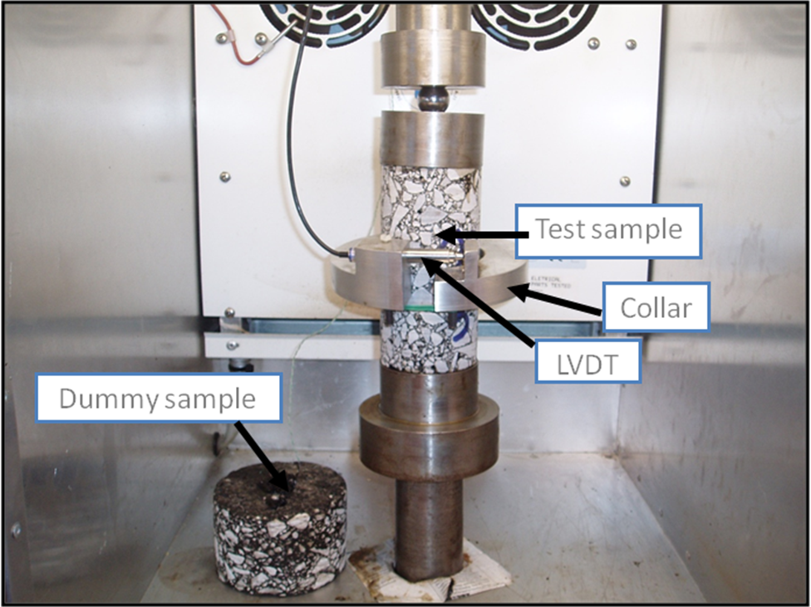

Funding
Source | None |  | Secured? (yes/no)
Funding details

Request for support by Departmental EPSRC funds? (yes/ no) | Yes

Candidate: special qualities/background required (e.g. 1st degree must include fluids)
Good first degree in any engineering or science discipline.

Submitted by | Dr Khalid | Date | 20 March 2009

