MPhil / PhD Project
Ref: input.doc

Supervisor(s) | Dr Hussain A Khalid | Suitable for  (MPhil, MPhil/PhD, PhD) | MPhil/PhD
Project Title | Fracture mechanics properties of asphaltic materials

Project Description
Asphalt is prone to fracture due to repeated traffic loading and/or thermal cycling caused by temperature fluctuations. Asphalt fracture and resistance to crack propagation properties are measured in the semi-circular bending beam (SCB) test, which is conducted on notched specimens under monotonic and cyclic loading modes. Fracture mechanics principles are utilised to evaluate the stress intensity factor, fracture energy and strain energy release rate, also known as the J-integral, of materials under the influence of a multitude of parameters, e.g. moisture damage, opening mode, healing and others.
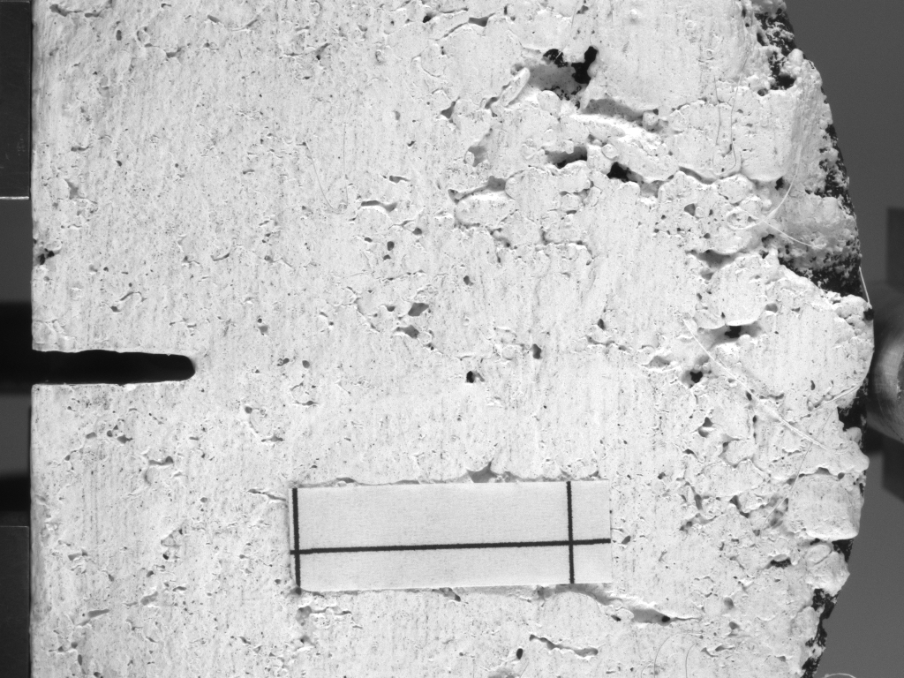
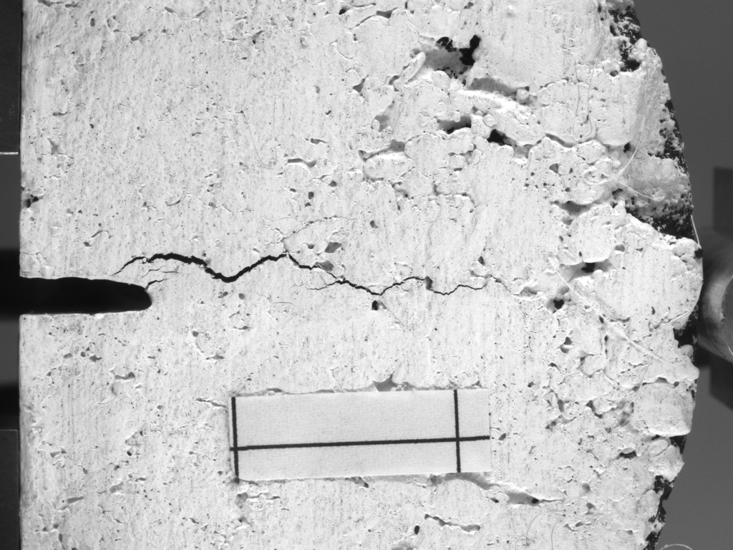

Source | None |  | Secured? (yes/no)
Funding details

Request for support by Departmental EPSRC funds? (yes/ no) | Yes

Candidate: special qualities/background required (e.g. 1st degree must include fluids)

Submitted by | Dr Khalid | Date | 20 March 2009

