MPhil / PhD Project
Ref: input.doc

Supervisor(s) | Dr Hussain A Khalid | Suitable for  (MPhil, MPhil/PhD, PhD) | MPhil/PhD
Project Title | Rheological characterisation of bituminous binders with polymeric additives

Project Description
Binder properties have a major influence on flexible pavement performance, be it for roads or airfields. Asphalt binders are visco-elastic under normal service conditions of temperatures and loading rate. The binder’s fundamental properties can be measured in a Dynamic Shear Rheometer (DSR) where the influence of a wide range of parameters could be investigated. The DSR can operate in a number of modes, e.g. oscillatory, creep/creep recovery and viscometry. Vital information can be obtained from the DSR at a micro-scale level, which can be linked to performance-related properties of the whole asphalt mixture. Such properties include fatigue and low-temperature cracking and permanent deformation or rutting.
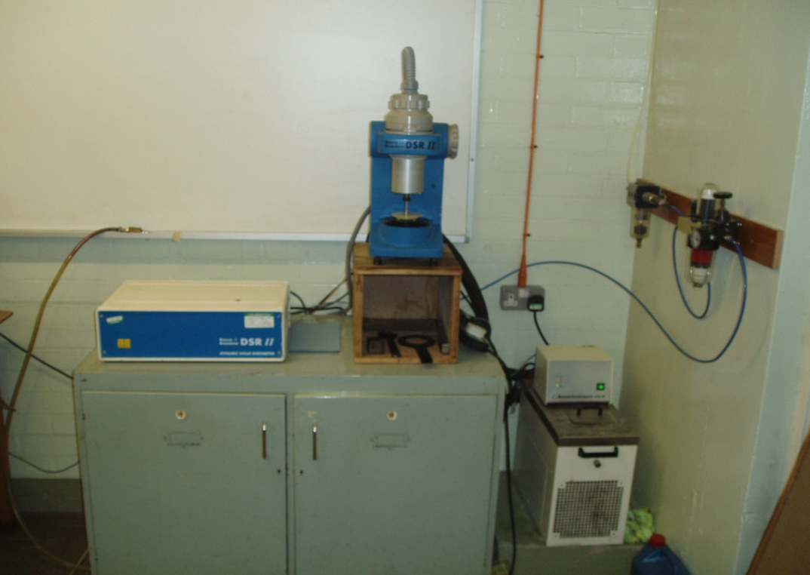

Funding
Source | None |  | Secured? (yes/no)
Funding details

Request for support by Departmental EPSRC funds? (yes/ no) | Yes

Candidate: special qualities/background required
Good first degree in any engineering or science discipline.

Submitted by | Dr Khalid | Date | 20 March 2009

