MPhil / PhD Project
Ref: input.doc

Please save this document using your surname (e.g. ResProj-surname.doc ) and return to pgeng@liv.ac.uk as an attachment. Thank you. Dr D Nicolaou, Postgraduate Admissions Tutor.

Supervisor(s) | Dr MW Johnson | Suitable for  (MPhil, MPhil/PhD, PhD) | PhD
Project Title | Drag reduction using optimised surface protrusions

Project Description
Turbulent drag increases energy consumption in transport (aircraft, land vehicles and ships) and in pipelines. Engineers therefore strive to develop technologies through which turbulence can be suppressed. One proven technique is the use of riblets which are used on ship hulls, but have also been tested on aircraft. Riblets are also found on many marine mammals. Research work has shown though that other surface protrusions with very differing geometry e.g. dedricles can also suppress turbulence. It therefore seems likely that none of the current protrusion geometries is optimal.

There are two main objectives of the project. The first will be to develop numerical methods for predicting turbulence generation and suppression on surfaces with protrusions. These methods will then be used to optimise the surface protrusion geometry in order to achieve maximum turbulence suppression. The second objective will be to construct this optimum geometry and to test it in either a wind or water tunnel in order to validate the numerical results.

Funding
Source |  |  | Secured? (yes/no)
Funding details

Request for support by Departmental EPSRC funds? (yes/ no)

Candidate: special qualities/background required (e.g. 1st degree must include fluids)
First degree in Engineering, Physical Sciences or Maths.

Submitted by | 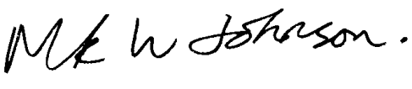 | Date | 18/3/09

