PhD Project
Ref: Rotor Active Flow Control

Supervisor(s) | Dr G. Barakos | Suitable for  (MPhil, MPhil/PhD, PhD) | PhD
Project Title | CFD Study of Novel Rotor Configurations with Active Flow Control

Project Description
The CFD lab of Liverpool is a centre for rotorcraft CFD and the Helicopter Multi-Block solver (HMB) is now used by industry and academia for the study of helicopter flows. At present, the lab is a partner in several projects aiming to develop a new generation of rotors with active flow control elements. These include flaps and active surfaces, jets and micro vortex generators as well as active blade morphing. This project will aim to quantify the effect of each flow control method and provide an estimate of the benefits to be obtained from flow control over passive designs.

This project will first attempt to use the experiments of the REACT project to validate the predictions of the HMB method before embarking in a systematic comparison of the flow control methods. A typical modern main rotor will be the starting point for the comparisons, and data for the passive design (without flow control) will first be obtained. The project will then compare the efficiency of the rotor in hover and forward flight with the flow control devices. This will involved both open- and closed-loop control methods coupled with the CFD to extract the maximum benefit of each flow control device. In parallel data obtained in wind tunnels around Europe as part of the EC project GOAHEAD will be used for validation of the flow control devices for simpler flow cases. These include jets on bumps and aerofoils as well shock/boundary layer interaction control.

Computations are to be performed using the HMB CFD method of Liverpool and the student working on this project will benefit from state-of-the-art parallel computing and visualisation as well as industrial input via the AgustaWestland Liverpool –Advanced Rotorcraft Centre. During parts of the project, the student will be seconded to AgustaWestland to access real-world data for comparisons against the CFD predictions.
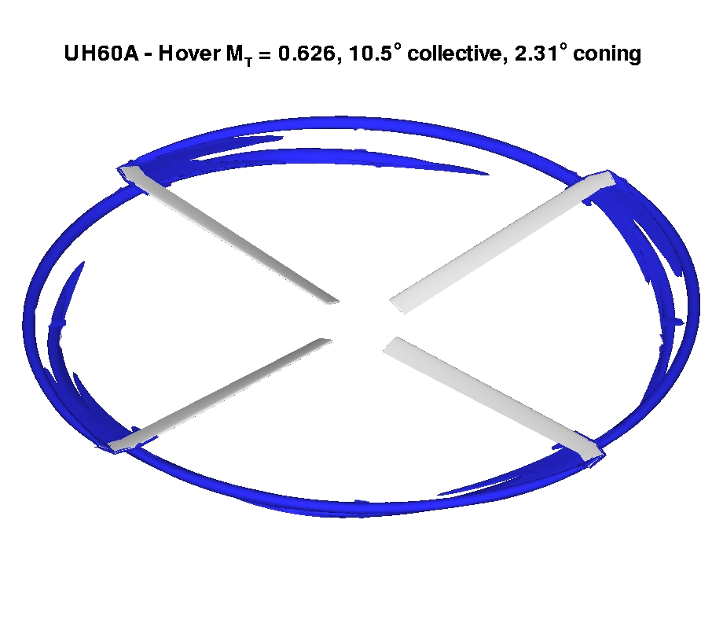
Figure 1: Flow below the UH60A rotor in hovering flight.

For the prospective candidate, the proposed research project will provide an opportunity to learn about modern CFD methods as well as take a first step in a research area that is seeing renewed interest from research groups worldwide, due to the need for efficient, lower-cost, green helicopters for civil and military applications.

Funding
Source | Dta |  | Secured? (yes/no) | No
Funding details |  | Possible funding through the departmental DTA. This depends on the quality of the applicant and early application is advisable since dta awards are competitive. Each award provides funding for a period of up to three and a half years and covers tuition fees at the UK/EU rate and a stipend in the range £13000 to £17500 p.a. for living expenses. An additional £1000 p.a. will be available to support the research of each candidate. Only UK citizens and EU citizens with last three years uninterrupted residency in the UK are eligible for the tuition fees. Please note non-EU citizens have to pay the difference between the home rate and foreign student rate.

Request for support by Departmental EPSRC funds? (yes/no) | No

Candidate: special qualities/background required
Potential candidates should have a good level of Fluid Mechanics and preferably previous experience with Computational Fluid Dynamics gathered during 1st degree final year project work. Also, programming experience (preferably C/C++ or Fortran) as well as experience with Linux/Unix would be a bonus.

Submitted by | G. Barakos | Date | 6-1-10

