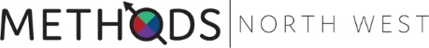
Methods X 2019
Paper Submission Form

Please indicate with of the four Methods X Streams your paper will best align with:
☐ Archives, Collections and Documents of Life
☐ Fieldwork
☐ New Forms of Data / Digital Methods
☐ Quantitative Methods

Please indicate the kind of presentation you would like to give:
☐ 5 minute talk
☐ 15 minute talk

Presentation Title:

Abstract Content (Max. 400 words):

Please ensure you also book a place on our Eventbrite registration page
Please submit your completed registration form to engage@liverpool.ac.uk

