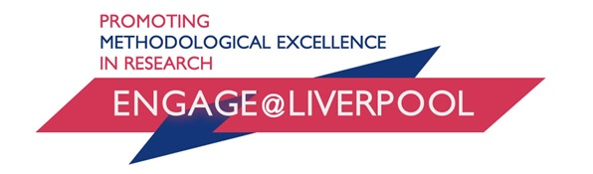

Methodological Innovation and Development Award Scheme (MIDAS)

Application Form 2026/27

Proposals are invited from University of Liverpool academics, early career and postgraduate researchers for methodological innovation and development funding through engage@liverpool via its Methodological Innovation and Development Awards Scheme (MIDAS).
MIDAS is an open, responsive funding stream which can be applied for at any time through the year, with a 3-4 week turnaround.
Methodological Innovation and Development Awards support activity in three areas:
- Research-focused workshops/events emphasising methodological and intellectual innovation;
- Practice- or impact-focused workshops/events seeking to engage people, communities and organisations;
- Short-course and advanced methods training workshop development.
We particularly encourage creative proposals that seek to work across disciplinary pathways and research fields and speak to emerging areas of interest.
Awards will normally be up to £500 but supplementary funding may be available beyond that where a strong case can be made for additional support.

Project Name:
Dates of project / activity:
Key Contacts:
(Name & Email)

Elevator Pitch
Brief Project Description:

Background and Rationale (300 words)

Plan of activities (500 words)

Target Audience:
Planned Outcomes:

Costing
Amount Claimed For:
Cost Breakdown:

Signature: |  | Date:

Please submit your completed form to engage@liverpool.ac.uk.

You will then receive an email confirming we’ve received your application, and it’ll be shared with the reviewing panel. Once a decision has been made you will be notified of the outcome. Please note that this turnaround may take up to 4 weeks.

Ideally, events funded through this year’s call should take place by August / September 2027 – we are available to discuss later dates if necessary.

