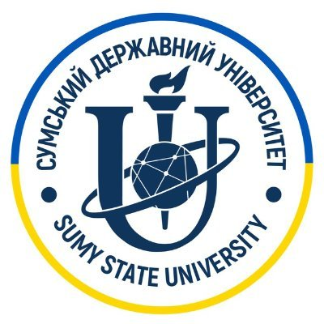

UoL and SumDU Collaboration for
Digitalisation and Digital Transformation of Ukraine

A Call for Visiting and “Remote from Ukraine” Scholarships Proposals

The University of Liverpool and Sumy State University aim to establish a strong comprehensive partnership across all academic activities and initiate our collaboration in research and innovation. Our objective is to support research teams, perform joint research, provide complementary expertise, and develop plans for long-term research and innovation projects.

At the initial stage, we aim to focus on Digitalisation and Digital Transformation research which is the strategic priority of both universities and countries. The research twinning activities in 2023 will be organised in the form of “remote from Ukraine” and visiting scholarships to the University of Liverpool(UoL). UoL will cover the expenses of the visiting scholars at the level of £3000 per person and the “remote from Ukraine” scholars will receive a bursary at the level of £1000 per person. UoL academics are welcome to submit a proposal in the area of Digitalisation and Digital Transformation for hosting visiting and “remote form Ukraine” schools. The proposals will be available for Ukrainian academics to apply by submitting a justification of their suitability for these projects.

Please return your application to host Ukrainian scholars by the 5th of April 2023 by sending both word/pdf forms to Prof. Igor Potapov <potapov@liverpool.ac.uk> with the subject: Liverpool-Sumy Research Twinning.

Title of Project (up to 15 words)
How many scholars you can host “remotely from Ukraine” or “in-person” at the University Liverpool within proposed project?
Six-Week Visiting Scholars within June-August 2023: ____
3-month “Remote from Ukraine” Scholars in June-August 2023: ___
Investigators
University of Liverpool
Co-ordinator Name:
Post:
School / Institute:
Department (if relevant)
Email:
Contact phone number:

UK Co-Investigators – Name | Post | School/Institute/Department | E-mail address

Project Details
Briefly summarise the research area related to this proposal (upto 400 words):

Please summarise the list of more specific research questions and proposed activities for joint research (upto 400 words):

Please add references and weblinks on related research papers or project webpages (upto 5 references):

- …
- …
- …
Please summarise your expectations on the short- and longer-term outcomes for successful research collaboration.
Could such collaboration in your opinion lead to knowledge transfer, publications, impact, submitted research grants or other forms of the outcome? (upto 200 words, you can summarise with several bullet points)

Please return your application to host Ukrainian scholars by the 5th of April 2023 by sending both word/pdf forms to Prof. Igor Potapov <potapov@liverpool.ac.uk> with the subject: Liverpool-Sumy Research Twinning.

