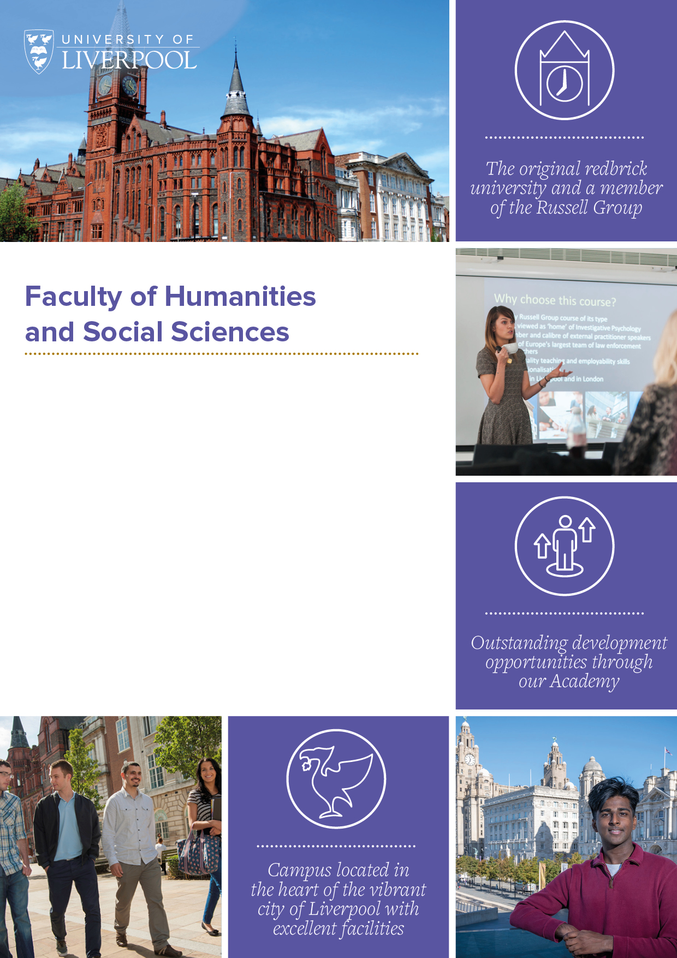

*Online application> Shortlisting > Interview Process> Job Offer*

**Associate Tutors for Open Languages Programme**

**Area:** Open Languages

**Job Ref:** n/a

**Location:** University Campus, Liverpool City Centre and the Wirral.

**Grade:** Grade 6, point 25

**Salary:** hourly rate plus holiday allowance

**Working Hours:** part time including evenings

**Tenure:** Zero hours contract as bank tutor, hours dependant on student enrolment numbers

**Role overview and University context:**

* The Open Languages programme offers language learning opportunities to all our University students and the wider public. Based in the Faculty of Humanities and Social Science, we provide credit-bearing language modules to allow current UG students to learn a language as part of their degree, as well as extracurricular evening classes for all students, staff and the public. We currently offer Arabic, French, German, Italian, Mandarin, Japanese, Portuguese, Russian, and Spanish, across stages 1-8.
* We are always keen to speak to potential new tutors to join our pool. The successful candidates will teach on our language modules, which offer both credit and non-credit options. We offer some day-time classes, and our evening courses take place from 6-8 pm. Teaching will take place on our Liverpool City Centre Campus, and some classes also run at Ness Gardens on the Wirral. In addition, there may be the opportunity to teach short online courses during the summer period. The successful candidates will be added to the Associate Tutor Bank and allocated hours based on student enrolments and the number of classes running.
* Salary & Hours:-
* Terms and conditions of employment will be those for Grade 6 Zero hours teaching only tutor.
* Grade 6, point 25. Salary for this grade is currently £16.23 plus 13% holiday pay per hour. Classes are usually 2 hours, and tutors are paid for 2 hours teaching and 2 hours preparation for each class (this results in an effective hourly rate for teaching of £36.68). Classes run for 12 weeks, once per semester.
* All of our Associate Tutor posts are academic pensionable posts and are eligible for USS pension scheme membership.

**Responsibilities:**

* Contribute effectively to the subject area in a chosen area of scholarly development with support and assistance from colleagues as required.
* Contribute effectively to the design and planning of the curriculum including preparation of own teaching and learning materials and course documentation.
* Effectively oversee the welfare, progress, examination, and assessment of the students as designated by the Head of Area.
* Promote the work of the University and participate in the recruitment, selection, and induction of students.
* Provide support to individual students and groups of students in accordance with procedures, referring students to further support services as appropriate.
* Contribute to the curriculum development of the area’s academic programmes.
* Seek to enhance the quality of education and provision by ensuring that high standards of teaching and learning are maintained on the relevant courses to which they contribute.
* Contribute effectively towards the development of the Open Languages Programme.
* Organise and administer tasks in an efficient and effective manner.
* Use teaching and learning strategies, which encourage student involvement and advance their independent learning.
* Carry out any other duties associated with the area to be included by the programme director.

**Duties:**

* Create weekly learning materials and deliver classes
* Provide content and update the VLE - CANVAS
* Assist in reviewing the Module Evaluation Forms at the end of each semester
* Prepare assessment and resit tasks
* Marking of assessment tasks and returning marks and feedback to students
* Attend up to 4 programme meetings per year (September, December, January, May)
* Attend compulsory training sessions as required (no more than two per year)
* Undertake other duties commensurate with the grade as required.

**Additional requirements:**

* Competence/Proficiency in relevant language
* Availability to teach in the evenings

**In addition to the above, all University of Liverpool staff are required to:**

* Adhere to all University policies and procedures, completing all obligatory training and induction modules, including Equality & Diversity and Health & Safety.
* Respect confidentiality: all confidential information should be kept in confidence and not released to unauthorised persons.
* Participate in the University’s Professional Development Review scheme and take a proactive approach to own professional development.
* Demonstrate customer service excellence in dealing with all stakeholders.
* Embody and uphold the University’s Vision and Values.

|  |  |  |
| --- | --- | --- |
| **Essential Criteria** | | **Desirable Criteria** |
| **Experience** | | |
| 1.1 | Competence/Proficiency in relevant language |  |
| 1.2 | Successful teaching experience in Higher Education or other evidence  of the ability to be an effective teacher at this level |  |
| 1.3 | Knowledge and understanding of  the CEFR and HSK levels |  |
| **Education, Qualifications and Training** | | |
| 2.1 | A good relevant honours degree or equivalent qualification and experience of Higher Education learning |  |
| 2.2 | Higher qualifications relevant to the post, such as PCET/PGCE or equivalent for teaching a language or evidence of satisfactory progress towards such qualifications |  |
| 2.3 | Maintain current knowledge of the subject and advise on changes to the syllabus. |  |
| **Skills, General and Special Knowledge** | | |
| 3.1 | An effective and engaging communication style and interpersonal skills | Experience of using CANVAS to support learning and teaching |
| 3.2 | Ability to develop and use effective, flexible, and innovative approaches to teaching, learning and assessment |  |
| 3.3 | Ability to use Information and Communication Technology (ICT), including a VLE,  to support teaching and learning |  |
| 3.4 | Ability to contribute to the assurance of academic quality and standards |  |
| 3.5 | Ability to assess language learning in the four elements of: reading, listening, writing and speaking |  |
| 3.6 | Ability to support the diverse academic and personal needs of individual students |  |
| 3.7 | Ability to support the general processes of the department in a timely manner |  |
| **Personal Attributes and Circumstances** | | |
| 4.1 | A flexible approach to working part time hours including evenings |  |
| 4.2 | A reliable and professional approach, with resilience and ability to work as part of a team. |  |
| 4.3 |  |  |
| 4.4 |  |  |
| 4.5 |  |  |

**Criteria for Confirmation in Appointment for Academic Staff –**

**Probationary members of staff will:**

**Learning and Teaching**

* Demonstrate that they have fulfilled the agreed teaching expectations assigned to them to a standard expected in their subject area
* Demonstrate how they have contributed to the student experience at undergraduate and/or postgraduate level, including evidence of PGR supervision where appropriate
* Demonstrate that they have completed, or be near to completing within a defined deadline, the Certificate of Professional Studies

**Contribution and Engagement**

* Demonstrate their awareness of the University’s plans and priorities and that they are engaged with these
* Demonstrate that they have fulfilled agreed leadership and managerial activities assigned to them
* Demonstrate their awareness of departmental/school/institutional plans and priorities and how they contribute to and engage with these
* Demonstrate that they have an on-going longer-term career plan
* Demonstrate that they have an awareness of the University values

**Development**

* Demonstrate that they have fulfilled any required development and that they have an ongoing plan for the development of their career

***Our vision is to be a connected, global University at the forefront of knowledge leadership."***

***Vice-Chancellor, Professor Dame Janet Beer***

Established in 1881, we are an internationally renowned Russel Group university recognised for our high-quality teaching and research. We are consistently ranked as one of the best Universities both nationally and globally, and the majority of our research is rated world leading or internationally excellent. Find out more [here](https://www.liverpool.ac.uk/about/).

**Our Areas**

When you work at the University of Liverpool you are more than just your job role. You are a crucial part of our mission to improve lives on a local, national and international scale. Click on the relevant link(s) below for more information on the area you will be working in.

[Faculty](https://www.liverpool.ac.uk/humanities-and-social-sciences/about/) [Open Languages](https://www.liverpool.ac.uk/languages/open-languages/)

**Why Work Here**

We recognise, appreciate and celebrate the incredible work our staff do every day. As well as generous terms and conditions, we offer a range of enviable benefits and provide support for colleague’s wellbeing and development. Discover more [here](https://www.liverpool.ac.uk/working/whyworkhere/).

**Moving from abroad**

As a global institute, we welcome applicants from all nationalities, moving from a different country can be challenging and we would like to help as much as we can, we have put together some information on eligibility to work documentation, accommodation, schools, healthcare, life in Liverpool and the UK as well as other practical information. Discover more [here](https://www.liverpool.ac.uk/working/relocating/).

**Our Staff**

Whether it be their friendly colleagues, supportive managers or our outstanding facilities, our staff can explain better than anyone what it is like to work for us and why they enjoy their role. See what they have to say [here](https://www.liverpool.ac.uk/working/whyworkhere/colleagues-stories/).

***The University of Liverpool is committed to being an inclusive employer. We welcome applications from everyone regardless of age, gender, ethnicity, sexual orientation, faith or disability.***

**Contacting us**

Shortlisting and interview arrangements are the responsibility of the recruiting department. Please email: [Louise.medlam@liverpool.ac.uk](mailto:Louise.medlam@liverpool.ac.uk).

**Application process**

Our e-recruitment system enables you to register for an online account, where you can view, copy and edit your applications. Set up your account [here](https://my.corehr.com/pls/ulivrecruit/erq_search_package.search_form?p_company=1&p_internal_external=E).

Once you submit your application you will receive an automatic email acknowledgment.You can view your application any time by clicking into the application history section of your account.

**Job Description**

After the closing date this job description will be removed from our website. Should you wish to refer to this information at a later date please ensure you save a copy of this document.

**Right to work**

We have a legal responsibility to ensure that you have the right to work in the UK before you can start working for us. If you do not have the right to work in the UK already, any offer of employment we make to you will be conditional upon you gaining it. The UKVI have an interactive tool allowing you to immediately see if vacancies are eligible for a Skilled Worker visa. You will need to know the SOC code for the role, our most used SOC codes can be found [here](https://www.liverpool.ac.uk/intranet/media/intranet/humanresources/2014/recruitment/Check,if,a,job,role,is,potentially,eligible,for,a,skilled,worker,visa.docx), if none of these apply to this role, there are more codes on the eligibility checker. The skilled worker eligibility checker can be found on [GOV.UK](https://www.gov.uk/government/publications/uk-points-based-immigration-system-employer-information/the-uks-points-based-immigration-system-an-introduction-for-employers).

**Disabilities and alternative formats**

If you have any other requirements which will help you access the application or interview process or employment opportunities at the University, or if you require copies of documentation in alternative formats, please email: jobs@liverpool.ac.uk or telephone 0151 794 6771.

**Outcome of your application**

The recruiting department will endeavour to respond to each application. However, if you have not heard within six weeks of the closing date, please take it that your application has not been successful on this occasion.

cid:image006.png@01D8144E.E2C426A0cid:image002.png@01D8144E.E2C426A0