

**OPEN LANGUAGES PROGRAMME**

**HANDBOOK**

**For Students on Extracurricular or Standalone**

**Open Languages Modules**

Effective from September 2023

1. Welcome 3

2. Contact Information 4

3. Getting Started – a guide to registration and IT systems 6

3.1 An overview of the process 7

3.2 The online store 8

3.3 Your Student ID Number 9

3.4 Your Computing IT account and MWS (Managed Windows Service) username 9

3.5 About Canvas 10

3.6 Liverpool Life – student ID number and PIN 11

3.7 Two Factor Authentication 12

3.8 Welcome to Canvas 13

3.9 Virtual Classrooms with Zoom 18

3.10 : Using Zoom with a University IT MWS account 19

3.11: Using Zoom without a University IT MWS user account 20

3.12 In Your Zoom Session 22

3.13 More on Liverpool Life and the benefits of being a UoL student 23

4. STUDYING, RESOURCES & SUPPORT 25

4.1 Study Skills Support 25

4.2 What to expect 25

4.3 What we expect from you 26

4.4 If you encounter a problem 26

4.5 Health & Safety 27

4.6 Equality, Diversity and Inclusion (EDI) 27

4.7 Disability & additional support 28

4.8 Absence 28

5. ENGAGEMENT, ATTENDANCE AND ASSESSMENT 28

5.1 Engagement and Attendance 28

5.2 Certificate of Engagement 28

5.3 Assessment 29

5.4 Submission guidelines & deadlines 29

5.5 Extenuating Circumstances 29

5.6 Marking and results 29

5.7 Referencing, plagiarism & collusion 30

5.8 Appeals 30

5.9 Intellectual Property 30

5.10 Full time UoL Student Attendance on OL Courses and the HEAR 30

6. REVIEW, REFLECT & WHAT NEXT? 30

6.1 Course evaluation 30

6.2 Compliments & complaints 31

6.3 Choosing your next course 31

7. Location, directions & parking 31

8. Administration, Terms and Conditions for students studying extra-curricular or standalone Open Languages modules 32

8.1 Our courses 32

8.2 Who can join? 32

8.3 How to enrol 33

8.4 Registration 33

8.5 Fees 33

8.6 Fees for assessment 34

8.7 Course cancellations 34

8.8 Refund request or withdrawal from a course 35

8.9 Personal information and data security 35

8.10 IT and information security 36

8.11 Means of communication 36

8.12 Declaration of criminal convictions 37

8.13 Student conduct 37

8.14 The University’s general regulations 38

8.15 Complaints 38

8.16 Intellectual property 39

8.17 Health, safety and wellbeing 39

8.18 The University’s liability to you 40

8.19 Circumstances outside the University’s control 41

8.20 Termination of this agreement 41

8.21 Other important terms 42

# Welcome

Welcome to the Open Languages Programme.

Open Languages (OL) is a University-wide Language Programme available to undergraduate and postgraduate students of the University of Liverpool, who would like to study a language alongside their degree. These modules can be taken as an extracurricular option by all students in the university.

The Open Languages programme is also available to members of the public (aged 16 and over) who can enrol for classes.

Our classes are mainly run at the University of Liverpool campus, but we also offer some classes at Ness Botanic Gardens on the Wirral. Please note that Irish Language classes are held at the Irish Cultural Institute in Hammersmith, and online.

This OL handbook provides information specifically for students who are paying a separate fee to study standalone or extracurricular modules, as it contains information about the terms and conditions of your study. (If you are taking a languages module that counts towards your degree or other course credits, as part of your main full-time programme fee, this handbook is not intended for you, and you should refer to the T&Cs of your main programme enrolment.)

We are delighted that you have chosen to study a language with the University. This guide is designed to answer your questions and help ensure that you have an enjoyable and positive learning experience.

We offer most of our programmes as blended learning, with weekly on-campus teaching, supported by additional learning materials in Canvas, our virtual learning environment. Using Canvas as a key part of our blended learning programme allows us that flexibility, and makes use of the latest technology-enhanced learning styles. If your course is online, your weekly live classes will also take place in Canvas using Zoom.

Extracurricular Open Languages is a joint development within the Faculty of Humanities and Social Sciences. It is taught by the School of Languages, Cultures and Film, and administered by Continuing Education (CE). Irish Language classes are also in partnership with the University’s Institute for Irish Studies.

We hope you find this handbook useful. Your comments – compliments, criticisms, and suggestions for inclusion – are very welcome and should be sent to us at [openlang@liverpool.ac.uk](mailto:openlang@liverpool.ac.uk)

Very best wishes for success with your studies

# Contact Information

Our main information page, including the enrolment portal, is our website <https://www.liverpool.ac.uk/languages/open-languages/>

To support our hybrid learning programme, we have moved the majority of our support services online, and staff are available to respond to emails during office hours – 9.00am to 4.00pm weekdays. We suggest you use our main email as the most reliable means of communication with us - [openlang@liverpool.ac.uk](mailto:openlang@liverpool.ac.uk). We will use email as our main means of communication with our students. You can also reach us by phone if you need to on 0151 794 6900 during office hours. This will connect to a member of staff when they are available to accept phone calls.

The CE/OL staff are now working hybrid/remote patterns on a long-term basis; this is part of the University’s sustainability plans. We do not recommend you use posted mail as means of communication.

When we are on campus we are now based in G67 at 1-7 Abercromby Square (please note we no longer have an office in 126 Mount Pleasant).

**Open Languages Team:**

|  |  |  |
| --- | --- | --- |
| Head of School of Modern Languages and Cultures | Prof Anna Saunders | [Anna.Saunders@liverpool.ac.uk](mailto:Anna.Saunders@liverpool.ac.uk) |
| Programme Director Open Languages | Ms Marina Rabadán-Gómez | [rabadan@liverpool.ac.uk](mailto:rabadan@liverpool.ac.uk) |
| Deputy Programme Director Open Languages | Dr Rosalba Biasini | [rbiasini@liverpool.ac.uk](mailto:rbiasini@liverpool.ac.uk) |
| Open Languages Admin Team | For all general enquiries | [openlang@liverpool.ac.uk](mailto:openlang@liverpool.ac.uk) |
| Continuing Education Team Leader | Vacant |  |

# Getting Started – a guide to registration and IT systems

As a part-time student on a short course, you are still joining the University, so you have access to the same systems as our full-time students, and we need to process your registrations in the same way. This can sometimes seem a bit complex, or even unnecessary, but the good news is you only have to do most of it once, or once a year, no matter how many courses you take with us, so we hope you will feel the benefits are worthwhile.

Once fully registered, for the duration of your studies you will have access to a University of Liverpool student email account; a University of Liverpool Student ID card; The University of Liverpool library; study skills support; and access to some software such as Canvas, Zoom and Microsoft Office.

We know it can see a bit overwhelming navigating your way around new IT systems, so we have tried to make this as detailed as possible. For some of you, creating accounts and using new systems will already be familiar, you may skip through it very quickly and be up and running and no time at all. Others may need to go over things more at their own pace and may not even get it right the first time.

If you do get confused, our best advice is to take a deep breath, re-read the relevant section and try again (possibly even after a cup of tea!) – but if you really get stuck you can contact us and we will do our best to assist you.

## 3.1 An overview of the process

What the registration process looks like - the terms in bold are explained in the sections below. You will encounter a number of different IT systems as you enrol, it is important to make a note of the different usernames and passwords for the different systems.

IMPORTANT– Please note that your username can take at least 24 hours to become active on Canvas. If you activate your IT account after receiving the welcome email, please contact [conted@liverpool.ac.uk](mailto:conted@liverpool.ac.uk) so we can manually add you to Canvas

Choose your course on the website

Create an **‘online store’ username and password** to register and pay for the course

Receive a confirmation email and a receipt of payment

Receive email with **student ID number** (If you are a brand-new student only)

For returning students:

Your student ID number does not change throughout your student journey, therefore you will not receive this email. Please contact [conted@liverpool.ac.uk](mailto:conted@liverpool.ac.uk) if you are having trouble regaining access to your IT account.

Create a University **Computing IT Account** and set a **password**

An **MWS username** will be created- please make a note of this

Option to have access your **student email** inbox – login using your **MWS username** and password

You can choose to set up an IT account and email if you wish, and we encourage this for you to get the most out of your course. In the case of online courses, you don’t need an IT account to watch the synchronous Zoom sessions so you could skip those steps and go straight to the virtual classroom as a ‘guest’

(see section 4)

You will receive a welcome email from us with joining instructions for your course and Canvas link

Set up Liverpool Life account with **Student ID number** and **PIN (password)**

Access Canvas and Zoom link (if course is online)

## 3.2 The online store

When you enrol for a short course with OL, you need to create a username and password to use on the online store to pay and register – in a screen like this one

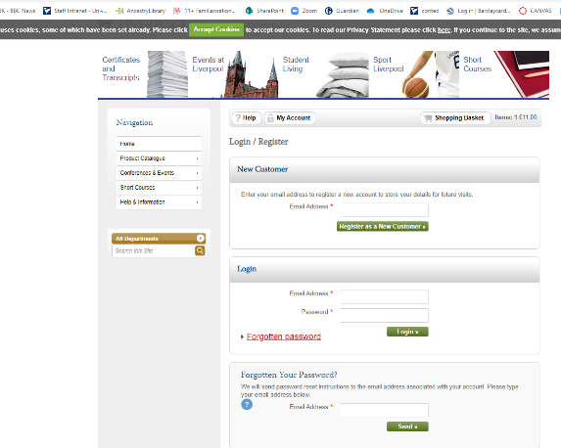

Most people use their personal email address as their username, and you create your own password. That username and password are only for the online store payment and registration system – you will need them to enrol for future courses, but they are not part of the system you use to set up your University IT account or access the online course content.

You will get two emails from the store once you have paid, a receipt for the payment and a confirmation showing that we have received your registration. Please check your junk mail folder if you don’t get these emails within a few hours of paying.

Please note that some emails may come from [openlang@liverpool.ac.uk](mailto:openlang@liverpool.ac.uk) or [conted@liverpool.ac.uk](mailto:conted@liverpool.ac.uk), but you will also get emails from other central University departments as an essential part of your registration and you should make sure you check your email junk folder for messages from [noreply@liverpool.ac.uk](mailto:noreply@liverpool.ac.uk) and any other emails from various addresses @liverpool.ac.uk.

## 3.3 Your Student ID Number

Once the CE Team have processed your registration, you should receive an email from the University containing your student ID number if you are a brand-new student. This may be a couple of days after you register and pay, especially if there is a weekend or bank holiday. This is a 9-digit number– i.e. 202123456.

For continuing students, your student ID number does not change throughout your student journey, so you will not receive this email, however, please do contact us via [openlang@liverpool.ac.uk](mailto:openlang@liverpool.ac.uk) if you are having trouble regaining access to your student account.

You need to keep a careful note of your student ID number and remember it for future use.

## 3.4 Your Computing IT account and MWS (Managed Windows Service) username

Once you have a student ID number, you can activate a University IT Computing account and create an MWS username. If you have been a student at University of Liverpool before, your previous account may still be active or may need re-activating.

The activation process can take 24 hours to process – if you activate your MWS IT account after you receive the course welcome email, please email us so we can manually add you to Canvas.

Go to <https://register.liv.ac.uk>

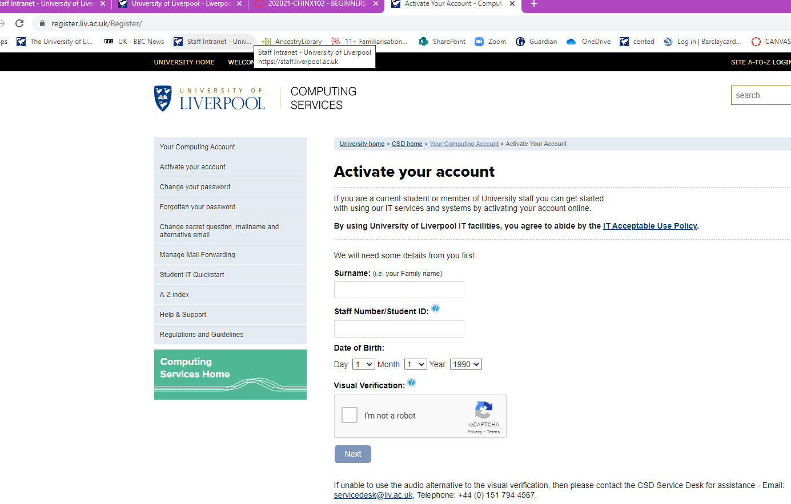

Follow the instructions onscreen to activate your MWS IT account (or check your previous account is active, or change your password if you have forgotten it). You will be given an MWS username. This will usually be 8 characters and will include initials from part of your first and last name. You will need to set a password.

Make sure you keep a record of your IT account username and the password you create.

Follow the instructions onscreen to activate your MWS IT account (or check your previous account is active, or change your password if you have forgotten it). You will be given an MWS username. This will usually be 8 characters and will include initials from part of your first and last name. You will need to set a password.

Make sure you keep a record of your IT account username and the password you create.

**Important Note** – your username needs to be in different formats depending on the system that you are trying to log in to

For example, if your username is abastuxz:

***To manage your IT account e.g change password*** - abastuxz

***To login to Canvas*** - [abastuxz@liverpool.ac.uk](mailto:abastuxz@liverpool.ac.uk)

***To login to Student Email account*** - [abastuxz@liverpool.ac.uk](mailto:abastuxz@liverpool.ac.uk).

***To login to Zoom -*** [abastuxz@liverpool.ac.uk](mailto:abastuxz@liverpool.ac.uk)

But - they do all have the same password as they are all linked to your student account

## 3.5 About Canvas

When you enrol on a short course, you will receive an email confirmation with a link to your courses’ Canvas space. Canvas is the University of Liverpool’s Virtual Learning Environment (VLE) – think of it as a webspace for your course through which you can access learning materials, find links to online lectures, message other students, and more.

Even if your course is delivered in-person, you will still have a Canvas space for your tutor to share materials.

If your course is online, you will access your live online classes and supporting materials via Canvas.

## 3.6 Liverpool Life – student ID number and PIN

The email with your student ID number will also have a link to direct you to the Liverpool Life webpages. Liverpool Life is the University's system for holding all of your information including your personal details and programme records. You can use your student ID number and set a PIN (password) to create a Liverpool Life account to get access to your University records. This PIN password is only used to access Liverpool Life.

You can use Liverpool Life to request a student card by uploading your photo and updating your term time address (which is usually your permanent home address). To find out more about what your student ID card can give you access to, see section 3.13.

In Liverpool Life, you can also see the courses (modules) that you are registered for and let us know if you move house or change phone number.

When you click on the link you will see this screen, and can choose your own PIN – but please note it must meet all the criteria shown – even though it says PIN, it needs to include letters, not just numbers.

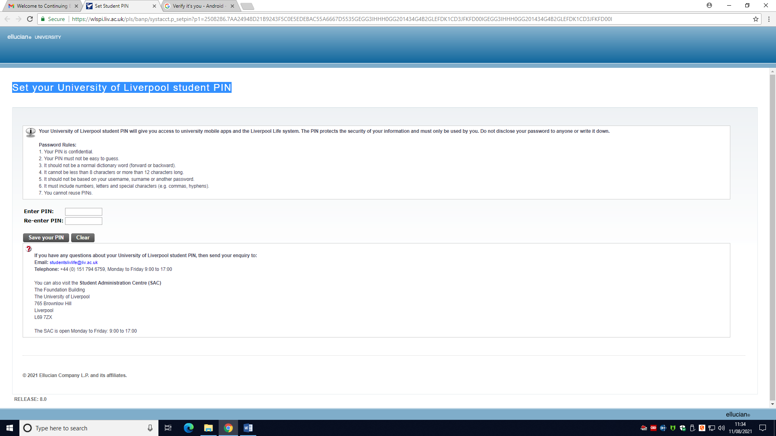

Once you have created the account and PIN – you will see a message that lets you know you must wait 24 hours for your account to be activated.

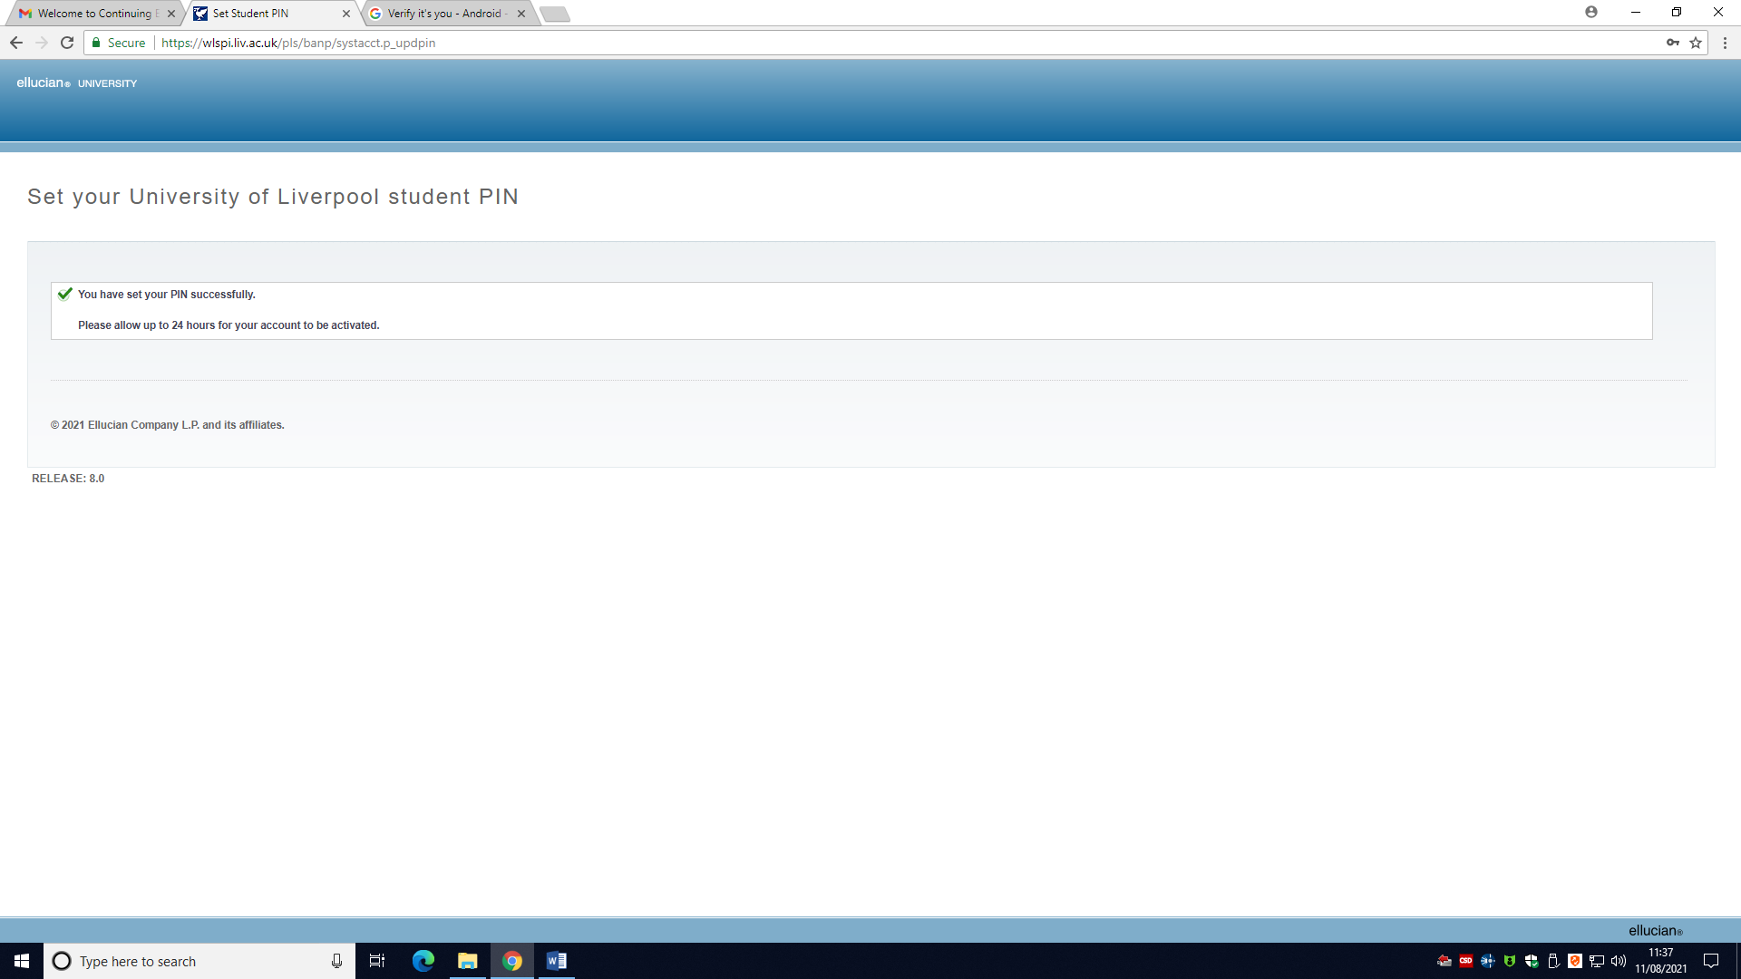

Once 24 hours have passed and the account is activated, you can go back to <https://liverpool-life.liverpool.ac.uk/> to log into your Liverpool Life account.

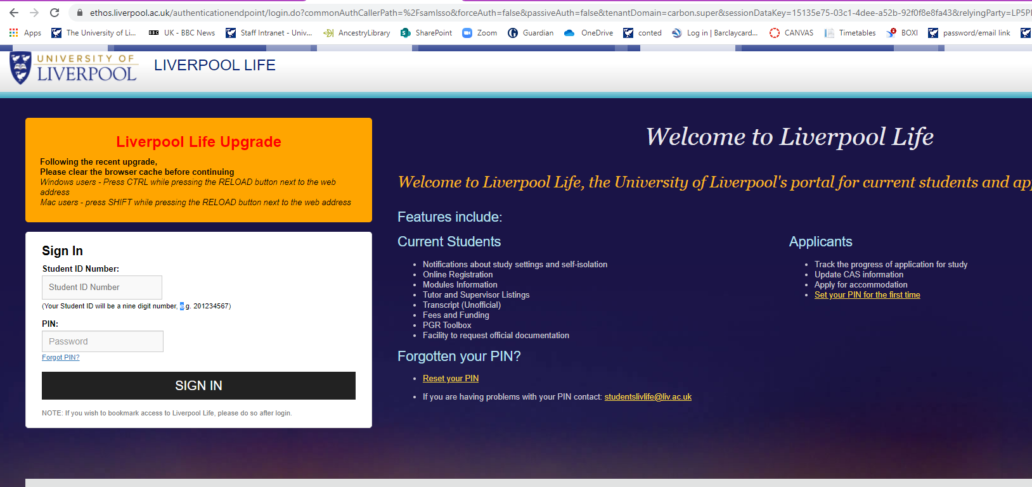

We will tell you more about Liverpool Life in Section 3.13 below, including the benefits of being fully registered as a student.

## 3.7 Two Factor Authentication

**What is two-factor authentication?**

Two-factor authentication (2FA) provides an additional layer of security beyond a username and password. It is commonly used for online services such as banking, Microsoft, and Apple accounts, and works by having more than one method of confirming your identity. For example, by using a mobile app or text message sent to a trusted number that you have enrolled with the service.

The University has partnered with industry experts at Duo Security to implement two-factor authentication. 2FA is being introduced across a number of University systems and you are likely to be asked to use it to login to some systems. It is a really simple process to enrol your mobile phone and to use Duo two-factor authentication to access services. You get the smoothest experience if you download the Duo Mobile app, but you can opt to use SMS text messages if you prefer.

Some of you, especially if you are also on other courses at the university, will already have set up Duo Mobile to access other University systems. If you have already done this, all University systems will automatically link to the same Duo Mobile account; you don’t need to do anything further.

**Why are we introducing Duo two-factor authentication?**

There has been a substantial rise in security attacks against UK universities, some of which severely impacted the target organisation’s ability to function. Duo 2FA is just one of a number of cutting-edge solutions being introduced as part of our IT security programme to help protect our services and data.

You can find more information and FAQs on the Student Intranet pages -

<https://www.liverpool.ac.uk/it/quickstart/two-factor/>

This includes how to access technical support if you do not have access to a mobile phone or other suitable device to set up 2FA.

You can find further information, guidance and advice in the self-service knowledge base. <https://liverpool.service-now.com/sp/?id=search&t=kb&q=duo> (This requires student account login)

If you require assistance with accessing services protected by two-factor authentication, you can also contact the IT Service Desk via the self-service portal. <https://servicedesk.liverpool.ac.uk/> (This requires student account login). Alternatively, please contact [servicedesk@liverpool.ac.uk](mailto:servicedesk@liverpool.ac.uk) for assistance.

## 3.8 Welcome to Canvas

About a week before the course start date, you will receive an email confirmation with a link to your courses’ Canvas space. Canvas is the University of Liverpool’s Virtual Learning Environment – think of it as a webspace for your course through which you can access learning materials, find links to online lectures, and more.

You can also access Canvas via the student intranet or using the app.

You will need to login to Canvas with your username in the format [username@liverpool.ac.uk](mailto:username@liverpool.ac.uk) and password to be able to use all the functions on Canvas. If you are on a course with assessment for credit it is a requirement to have a Canvas login, so that you can upload assignments.

For some courses, particularly those that are a single online session, you can just use the Virtual Classroom to watch the online lecture without needing to login and use some of the other features in Canvas, but for most courses that run for more than one session, we recommend you create an MWS username and login to Canvas to get the best use and functionality.

Please note that we add all the existing student usernames for each class to the Canvas course page a few days before the class starts. If you enrol very close to the class start dates and/or if you did not set up your MWS username (step 3.4 above) until after your first class, you will need to contact us to get your MWS username added to your Canvas course page.

This is an example of what a Canvas page might look like -

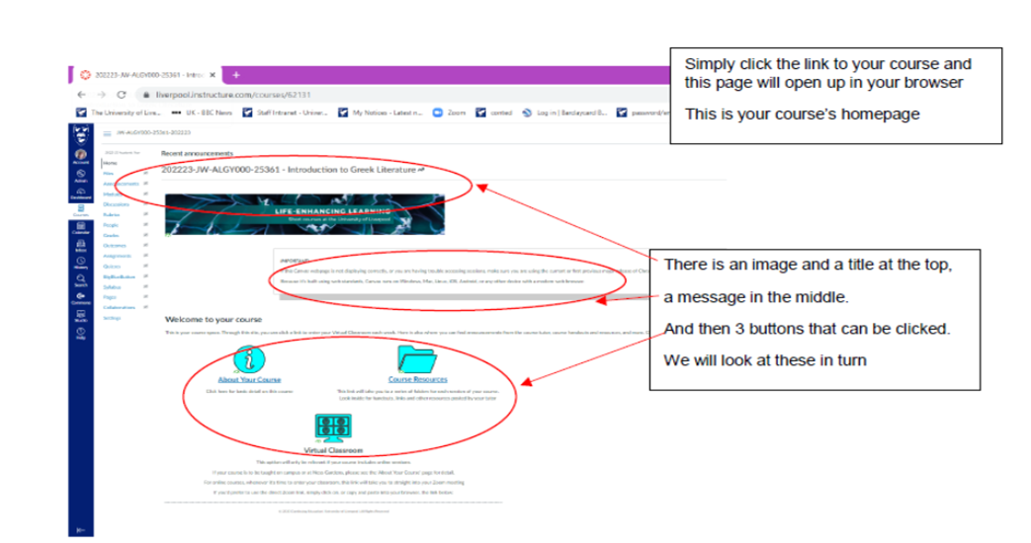

The ‘About Your Course’ Button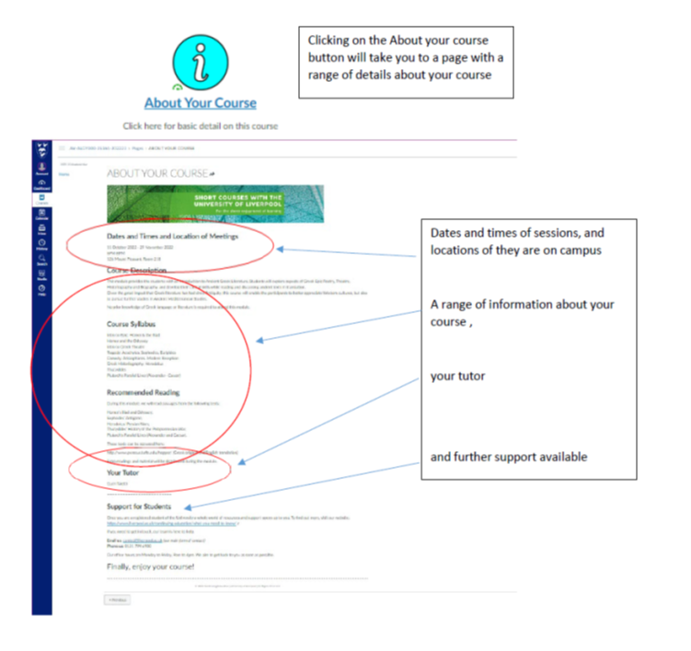

**TIP:**

**If you want to get back to**

**your course**

**’**

**s Home Page,**

**just look for the ‘Home’ link**

**at the top**

**left**

**of the screen**



The ‘Course Resources’ Button

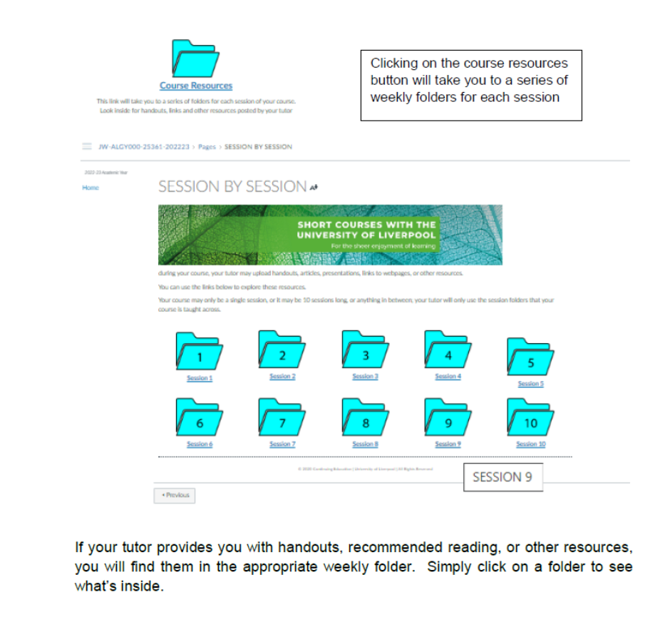

 (for online courses only) The ‘Virtual Classroom’ Button

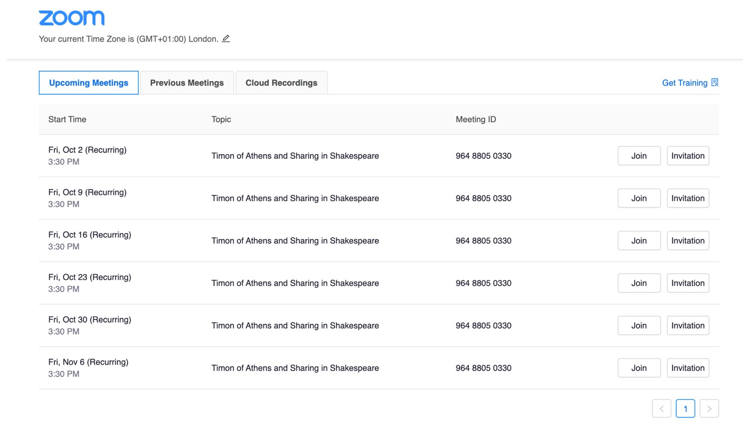

Whenever it is time for you to join your tutor and classmates in a session, simply click ‘Join’ at the appropriate date and time, and you will be admitted into your virtual classroom.

Your virtual classroom is a Zoom meeting. Many of you have used Zoom before, but if you haven’t, see below…

## 3.9 Virtual Classrooms with Zoom



How you enter Zoom will depend on whether you have a University of Liverpool student IT user MWS account.

We recommend you do set up an account to get the most out of your course, and it is easiest if you have already set this up by following section 3.4 of this guide above, then follow the instructions on Using Zoom with a University IT MWS account in section 3.10 below

If you haven’t yet set up a student user IT MWS account, you can still access your live taught sessions as a ‘guest’ by following the Zoom link without a University IT user account instructions in section 3.11 below.

Whichever access instructions you use, it’s a good idea to download the Zoom app to your device before you start if you haven’t used it before – you can find it in the app store or at [www.zoom.com](http://www.zoom.com/). Also check you have given Zoom permission in your device settings to access your microphone and camera.

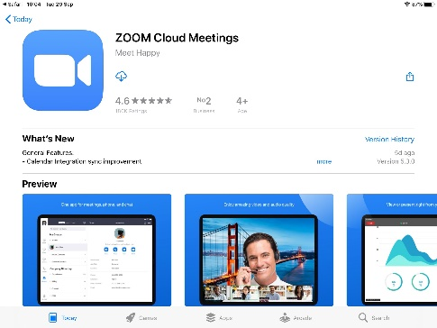

If you don’t have Zoom installed before you start you may get this message – you can download Zoom by clicking on the link to get to zoom.com

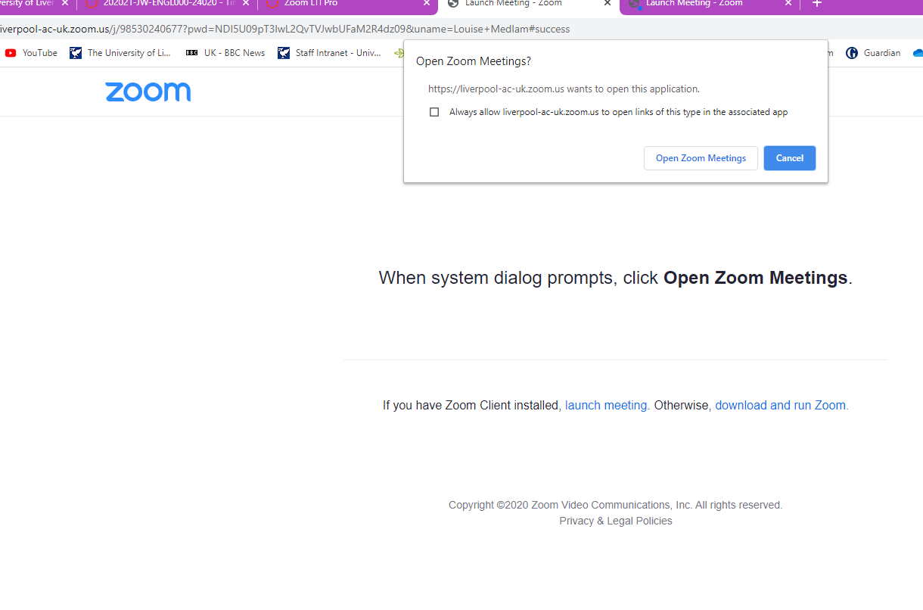

## 3.10 : Using Zoom with a University IT MWS account



When you first click to enter a Virtual Classroom session, you may be asked to sign in with your University of Liverpool credentials – in the format [username@liverpool.ac.uk](mailto:username@liverpool.ac.uk)

If you’ve logged in before, you may just be asked to reconfirm permissions.

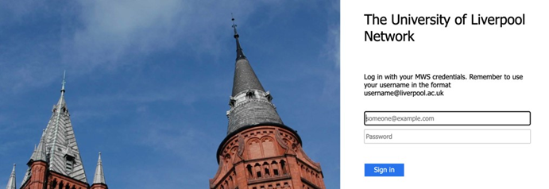

Next, you might be asked to type your name – this is the name that will be displayed by your image so that your tutor and classmates know who you are.

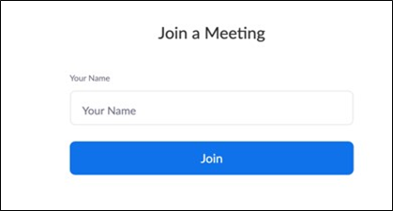

Following this, you might be given a series of options. If so, be sure to allow microphone and video so that you can be seen and heard.

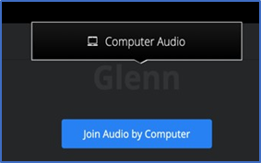

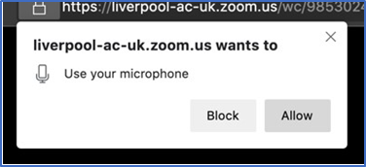

## 3.11: Using Zoom without a University IT MWS user account



When you click on the Virtual Classroom button, you might get a message like this – just click on the link

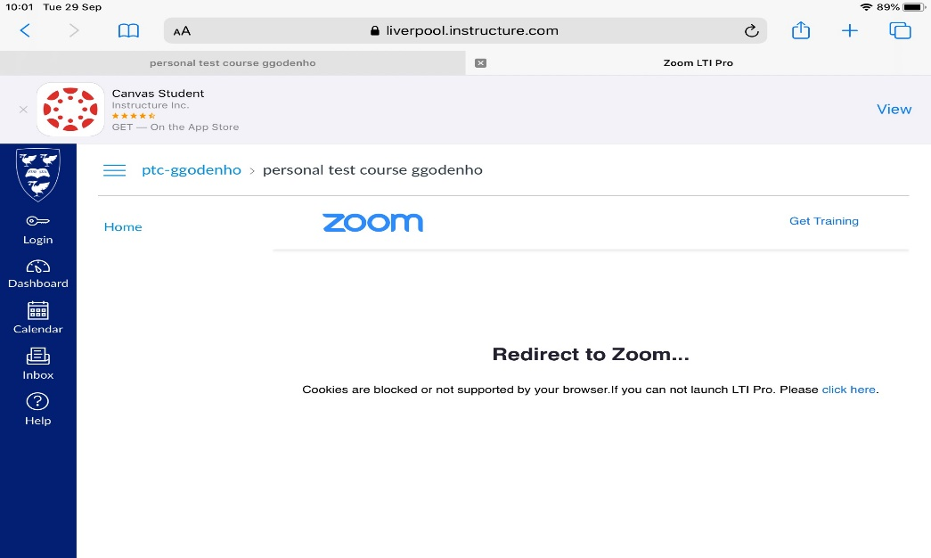

And you will then be able to see the weekly classes listed - pick the week you need and click join

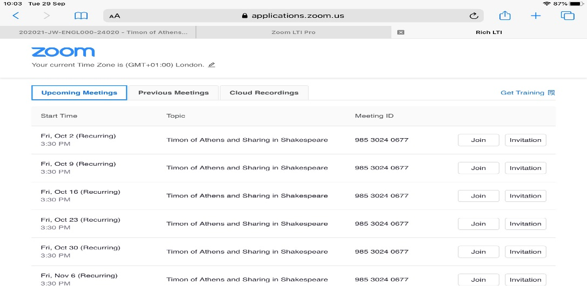



You will then get a series of prompts asking you to allow the camera and microphone to be used, and to enter a screen name – this name will be visible to the tutor and other students

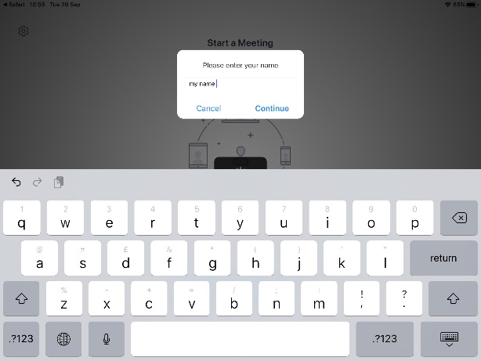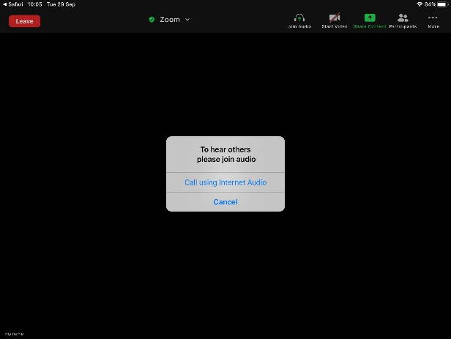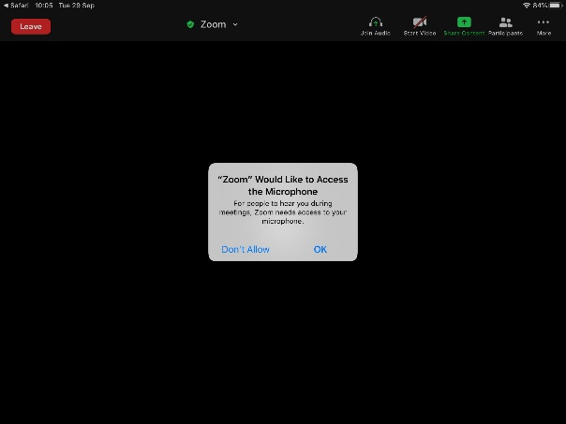

## 3.12 In Your Zoom Session

Clicking the audio and video buttons allows you to turn the microphone and camera on and off

The chat buttons allows you to type messages to your tutor and classmate

At the end of the session just click leave to exit



Once in your session, you will find a toolbar at the bottom of your

screen. Only a few of these

buttons are required by us

…

## 3.13 More on Liverpool Life and the benefits of being a UoL student

Liverpool Life is your view of the record we hold for you. You can see the details we hold, and you can update things like your address, your phone number, your alternative (non-university) email address, your emergency contact person, etc.

The first time you log in, you are confirming that these details are correct, and this is the final stage in confirming your registration as a University of Liverpool Student.

If there are errors in some key fields such as name or date of birth, you may need to contact us to update these and, in some instances, we may ask for evidence.

We hold two addresses for all students – a permanent (home) address and a term-time (student residence) address. If you live at home all-year round, please record your home address as also being your term time address, by clicking on the drop-down arrow next to the View/update option.

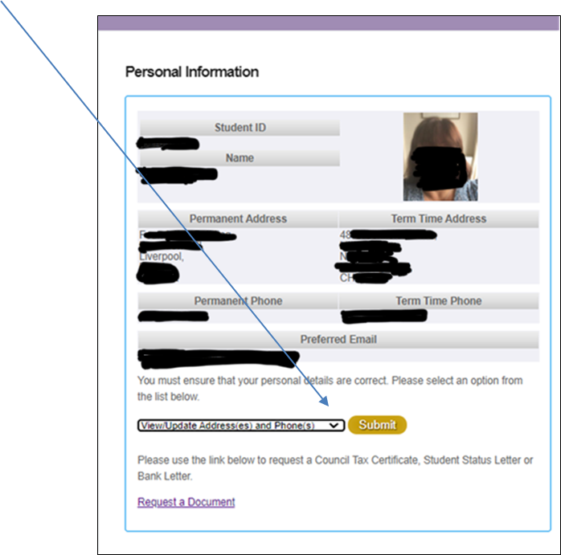

This is important as if this record is blank your student card will not be created.

The University has now introduced digital student ID cards and will no longer issue physical cards, in line with the sustainability agenda. To access your digital student card, please go to the app store on your phone and download the My Liverpool app.

To login to the app, you will need to use your MWS username and password.

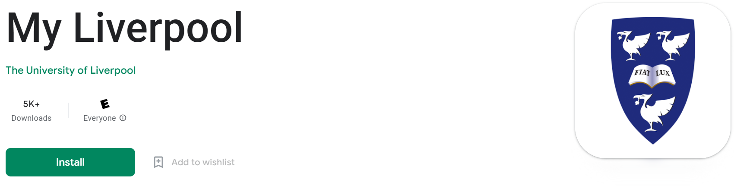

Your student card will give you access to teaching buildings and to the library. Most buildings are open during the day without card access, but it’s a good idea to bring your card with you just in case!

Your student card is useful form of photo ID and that’s not all! The UoL Student ID card opens even more opportunities for you. It can be used to access discounted (sometimes even free) entrance to paid exhibitions in some local museums and galleries, and many local shops offer a discount to UoL students. The Student ID card can be used as a payment card for the Campus cafes if you register with our Loyalty Plus scheme, where you will earn rewards and discounts, such as 10% off hot drinks, loyalty points and a free coffee when you have bought nine <https://www.liverpool.ac.uk/food-and-drink/loyalty-plus/>

Having a student account also gives you access to the University Library - <https://libguides.liverpool.ac.uk/library/>

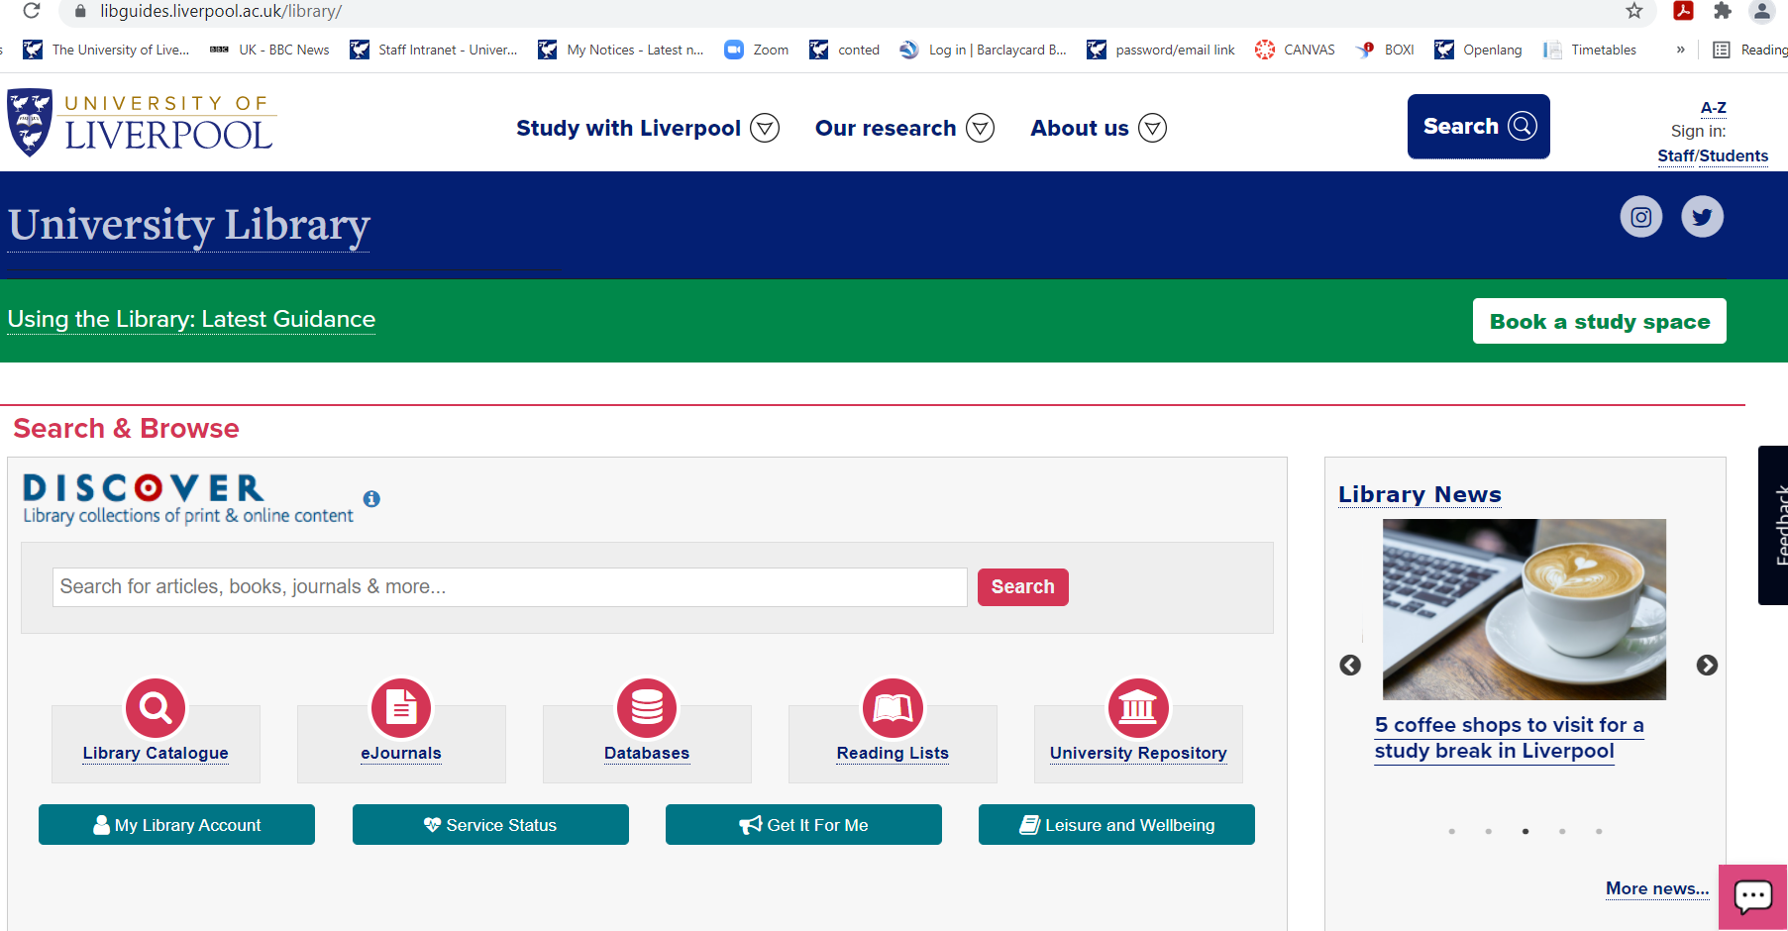

This allows you to view the online catalogues; reserve books for collection; book a PC or a study space to use; and read online books and journals. Make sure you set up your library account via Liverpool Life to make the most of this fantastic additional resource available to you as part of your studies.

Your digital ID card will have an end date which reflects your length of study; this can be reactivated at any point upon registering for any future courses.

# STUDYING, RESOURCES & SUPPORT

## 4.1 Study Skills Support

Once you are registered as a student, you will be able to access [KnowHow](https://student.liverpool.ac.uk/advice-and-guidance/knowhow) (<https://student.liverpool.ac.uk/advice-and-guidance/knowhow>) which is an online resource designed to help you develop the appropriate skills that you need to study successfully at university level.

Writing@Liverpool is a free service that can help all Humanities and Social Sciences students to develop their academic writing skills. Our Writing Tutors are postgraduate researchers and expert academic writers who are specially trained in tutoring students in 1:1, workshop and online contexts. Email [writing@liverpool.ac.uk](mailto:writing@liverpool.ac.uk) for further details.

## 4.2 What to expect

OL classes are welcoming, informal and provide an encouraging environment in which to learn. Your lecturer will outline the course syllabus, aims and objectives and provide professional support materials (as appropriate) as the course progresses. We aim to enhance your study experience by promoting the friendly discussion and exchange of ideas, and to equip you to take an active role in your own learning.

OL modules are not credit-bearing, but they do include regular formative assessment and feedback. This optional assessment provides opportunities for students and tutors to review progress and development. There are usually 11 weeks of teaching followed by the optional final assessment in the 12th week; the cost of the course is the same whether you choose to take the final assessment or not.

Although assessments are optional, we do require a certain level of commitment if you wish to progress in your learning.

Certificates of Engagement are issued to students who successfully pass all assessments or who obtain an attendance record of at least 70% in all scheduled teaching sessions.

## 4.3 What we expect from you

Enthusiasm for the subject and respect for lecturers, staff and fellow students are essential requirements. Homework and the submission of assignments are optional, although students who engage in this way often enjoy their studies more and get the most benefit from them.

The University takes students’ wellbeing very seriously and works to create a safe, supportive and respectful learning community. To ensure that our learning environment remains inclusive and welcoming to all, we expect high standards of behaviour: our students are respectful of others and look out for one another.

You should be aware that your behaviour on and off campus, online and offline, is expected to reflect the values of our community of learning and abide by the Policy on Student Conduct and Discipline. You agree to the terms of this Policy upon receipt of confirmation of your course place. You can read the Policy at

<https://www.liverpool.ac.uk/student-administration/policies-procedures/conduct-discipline/>

You should also be aware that the University operates an Academic Integrity Policy which is concerned with the ethical code applied to standards by which the academic community operates. This covers issues such as plagiarism, referencing, and cheating.

<https://www.liverpool.ac.uk/media/livacuk/tqsd/code-of-practice-on-assessment/appendix_L_cop_assess.pdf>

## 4.4 If you encounter a problem

We hope your OL experience will be a wholly positive one, however in the rare instance that a problem arises we are here to help. In the first instance, you should talk to your lecturer. He/she will provide guidance relating to academic difficulties and advise you on other issues. If your query is a general enrolment or administrative matter, seek advice from [openlang@liverpool.ac.uk](mailto:openlang@liverpool.ac.uk)

You should be reassured that any complaint will be considered by the relevant member of senior staff, and you will receive a response within 10 working days.

If you wish to make a formal complaint when all informal communication channels have been exhausted, please visit <https://www.liverpool.ac.uk/student-administration/policies-procedures/complaints/> to complete a student complaints proforma.

## 4.5 Health & Safety

Ensuring the well-being of students, staff and visitors is a priority for the institution which acts in accordance with all health and safety legislation to ensure a safe working and study environment.

Please take care for the safety of yourself and others while on University premises. Read fire procedure notices and locate fire exits, report accidents, near misses or dangerous conditions to a staff member and co-operate with health and safety instructions.

You should make yourself familiar with all the University's procedures and regulations relating to health and safety, including the University's Safety Policy (available at <https://www.liverpool.ac.uk/safety/universitysafetypolicy/>) and any specific rules that apply to your programme or the building in which you are located. All health and safety procedures and regulations must also be followed when you are studying off campus.

Further information is available at

<https://www.liverpool.ac.uk/intranet/safety/what-you-need-to-know-and-latest-news/student/>

The University of Liverpool, like many public institutions, cannot control entrance to every building or take responsibility for the safety of student possessions. For this reason, please do not leave valuables unattended, even for short periods. This of course applies also to all off-campus venues.

**Emergency**

In the case of a real emergency on-campus, dial 999 if necessary, then contact the University Support Service by dialling 2222 on any internal telephone or 0151 794 2222 from your mobile. If you are studying at another location please refer to your tutor for advice on the local procedures, but in a real emergency please dial 999.

## 4.6 Equality, Diversity and Inclusion (EDI)

Please help the University provide a positive learning environment for students irrespective of gender, race, disability, age, religion or sexual orientation. If you encounter any difficulties with discriminatory behaviour, please make your course lecturer aware.

Find out more at <https://www.liverpool.ac.uk/equality-diversity-inclusion/>

## 4.7 Disability & additional support

The University is committed to creating an accessible and inclusive environment to meet the needs of all students. For more information, please visit our webpage <https://www.liverpool.ac.uk/languages/open-languages/what-you-need-to-know/disability_support/>

Your lecturer will be keen to support you in your learning so please ensure that he/she is aware of any special need you have.

If your class is being held on campus the venue will usually have wheelchair access and facilities. However, venues off campus may not be so well-equipped, so it is vital to let us know if you have mobility problems.

## 4.8 Absence

If you have to miss a class due to illness or other circumstances, please let the Open Languages Team or your tutor know in advance, if possible, by emailing [openlang@liverpool.ac.uk](mailto:openlang@liverpool.ac.uk)

# ENGAGEMENT, ATTENDANCE AND ASSESSMENT

## 5.1 Engagement and Attendance

Our courses will engage you, challenge you – and encourage you to take the lead in your own learning. Students who take an active role in their learning, and who participate in class discussions and activities, are often the ones who get the most out of their course. Attendance in scheduled sessions is recorded, as one way of measuring engagement.

OL extracurricular modules are not credit-bearing, but they do include regular formative assessment and feedback. The optional assessment provides opportunities for students and tutors to review progress and development.

Please note that to ensure your own progress and enjoyment of the course, we require a certain level of commitment and responsibility to ensure a consistent standard for the whole group. Therefore, although taking part in homework and assessment is optional, it is highly recommended that you do so to keep up with the pace of work.

## 5.2 Certificate of Engagement

We recognise the achievement of students who have engaged well in their course with a Certificate of Engagement. These are issued to students who successfully pass all assessments and/ or who obtain an attendance record of at least 70% in all scheduled teaching sessions.

## 5.3 Assessment

Assessment can take many forms and will be appropriate to the subject and course that you are studying. It can include, for example, the completion of an online activity, the preparation of a portfolio of materials and/or an in-class test. Your course lecturer will provide information about the assessment process, and it will be included in the module handbook. Your tutor will also provide you with feedback on your assessment and this will help you focus on areas for future improvement.

There are usually 11 weeks of teaching with some in-class assessment as you go along, followed by the optional final assessment in the 12th week; the cost of the course is the same whether you chose to take the final assessment or not.

## 5.4 Submission guidelines & deadlines

Your lecturer will provide precise instructions about assessments undertaken for credit, including the academic expectations and submission date. These vary according to subject.

For electronic submissions, we encourage all students to use a word processing software such as Microsoft Word. Hand-written assignments must be legible and, in all cases, students must keep a copy of their work. Penalties can be applied for the late submission of work but if you have difficulty in meeting a deadline talk to your lecturer in confidence.

## 5.5 Extenuating Circumstances

We realise that students sometimes have unexpected events and are sympathetic to individuals with mitigating circumstances and to requests for extensions. Please direct any enquiries to your tutor and [openlang@liverpool.ac.uk](mailto:openlang@liverpool.ac.uk) in the first instance as modules are not credit-bearing.

## 5.6 Marking and results

Although the way your work is assessed will vary according to subject, the marking criteria applied will always be in accordance with University standards:

70 to 100: Work which provides evidence of good critical analysis and/or an original contribution with a command of data or literature which is either broad or intense.

60-69: Work which is thorough, clear and shows evidence of understanding of context and the efficient and competent use of data or literature.

50-59: Work in which the treatment of data or literature is basically sound but underdeveloped.

40-49: Work that shows some understanding but which offers a basic treatment using a limited range of data and methodologies and arguments which contain some flaws.

35-39: Work that fails by a small margin to achieve the standards required for a pass.

Under 35: Work that is unstructured, ill-presented, contains serious omissions/errors and which fails to demonstrate adequate knowledge, understanding or sustained argument.

## 5.7 Referencing, plagiarism & collusion

Plagiarism includes a failure to reference sources, close paraphrasing without acknowledgement and, in the most serious cases, copying or downloading another’s work verbatim and presenting it as your own. Collusion occurs when there is unauthorised and unacknowledged collaboration. Penalties for plagiarism and collusion vary but could result in serious mark reduction or a mark of 0%.

To avoid plagiarism, take good care to reference your work well and completely. Your lecturer will provide guidance, or you can find out more at <https://libguides.liverpool.ac.uk/referencing>

## 5.8 Appeals

If you have concerns about your assignment or marking procedure, in the first instance speak to your course lecturer.

## 5.9 Intellectual Property

Where you are registered on an OL course, and where you are not also considered to be an employee of the University, you will own all Intellectual Property that you create and/or develop while you are studying at the University.

## 5.10 Full time UoL Student Attendance on OL Courses and the HEAR

Students who attend OL courses on an extra-curricular basis and who want the attendance or achievement to be recorded on their Higher Education Achievement Report (HEAR), must attend a minimum of 70% of the total course hours and/or pass the module at a total mark of 40% and above.

Modules will be automatically added to the HEAR if you meet the requirements.

# REVIEW, REFLECT & WHAT NEXT?

## 6.1 Course evaluation

Your views on your studies and learning experience are vitally important to us.

You will be asked to give us feedback during or after you course. You may also be invited to provide feedback at an earlier stage. Please ensure that you follow the guidance provided about how to complete the questionnaire, as your feedback is very important in helping us develop future courses.

## 6.2 Compliments & complaints

We are keen to hear your comments about any aspect of the programme, including compliments, complaints and information about the types of course you would like to see included in the OL programme. In the first instance please contact us by emailing [openlang@liverpool.ac.uk](mailto:openlang@liverpool.ac.uk)

## 6.3 Choosing your next course

Please also note that both OL and CE courses are arranged throughout the year so be sure to visit our website for the latest news.

If Open Languages has inspired you to continue learning, there are other opportunities offered by the University that you may like to consider.

*Continuing Education* at the University of Liverpool has been offering courses to the local community in the city and wider region for over 100 years. It offers an exciting and diverse range of courses, lectures and events from across the University’s subject areas. Drawing on the experience and expertise of the University’s academic community its purpose is to build a stimulating and enjoyable learning environment for all – whether you are studying for advancement or for the sheer pleasure of learning. Please visit our website at <https://www.liverpool.ac.uk/continuing-education/> for more information about other courses. You can also sign up for our CE newsletter or find us on Facebook by searching for ‘Continuing Education at University of Liverpool’.

*Go Higher* is an intensive one-day a week, one-year course for adults who want to return to education with a view to going on to a degree course either at the University of Liverpool or elsewhere. No formal qualifications are required. For information visit [*http://www.liverpool.ac.uk/humanities-and-social-sciences/go-higher/*](http://www.liverpool.ac.uk/humanities-and-social-sciences/go-higher/)or call 0808 100 6060.

Undergraduate & Postgraduate degrees: Part-time and full-time programmes are available. For a copy of the undergraduate or postgraduate prospectus call 0151 794 5927 or visit [*www.liverpool.ac.uk*](http://www.liverpool.ac.uk)

# Location, directions & parking

Open Languages staff work on a hybrid/remote pattern and are not in the physical office in 1-7 Abercromby Square every day.

Should you need to visit us, please email us to arrange an appointment first as the office is not staffed in person every day. We will aim to resolve all issues by phone or email in the first instance.

A University Visitors’ Car Park is located next door to 126 Mount Pleasant (access from Mount Pleasant and Brownlow Hill/Ashton Street). Parking charges apply.

Campus maps and car park locations can be found on our website at <https://www.liverpool.ac.uk/maps/>

# Administration, Terms and Conditions for students studying extra-curricular or standalone Open Languages modules

These T&Cs apply specifically for students who are paying a separate fee to study standalone or extracurricular modules. (If you are taking a languages module that counts towards your degree or other course credits, as part of your main full-time programme fee, you should refer to the T&Cs of your main programme enrolment.)

## 8.1 Our courses

All our courses are listed on the OL website at [www.liverpool.ac.uk/languages/open-languages/.](http://www.liverpool.ac.uk/languages/open-languages/)

Here you will find full course descriptions and information relating to fees payable. All information provided is correct at the time of publication and is subject to change.

If you require more in-depth detail about the course content than that offered on the website, please contact the OL team at openlang@liverpool.ac.uk.

OL reserves the right to change, due to unforeseen circumstances, a course lecturer or to revise the content or delivery of courses from those set out in the online prospectus. Any course changes will be notified as soon as it is practical and reasonable to do so.

## 8.2 Who can join?

We welcome anyone aged 16 and over who can benefit from the opportunities available at the University. Our students come from all walks of life; some have no previous experience of higher education. There are no formal entrance requirements – all that is required is interest and a real love of learning. To study an Open Languages course, you should have an IT device (mobile phone/laptop/tablet/computer) that can connect to the internet. Additionally for online courses, you will need an IT device that has a camera and microphone.

Please be aware that OL is designed as an adult learning environment, where discussions are at a mature level and self-motivation is essential. Very occasionally, course content may not be suitable for under-18s. Course descriptions will clearly state if this is the case.

If you are under 18 years of age we need to ask you to supply written permission to participate from your parent or legal guardian. A standard form is available for the purposes of giving permission. The person giving permission will also need to supply an emergency telephone number. We are not able to admit those under the age of 16.

If you are a University of Liverpool under- or post-graduate student, you can take OL courses as extra-curricular modules.

## 8.3 How to enrol

Please enrol as soon as possible as we operate a ‘first come, first served’ policy. Except in the case of some free events, you need to enrol in advance of the course start date.

All our enrolment takes place online. Visit our website at https://www.liverpool.ac.uk/languages/open-languages/ and follow the link to browse the languages on offer and book courses.

For security reasons, we are not able to accept paper enrolments either in person or by post, and we are unable to accept cash or cheques.

## 8.4 Registration

We cannot register you onto a course unless you fully complete the online enrolment form and have paid the appropriate fee via our online store.

## 8.5 Fees

Fee details are included in each course description.

Standard course fee: this applies by default where evidence of eligibility for a concessionary fee cannot be provided.

Concessionary fee: this applies if you receive (or you are an unwaged dependent on someone that receives) one of the following UK means-tested benefits, or if you receive a University of Liverpool means-tested or income-related bursary: -

* Universal Credit
* Pension credit
* Council Tax Reduction (Please note that this is different to Council Tax discounts, exemptions and disregards)
* Income-related Employment and Support Allowance
* Income Support
* Housing Benefit
* Working Tax credit
* Child Tax credit

Proof of entitlement to a concession will be requested each time you enrol. Concessionary fees are available due to the generous support of the John Hamilton Bequest.

Please note that we are unable to offer concessionary fees to those who receive non-means tested benefits (such as PIP/disability living allowance, new-style Job Seekers Allowance, careers/attendance allowances or contribution-based allowances).

Any additional course costs, such as books, trips or entrance fees, are clearly indicated in course descriptions on our website. Please note most OL courses require the purchase of a text book.

Please note these fees apply to OL courses only, and do not apply to Continuing Education courses administered by CE. Please refer to the separate [Continuing Education Terms and Conditions](https://www.liverpool.ac.uk/continuing-education/what-you-need-to-know/) for these courses.

Postgraduate students who are taking OL modules to support their programme are not entitled to free courses and are required to pay the concessionary course fee. If the fee is to be paid by your main teaching/research department then please [contact us](mailto:openlang@liverpool.ac.uk) to arrange this.

## 8.6 Fees for assessment

Open Languages extracurricular modules are not eligible for University credits, and do not contribute towards any award. However, regular formative assessment and feedback is undertaken to allow students and tutors to measure and discuss progress.

The fee for this assessment is already incorporated into the course fee and is non-refundable even if students decline to participate in assessments, as formative assessment is integral to the course design.

There are usually 11 weeks of teaching followed by the optional final assessment in the 12th week; the cost of the course is the same whether you choose to take the final assessment or not.

Although assessments are optional, we do require a certain level of commitment if you wish to progress in your learning.

Shorter ‘taster’ courses do not include assessments.

## 8.7 Course cancellations

If a course is full or has to be cancelled, we will always notify you as quickly as possible. Courses require a minimum number of students to run; this can vary by course. Where a course is cancelled by the University due to low numbers, a full refund will be issued to the same card that was used to pay the fee. Refunds will be identified on bank and credit/debit card statements as being from the University of Liverpool. OL reserves the right to change a course lecturer or withdraw a course in the event of unforeseen circumstances.

Weekly course meeting dates are normally sequential (unless otherwise stated) but on occasion planned dates may need to be rearranged, postponed or cancelled due to unforeseen or unavoidable circumstances such as staff illness, industrial action or local/government restrictions.

We recommend that you do not purchase any books or other equipment for your course until we have confirmed the course is definitely running. Decisions are usually made around 7 days prior to the course starting.

More information about circumstances which might occur and that are outside the University’s control are outlined in section 8.19.

## 8.8 Refund request or withdrawal from a course

If you wish to withdraw from a course, an emailed application for a refund must be sent to [openlang@liverpool.ac.uk](mailto:openlang@liverpool.ac.uk) a minimum of 14 days prior to the course start date. No refunds will be issued after this date. All withdrawal refunds are subject to an administrative charge of 10% of the relevant fee.

This does not affect your statutory right to cancel this contract at any time within the 14 days immediately following your registration on a course, without giving any reason. In such a circumstance, you will be entitled to a refund of any course fee you have paid to the University prior to your decision to cancel.

All notices of cancellation must be made in writing.

## 8.9 Personal information and data security

The Student Enrolment and Registration Form collects information that is required by the Higher Education Statistics Agency (HESA) by law, and which is used as the basis for your student record and the University’s monitoring of equal opportunities. We are not able to enrol you if you do not complete all sections of the enrolment form.

When you enrol onto a course delivered by OL, you accept that the University will collect, retain and process certain personal data about you, which will include sensitive personal data about you (for example, data concerning your racial/ethnic origins, criminal convictions, health and wellbeing). The University will hold and process these data in accordance with its legitimate interests and the lawful basis of ‘public task’, in order to exercise its responsibilities, and to fulfil its education and support obligations to you.

The University will hold and process your personal data in compliance with our obligations as Data Controller under the General Data Protection Regulation and Data Protection Act 2018. We will not share your data with third parties unless we have an appropriate consent from you, are under a statutory or regulatory obligation to do so (such as with Liverpool Guild of Students, Office for Students, Higher Education Statistics Authority, Student Loans Company, Skills Funding Agency, local authorities or the Police), or are otherwise permitted to do so under the aforementioned Acts of Parliament.

In the interests of transparency, the University maintains a series of Privacy Statements which outline in more detail how it collects, retains and processes your personal data, which may be updated from time to time. These are available at [www.liverpool.ac.uk/legal/data_protection/privacy-notices/](http://www.liverpool.ac.uk/legal/data_protection/privacy-notices/).

## 8.10 IT and information security

You must comply with all regulations, policies and codes of practice in relation to the use of IT during the course of your studies. These can be found on the University’s [website](https://www.liverpool.ac.uk/csd/regulations/).

Use of all IT equipment and its connection to the University's IT network must comply with the relevant sections of the regulations and policies. These prohibit the use of computing devices and the University's network for, amongst other things, any illegal activity, the creation or transmission of offensive or obscene material, and the creation or transmission of any material which infringes the IP rights of another person. The University may monitor the use (including any personal use) of its network and systems (including telephone, email, voicemail, internet, other communications, and computer systems) and review or restrict information transmitted using them as reasonably necessary to ensure the appropriate use of its services and to comply with its legal obligations.

By connecting to the University's IT network, you are accepting all of the associated risks. This includes when you connect to the network with any of your own devices. The University will not be liable for any damage that is caused by your use of IT equipment and/or connection to the University's network, except in the case of any foreseeable damage resulting directly from the University's negligence or failure to comply with this contract.

## 8.11 Means of communication

Email is the primary form of communication for all course matters. Please ensure that the OL Office has your current email address and that you check your email account regularly, including your junk folder.

You are entitled to create a University of Liverpool student email account and we would encourage you to do so and to check this account regularly. Further information about this process is available at on the [IT Services website](https://www.liverpool.ac.uk/it/).

You can also contact us by telephone: +44 (0)151 794 6900

## 8.12 Declaration of criminal convictions

The main aim of the University of Liverpool is to admit students with the ability to benefit from the opportunities available at the University. Possession of a criminal conviction will not necessarily mean that an application to study in OL will be unsuccessful. It is, however, important that this aim is achieved without prejudice to the safety and well-being of other members of the University community, and there may be occasions where this has to be placed ahead of all other considerations. Decisions regarding the admission of an applicant with criminal convictions are taken fairly and only after the implications of any conviction have been fully explored.

OL requires all applicants who have a *relevant* criminal conviction to declare this on the standard enrolment form. A relevant criminal conviction is one which involves offences against the person, whether of a violent or sexual nature, and convictions for offences involving unlawfully supplying controlled drugs or substances where the conviction concerns commercial drug dealing or trafficking.

Convictions that are spent (as defined by the Rehabilitation of Offenders Act 1974) are not considered to be relevant. You can find more information on this at

<https://www.liverpool.ac.uk/media/livacuk/study/undergraduate/applying/criminal-convictions-policy.,2022.pdf>

It is important to note that a failure to declare a relevant unspent criminal conviction is taken very seriously and could result in expulsion from the University. You should therefore seek advice before completing our enrolment form if you are in any doubt about what you might need to declare.

## 8.13 Student conduct

The University takes students’ wellbeing very seriously and works to create a safe, supportive and respectful campus community. In order to ensure that our campus environment remains inclusive and welcoming to all, we expect high standards of behaviour on and off campus: our students are respectful of others and look out for one another.

You should be aware that your behaviour on and off campus, online and offline, is expected to reflect the values of our community of learning and abide by the Policy on Student Conduct and Discipline. You agree to the terms of this Policy when you enrol on a course. You can read the Policy at [www.liverpool.ac.uk/student-administration/policies-procedures/conduct-discipline/](http://www.liverpool.ac.uk/student-administration/policies-procedures/conduct-discipline/).

## 8.14 The University’s general regulations

By enrolling on a course delivered by OL, you accept and agree to be bound by the terms of this document, by the University’s instrument and articles of government, by the University’s regulations, policies and procedures, by any additional agreement that is required as part of your course, and by the other documents referred to in these terms and conditions. All of these documents can be found on the University’s website and, unless otherwise agreed, the latest versions of these documents will apply.

In particular, you accept and agree to be bound by all [Statutes](https://www.liverpool.ac.uk/media/livacuk/cgso/calendar/Statutes.pdf), [Ordinances](https://www.liverpool.ac.uk/media/livacuk/cgso/calendar/Ordinances,1-34,February,2023.pdf), Regulations, Rules, Policies and Codes of Practice of the University, as they may be updated from time to time, including and where appropriate, but not exclusive to:

* [The Student Charter (including its Annual Annexe)](https://www.liverpool.ac.uk/media/livacuk/student-administration/student-administration-centre/documents/Student_Charter_final_June_15.pdf)
* [Student Complaints Policy and Procedure](https://www.liverpool.ac.uk/student-administration/policies-procedures/complaints/)
* [Policy on Student Conduct and Discipline](https://www.liverpool.ac.uk/student-administration/policies-procedures/conduct-discipline/)
* [IT Regulations and Policies](https://www.liverpool.ac.uk/csd/regulations/)
* [Library Regulations](https://libanswers.liverpool.ac.uk/faq/80463)
* [Diversity and Equality of Opportunity Policy](https://www.liverpool.ac.uk/intranet/hr/my-hr/information/policies/diversity/opportunity/)
* [Dignity at Work and Study Policy](https://www.liverpool.ac.uk/intranet/hr/my-hr/information/policies/diversity/dignity/)
* [Code of Practice on Freedom of Speech](https://www.liverpool.ac.uk/media/livacuk/cgso/policycentre/policies/governance/Policy,and,Code,of,Practice,on,Freedom,of,Speech,2022,FINAL.pdf)

The University may change this document, any one of the above regulations, policies, procedures or codes of practice, or any other elements of your contract from time to time in order to ensure that it operates efficiently for students, is consistent with best practice, and/or complies with any legal or regulatory requirements. The University will ensure that any important changes to these documents are notified to you as soon as possible.

## 8.15 Complaints

The Student Charter sets out your general entitlements and responsibilities. If you believe you have a legitimate complaint, you should refer in the first instance to the Student Charter to clarify what is reasonable for you to expect from the University in the relevant area and whether you have discharged your corresponding liabilities.

If you wish to proceed with a complaint then you may invoke the Student Complaints Policy and Procedure. The Policy and Procedure sets out how you may seek to have your complaint addressed.

It should be recognised that the vast majority of concerns can be handled fairly, amicably and to the satisfaction of all concerned on an informal basis. Only when informal means have been exhausted should a complaint be pursued.

The Student Complaints Policy and Procedure, as well as a pro-forma for the submission of a complaint, is available at [www.liverpool.ac.uk/student-administration/policies-procedures/complaints/](http://www.liverpool.ac.uk/student-administration/policies-procedures/complaints/) or from [openlang@liverpool.ac.uk](mailto:openlang@liverpool.ac.uk).

## 8.16 Intellectual property

Intellectual property (IP) refers to creations of the mind, such as inventions; literary and artistic works; designs etc.

Subject to the remaining provisions of this section, where you are enrolled on a course delivered by OL, and where you are **not** also considered to be an employee of the University, you will own all Intellectual Property (“IP”) that you create and/or develop while you are studying at the University, subject to the exceptions prescribed below.

Exceptions to your sole ownership of IP may include, yet not be exclusive to:

* Where you generate IP as part of an activity where a third party requires ownership (e.g. where on a placement your host requires ownership, or where your studies are sponsored and the sponsor requires ownership);
* Where you generate IP that builds upon existing IP generated by employees of the University;
* Where you generate IP that you jointly create and/or develop with employees of the University;
* Where you generate IP outside the normal teaching and learning activities of your course, and with more than incidental use of University resources;
* Where you are recruited on a programme of study under the specific understanding that, due to the particular commercial or IP-sensitive environment, your IP position is varied.

Where your situation falls within the exceptions prescribed above, the University may require you to assign your IP rights to the University whereupon you will have access to the revenue sharing scheme applicable to employees of the University. More information on this process can be found at [www.staff.liverpool.ac.uk/research/ip-commercialisation/](http://www.staff.liverpool.ac.uk/research/ip-commercialisation/) .

The University will share with you any financial benefit accruing to it from the commercial application of University-owned IP which you create and/or develop, in accordance with its [Intellectual Property Policy](https://www.liverpool.ac.uk/intranet/media/intranet/humanresources/2014/myhr/policiesandprocedures/Intellectual,Property,Policy.pdf) from time to time in place.

You acknowledge that during the course of your studies you may have access to confidential information belonging to the University or a third party and you agree that you will not use such confidential information other than in connection with your studies (and then only upon such terms and conditions as may have been agreed) and will not without the prior consent of the University or the third party to whom it belongs disclose such confidential information.

## 8.17 Health, safety and wellbeing

The University will act in accordance with all health and safety legislation and regulations to provide a safe working environment for you during the course of your studies. This applies to all campuses where staff and students may be working or studying, or to the virtual learning environment for blended or distance learning programmes delivered online.

The University will monitor health and safety to ensure continuous improvement, to reduce the risk of an accident and to prevent injury and ill-health. If you are studying remotely from your own home/office/non-university location, you are responsible for the health and safety of your own physical environment.

The University will provide such information, instruction, training and supervision as is reasonably necessary to ensure the health and safety of its staff and students.

You must make yourself familiar with all of the University's procedures and regulations relating to health and safety, including the University's [Safety Policy](https://www.liverpool.ac.uk/safety/universitysafetypolicy/) and any specific rules that apply to your programme or the building in which you are located. All health and safety procedures and regulations must also be followed when you are studying off campus. If you fail to follow health and safety procedures and regulations, the University may take disciplinary action against you.

You must inform the University if you have any mobility issues or if there is any other reason which would affect your ability to follow any health and safety procedures or regulations whilst on the campus or organised field trips. The University will make any reasonable adjustments and provide you with additional support to ensure your safety and wellbeing.

## 8.18 The University’s liability to you

If the University fails to comply with its contract with you, the University is responsible for any loss or damage you suffer that is a foreseeable result of the University's breach of contract or failure to use reasonable skill and care. However, the University is not responsible for any loss or damage that is not foreseeable. Loss or damage is foreseeable if it is an obvious consequence of the University's breach or if it was contemplated by you and the University at the time the contract was entered into.

The University does not exclude or limit in any way its liability for:

* death or personal injury caused by the negligence of the University or its employees, agents or sub-contractors;
* fraud or fraudulent misrepresentation; or
* any other act or omission, liability for which may not be limited by law.

Subject to the points immediately above, the University's total liability to you (whether in contract, tort (including negligence), breach of statutory duty, or otherwise), in connection with your contract with the University shall be limited to the value of the course fees paid by you or on your behalf or the amount, if any, that the University receives from its insurers in respect of a particular loss, whichever is the greater.

The University will not be liable to you for any lost or unreturned work submitted for assessment. It is important that you follow any instructions from the University in submitting work and that you retain copies of work submitted.

You will not be liable to the University for any failure or delay in performing your obligations under this contract which is due to any cause beyond your reasonable control. Similarly, the University will not be liable to you for any failure or delay in performing its obligations under this contract which is due to any cause beyond its reasonable control (including, but not exclusive to, those circumstances described in paragraph below).

## 8.19 Circumstances outside the University’s control

It may be necessary for the University to:

* revise the terms, content or delivery (such as replacing physically attended activities with synchronous and/or asynchronous online teaching) of courses from those set out on the website and/or relevant course literature; or
* discontinue, suspend, merge or combine options within courses; or introduce new options within courses,

in circumstances outside the University’s control. These circumstances may include (yet are not exclusive to) the lack of availability of key personnel without whom the University cannot provide its services; over- or under-demand from students; lack of funding; the acts or omissions of placement providers and other third parties; cancellation of third party licences; changes in the requirements of a commissioning or accrediting body; strikes and other industrial action; and other events such as government restrictions, global and/or national pandemics and/or epidemics, civil unrest, severe weather or failure of public or private communications networks.

If the University’s services to you are affected by such an event the University will give you as much notice as possible and, where necessary, take reasonably practicable steps to mitigate the effects on the services it provides to you, which will involve every effort being made to preserve the continuation of your study.

## 8.20 Termination of this agreement

We may terminate this agreement with immediate effect in writing and terminate your registration as a student with the University in any one or more of the following circumstances:

* If, in our reasonable opinion, you provide us during the process of your admission to the University with information which is fraudulent, untrue, inaccurate, incomplete and/or misleading;
* If you voluntarily withdraw from your course;
* If your studies are terminated as a result of your failure to adhere to the rules which regulate the conduct of students, following an appropriate course of disciplinary action taken in accordance with the Policy on Student Conduct and Discipline;
* If your continued registration with the University places the University in breach of any of our legal obligations, including under UK immigration law;
* If you materially breach any of the provisions contained within this agreement;
* If your studies are terminated for any other reason permitted by the Statutes, Ordinances, Regulations, Rules, Policies and Codes of Practice of the University, as they may be updated from time to time.

A decision to terminate your registration as a student will mean that you shall be required to cease studying on your course and to leave the University with immediate effect.

This contract will terminate automatically if you withdraw from your programme of study.

## 8.21 Other important terms

If there is any conflict or inconsistency between this document and the other documents which form part of your contract with the University, the various documents will apply in the following order of priority

* this document;
* the University's website;
* any agreement relevant to your programme.

The University may transfer its rights and delegate its obligations under this document to another organisation. However, the University will always notify you in writing if this happens and will ensure that no such transfer or delegation will affect your rights under this document.

Your contract with the University (of which this document forms part) is between you and the University. No other person shall have any rights to enforce any of its terms.

Each of the provisions of your contract operates separately. If any court or relevant authority decides that any provision is unlawful (in whole or part), it shall be deemed to have been modified to the minimum extent necessary to make it lawful and the remaining provisions will be unaffected and will remain in full force and effect.

If you are in breach of your contract with the University and the University decides to waive that breach or refrains from, or delays in, enforcing its rights against you or requiring you to perform your obligations, that will not mean that the University has waived its rights against you for that or any other breach, nor that you have been released from those obligations.

This document is governed by English law. You and the University both agree to submit to the exclusive jurisdiction of the English courts.