Brief Guide to Learning Outcomes
Introduction
At module level, learning outcomes describe what a student should be able to do or achieve at the end of that module. This process shifts attention from content (teacher centred approach) to student achievement and ability on successful completion of a module (student centred approach). As a result, learning outcomes are considered a helpful arrangement in terms of:
- Communicating the purpose a module is intending to accomplish
- Making explicit what is expected of the student
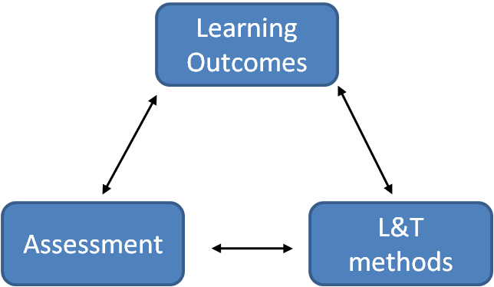
- Specifying the minimum acceptable standard for passing a module (threshold level)
Moving on a step further, it is essential to ensure that assessment tasks associated with a module are designed to fulfil the learning outcomes of that module. Every learning outcome must be assessed and should be fulfilled through the learning and teaching methods used during the delivery of the module content. This concept is known as “Constructive alignment” (Biggs, 2003)
Figure 1. Constructive Alignment
Writing Learning Outcomes:
This is a challenging task that requires particular attention as it can influence the effectiveness of the learning experience of students in a module. Good practice for writing clear learning outcomes recommends the use of the following four components:
- Introduce the Learning Outcome using the following expression: “at the end of this module/course you should be able to ...”
- Then use an active verb that indicates what the student is expected to be able to do at the end of the period of learning (see red text in examples below)
- Next, provide a few words that indicate on what or with what the student is acting (see green text in example below)
- Finally and if necessary, add brief text to indicate the nature of the performance required as evidence that the learning was achieved (see blue text in example below)
Some examples:
At the end of this module/course you should be able to
- Define the terms wavelength, frequency, amplitude and node
- Describe the Bohr model of the atom and use it to account for the emission line spectra of the H atom
- Apply the techniques of multivariate analysis in order to be able to handle straightforward multivariate data sets in practice
- Appraise any risks or safety aspects that may be involved in the operation of computing equipment within a given context
- Demonstrate how magma geochemistry relates to partial melting of the mantle by contrasting the outcomes of this process in different tectonic regimes through the critical analysis of specific case studies.
- Apply the principles underpinning the use of computer graphics in the design of user-friendly interfaces
Below you can find some suggestions for active verbs (red part of the LO) you may want to use when you write your module’s learning outcomes (a more complete list of verbs can be found at J. Moon, 2002 book – see reference list, or search for Bloom’s taxonomy verbs on the web):
- For activities giving evidence of knowing (what do you expect students to know?):
  - define; state; list; outline; recall; extract; write; describe; label; reproduce
- For activities giving evidence of comprehension (How do students convey what they have understood?):
  - explain; identify; discuss; describe; interpret; justify; compare; illustrate; estimate; paraphrase
- For activities giving evidence of knowledge/application (How do students use a theory or information in a new situation?):
  - demonstrate; apply; operate; employ; illustrate; construct; produce; explain; verify; assess
- For activities giving evidence of analysis (How do students break down material and ideas into constituent parts to show how they relate to each other and how they are organised?):
  - distinguish; appraise; debate; solve; examine; investigate; calculate; analyse; criticise; compare
- For activities giving evidence of synthesis (How do students work with elements and combine them in a way that was not there before?):
  - propose; formulate; teach; compile; devise; design; relate; summarise; argue; manage
- For activities giving evidence of evaluation (How do students construct an argument, compare opposing arguments, make judgements?):
  - judge; evaluate; appraise; assess; criticise; rate; defend; question; discriminate; contrast

- Note: It is recommended that you consider avoiding the use of the verbs ‘understand’ or ‘appreciate’ in the learning outcomes of a module. These terms tend to be ambiguous, and as a result, it is not made explicit to students the level of ‘understanding’ or amount of ‘appreciation’ that is required for successful completion of the module.
References and further reading
Biggs, J. (2003) Teaching for quality learning at university. 2nd ed. Buckingham: SRHE and OUP
Higher Education Academy (2005) Writing Learning Outcomes. http://www.heacademy.ac.uk/assets/ps/documents/primers/primers/ps0091_writing_learning_outcomes_mar_2005.pdf
Moon, J. (2002) The Module and Programme Development Handbook. London: Kogan Page
Kahn, P. (2003) Guidance on writing aims and intended learning outcomes. Academic Framework and Regulation Project

