Peer Evaluation with Buddycheck - Student Explainer
Author(s): Will Moindrot

Description:
A reusable textual explainer for members of staff to adapt to fit your needs, in order to introduce Buddycheck or Peer Evaluation processes to students as part of an assessment design.
Communicating clearly with students about why and how peer evaluation is being used to support their learning is an important way to encourage buy-in and confidence with the process, helping students to get the most out of the learning experience, and helping the peer evaluation to run more smoothly.

Instructions for use:
The following text, provided in Microsoft Word format, may be copied, adapted and added into your course materials, such as within a module handbook or assessment briefing. You may wish to use Word’s Clear Formatting or Format Painter to ensure consistent formatting throughout.
Please remember to update the information with specifics on how you will use Buddycheck or Peer Evaluation, for example under the section ‘How will this be used in calculating your grade?’
If you find this resource useful, please feel free to share with others. Please do so retaining this cover sheet and if you are from outside the University of Liverpool we would ask you to attribute our text – thank you.
© 2023 by the University of Liverpool, Centre for Innovation in Education.
Peer Evaluation with Buddycheck - Student Explainer by Will Moindrot is made available under a Creative Commons Attribution-NonCommercial 4.0 International License.

Rationale
Groupwork is an important aspect of this module. Strong groupwork skills and experience is something that is highly valued by employers and industry. You will be assigned into groups and you will need to work hard to ensure that your groups work effectively in order to be able to achieve your shared goal. Your final grade for the module will be generated in part from the shared output of your groupwork task. You may find that there are different levels of contribution within the team, and for this reason after you have submitted your groupwork task you will have the opportunity to evaluate the contribution of peers using a tool called Buddycheck. The data from this will be used to modify the marks in line with the contribution of the group members.

Buddycheck
Buddycheck is widely used across the University and built into Canvas. It is easy to use, it contains a good tutorial to guide you through the process, and it should only take you 5 – 10 minutes to complete.

How it will work?
After your group presentation we will give you a one week ‘window’ to undertake your Peer Evaluation in Buddycheck. Using Buddycheck you will be asked to assess your own contribution to the task and those of each of your peers through 5-point rating scales against a number of criteria. To find out more about the criteria, look at this page from Purdue University.

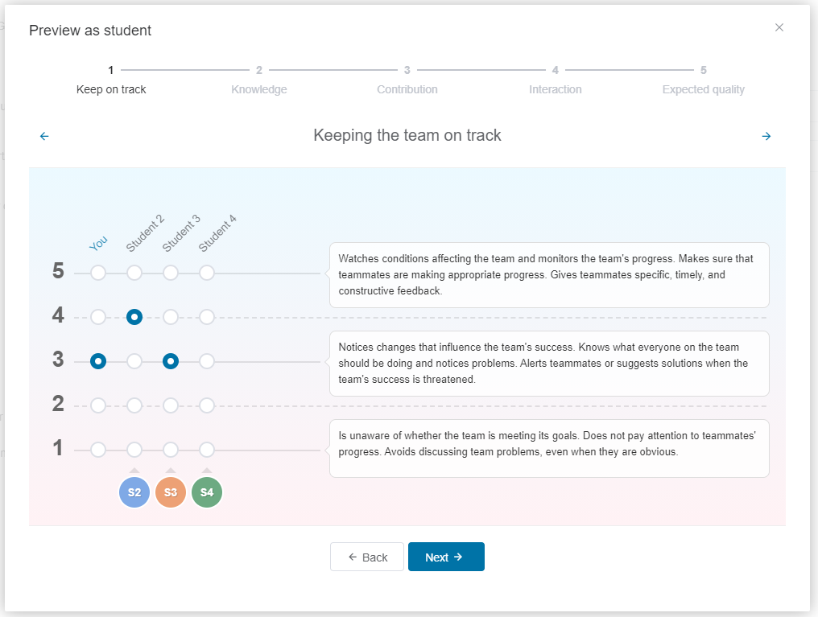

Anonymity
Your responses are confidential and anonymous - the recipient cannot see what score you individually gave them, they can only see an aggregate. Equally your teammates cannot see what feedback you receive.
How will this be used in calculating your grade?
The data generated through Buddycheck will help me to individualise your marks for your groupwork. Through the peer evaluation each team member will be given an ‘adjustment factor’ which I can apply to their mark from the groupwork. Through this you can potentially earn an additional [%] on your group mark, or up to [%] can be deducted. I will monitor the data and if any student receives a low adjustment factor then they will be removed from the peer evaluation process.
What other feedback can I receive?
In addition, you will receive a personal report showing the average that you received against each criterion against the group average, with tips on how to improve in the future.
What if something goes wrong?
If there appears to be a problem that the group cannot resolve, then I can intervene and use my academic judgment to decide how to proceed. In these cases, team members would need to contact me, and we can meet one-to-one or as a whole group to discuss issues and agree on a course of action.
Support on offer
We will be running sessions on groupwork which will help you to form groups and successfully start work. One of the early activities will be to draw up, fill out and sign a 'groupwork contract' in your teams. This sets out principles which you will collectively agree to work towards throughout your groupwork.
Remember
Remember that our aim for using peer evaluation and Buddycheck is to help you to feel more confident about groupwork, to encourage everyone to engage in the task, as well as helping you to develop your teamworking skills and giving you valuable tools for your future careers.

