Peer Evaluation student-facing support materials
Author(s):
Will Moindrot (Centre for Innovation in Education)
Duong Tran Bach (Management School)

Description
CIE have produced a collection of student-facing support materials around Peer Evaluation and Buddycheck, in collaboration with MSc Digital Marketing & Analytics student Duong Back Tran during her internship with CIE in 2023. These materials have been developed to help students improve their groupwork experience and introduce Buddycheck/Peer Evaluation in a fun and student-orientated way. You can view the materials on the next page and freely reuse them in your own course.

How to use the materials
The materials are available for you to use in a number of ways.

Copy into your course
Feel free to copy and paste the materials into your Canvas course or other course documents, or save a new copy of this document for your students to access (deleting this overview page).

Import the materials into your own Canvas course
Import the materials into your own course with embedded videos: Buddycheck and Peer Evaluation student support materials for Canvas (log into Canvas and click on Commons button first for this link to work)

Refer your students to KnowHow materials
The materials also sit within each faculty’s ‘KnowHow: Study for Success’ courses. Share these links with your students:
- KnowHow Study for Success - Faculty of Health and Life Sciences
- KnowHow Study for Success - Faculty of Humanities and Social Sciences
- KnowHow Study for Success - Faculty of Science & Engineering
- KnowHow Study for Success – Postgraduate Taught

Access on the CIE website
You can share a link to this resource from the CIE website (although it would include this overview page): Peer Evaluation with Buddycheck
If you find this resource useful, please feel free to share with others. Please do so retaining this cover sheet and if you are from outside the University of Liverpool we would ask you to attribute our text – thank you.
© 2024 by the University of Liverpool, Centre for Innovation in Education.
Peer Evaluation student-facing support materials by Will Moindrot and Duong Back Tran is made available under a Creative Commons Attribution-NonCommercial 4.0 International License.

Buddycheck and Peer Evaluation
So, you've been asked to complete a Buddycheck peer evaluation as part of your module. What is it and what do you need to do?
University of Liverpool, MSc Digital Marketing & Analytics student Duong Bach Tran worked as an intern at the Centre for Innovation in Education to produce these student support materials to help get you started.

What's your experience of Groupwork?
To get the most out of your groupwork, reflect on your past experiences:
- What are your high and low points from your experience of groupwork?
- Where have your groups worked well and where have they not performed as well as they could?
- What factors contributed to their success or failures?
Watch this: Group Experience
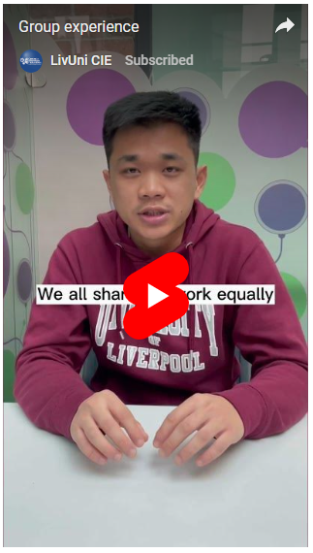

Improve your groupwork experience
What ways can you improve your experience and performance from groupwork?
Watch this: 5 top tips
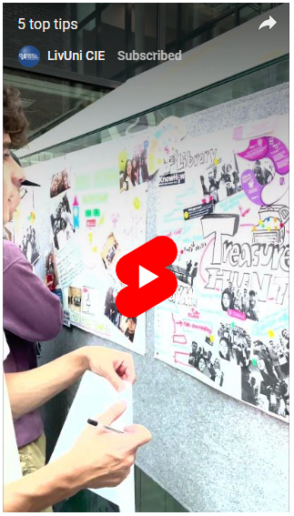
When starting out with a group task it is really important to establish how the group will work:
- Agree how the group will approach the task through a shared understanding of each other's aims and expectations
- Identify a timeline for key milestones and the overall project completion, taking into account each other's aims and abilities
- Assign roles to help break down the task and allow the team to work more effectively
To answer the above, in your group complete a Groupwork Contract to help your group decide and stick to an approach. Use this document to support any reflective activity, assist with peer evaluation, or to document for your tutor how your team approached the task.
Further reading: Blogpost - Teamwork makes the dream work.pdf

Peer Evaluation and Buddycheck
Many lecturers now use Peer Evaluation as a chance for students to feedback on the contribution of groupmates, which can make the assessment of groupwork fairer where peer evaluation is used to 'individualise' group marks, and thereby encourage engagement in group tasks. It can also be a valuable tool to provide feedback and gain advice on improving your group working skills.
Watch this: Peer review debunked
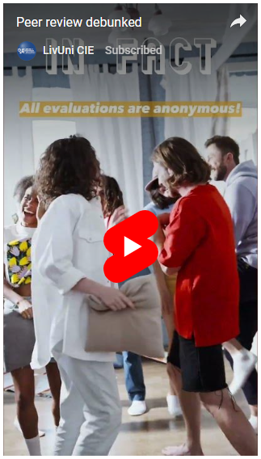
A popular peer evaluation tool is Buddycheck, which is built into Canvas. It allows you to grade peer contribution through rating scales across a number of groupwork criteria. Don’t worry, your responses are strictly confidential between you and the teacher, and your instructor will give you information about how it is used specifically on your course.
Student guide - Meet your new buddy - Buddycheck.pdf
Video tutorial - Complete a Buddycheck evaluation
Further reading: Blogpost - How can Peer Evaluation make groupwork fairer.pdf

