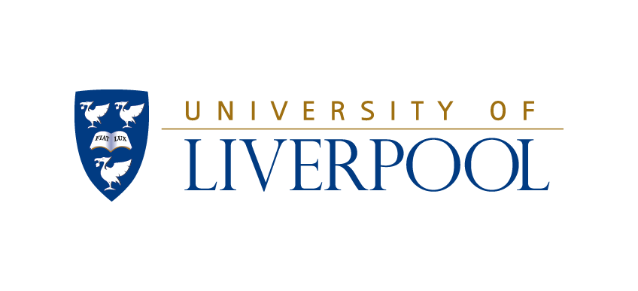

The Duncan Norman Research Scholarship
Terms of the Award

1. The Duncan Norman Research Scholarship is open to prospective Home, EU and Overseas candidates who have been accepted to study for a full-time postgraduate research programme (PhD), in any subject area, at the University of Liverpool starting between 1st October and 2nd January of the following calendar year. There is no scope to start outside these dates.
2. Taught Postgraduate, MRes or Liverpool School of Tropical Medicine candidates, off site or XJTLU based students and currently registered University of Liverpool MPhil/PhD students are not eligible to apply for this scholarship.
3. A candidate who applies for a Duncan Norman Research Scholarship would be expected to have made applications to other sources to secure funding, the Duncan Norman will top up any other funding for stipend and fees, all other elements will be available. This does not preclude candidates with no other funding, to anyone successful in the latter case, the full award will be available.
4. The holder of the scholarship will be required to register for a PhD at the University of Liverpool and to attend any Liverpool-based events organised by the Duncan Norman Trust.
5. The Scholarship is tenable for up to three years, subject to satisfactory academic progress, and includes the following features, these are non-negotiable:
- Full payment of tuition fees (does not include Bench Fees/Research Support Costs);
- An annual stipend of £15,000 or a top-up to this level of maintenance if the candidate is in receipt of other funding;
- An annual allowance towards accommodation rental either on the University campus or off for up to the value of £4635. This is only for use for a permanent residence and if not on campus, must be supported by proof of payment. On campus accommodation will be paid directly to our Accommodation Team.
- A laptop or desktop computer and software up to the value of £1000, also to be supported by proof of payment.
- Support for conference expenses in years 2 & 3 up to £500pa, also to be supported by proof of payment.

7. The deadline for applications noted on the application form itself.
8. Applications will be assessed by the University of Liverpool and shortlisted applications will be considered by an external International Advisory Panel.
9. Whilst every effort will be made to contact applicants to inform them of the results, because of the high volume of applications, this isn’t always possible. If you have not heard from us by 31st July, please assume that you have not been successful. Please also be aware that as this is a competitive scholarship, feedback will not be offered.

