CLEAN-Air(Africa)
NIHR Global Health Research Group

Scoping Visit Report:
KENYA

13th to 19th May 2018

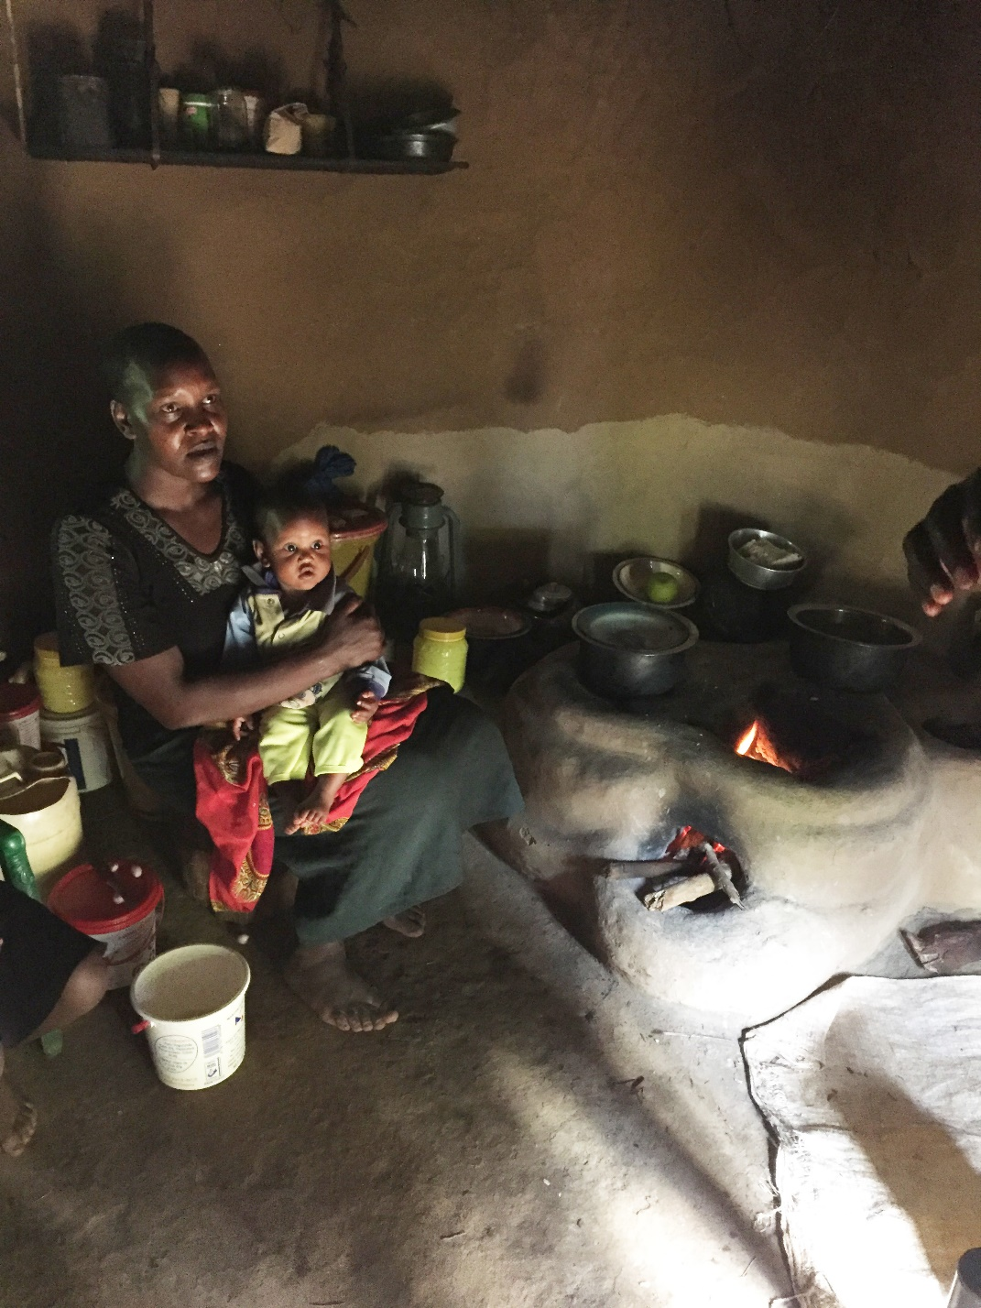

Summary of the scoping visit to Kenya, involving meetings with stakeholders, research partners and research communities

1. CLEAN-Air(Africa) NIHR GHRG Attendees:
- University of Liverpool: Daniel Pope (DP), Director of CAA NIHR GHRG; Rachel Anderson de Cuevas (RAdC), Study Coordinator; Debbi Stanistreet (DS).
- Moi University, Eldoret: Diana Menya (DM), Principal Investigator Kenya.
- GLPGP Country Director: Elizabeth Muchiri (EM).

2. Stakeholders visited:
- Ministry of Energy: Permanent Secretary of State (PS), Department of Petroleum
- Petroleum Institute of East Africa (PIEA): General Manager
- National Oil Corporation of Kenya (NOCK): CEO
- Equity Group Foundation: General Manager
- Ministry of Health, Public Health Department: Deputy Director of Environmental Health and Deputy Director of Community Health
- PayGo Energy: CTO & Co-Founder and Head of Operations
- Envirofit: General Manager
- Moi University, Eldoret: Dean, School of Public Health; Principal, College of Health Sciences; Senior Lecturer, Department of Epidemiology and Biostatistics and Research team, School of Public Health

3. Research communities and leaders visited:
- Two communities were visited as potential research sites: peri-urban Kesses in Uasin Gishu County and rural Keiyo, Elgeyo-Marakwet County.
- Biomass and LPG retail sites.
- Street vendors relying on biomass.
- Community health workers serving each community.

4. Programme of activities for the scoping visit:

Dan Pope (DP), NIHR Group Director, Debbi Stanistreet (DS) and Rachel Anderson de Cuevas (RAdC) from the University of Liverpool research team, undertook a scoping visit to Kenya between 13th and 19th May 2018. They were hosted in Nairobi (3 days) by Ms Elizabeth Muchiri (EM), Country Director, Global LPG Partnership and in Eldoret (3 days) by Dr Diana Menya (DM), Senior Lecturer, in the School of Public Health, Moi University, Eldoret. DM, Kenya PI, also accompanied the group to the Nairobi meetings.

MAY | People met | Organization | Details

Nairobi

Sunday 13
4-6 pm | Elizabeth Muchiri,  Country Director | GLPGP | Intercontinental Hotel

Monday 14
09:00 | Mr Andrew Kamau, Permanent Secretary State | Department of Petroleum, Ministry of Energy | Ministry office
10:00 | Ms Wanjiku Manyara, General Manager | PIEA (Petroleum Institute of East Africa) | PIEA office
12:00 | MaryJane Mwangi, CEO | National Oil Corporation of Kenya (NOCK) | NOCK office
14:30 | Eric Naivasha  General Manager | Equity Group Foundation (EGF) | EGF office

Tuesday 15
08:30 to 10:00 | Dr. James Mwitari, Deputy Director, Public Health, Environmental Health | Ministry of Health | Afya House, Cathedral Road
11.00 | Deputy Director of Public Health, Community Health | Ministry of Health | Workshop to review research agenda for community health
12:00 | Fausto Marcigot,  CTO & Co-Founder; Mark O'Keefe, Head of Operations | PayGo Energy | Avon Centre  Enterprise Road
15:00 | Mr Zulfiqar Wali  General Manager | Envirofit | Kabasiran Avenue, plot 16, Lavington

Eldoret

Wednesday 16
9:00 | Diana Menya | School of Public Health | Planning meeting
11:00 | Dr Mabel N Nangami,  Associate Professor, Dean | School of Public Health | Moi University
2 pm | Prof Paul O. Ayou, Principal | College of Health Sciences | Moi University

Thursday 17
All day | Research team | Moi University | Boma Inn, Elgon View

Friday 18
All day | Communities | Kesses | Uasin Gishu County
 |  | Kessup | Elgeyo-Marakwet County

- Meeting summary

  - Research (stakeholders and institutions - Nairobi)

Sunday 13th May

    - Elizabeth Muchiri, Country Director, GLPGP Kenya: EM gave an overview of the current situation in Kenya with regards to scale-up of LPG and of relevant policies and projects across the country, including a government-run initiative to make LPG available to the poorest communities through a subsidization programme, known as ‘Mwaninchi’ (meaning gas for ordinary people in Kiswahili) and microfinancing (as part of a projected launched by GLPGP). She also updated the team on the government policy initiatives which have impacted both positively and negatively on domestic fuel use across Kenya, including the introduction of Legal Notice (LN) 121 some year ago that has created market opportunities for illegal refilling of cylinders and is currently under review, the recent logging ban and a charcoal ban in one particular county.

Monday 14th May

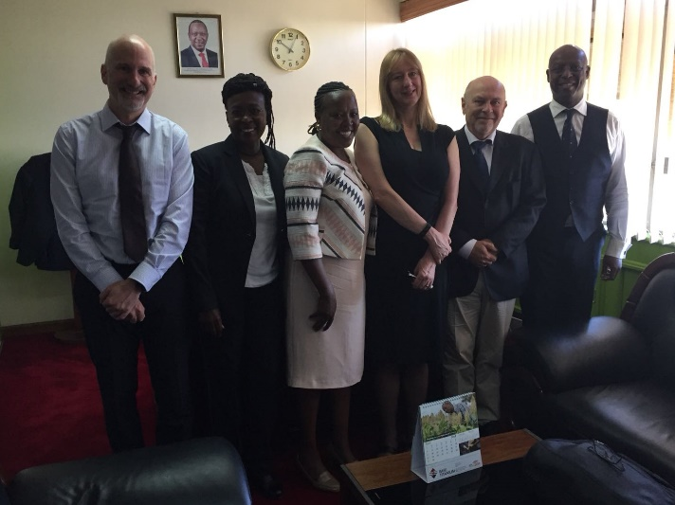
    - Andrew Kamau, Permanent Secretary (PS) of State Department of Petroleum: Mr Kamau outlined the main national policy initiatives in more detail, including the rural electrification programme, the changes to the law regarding LN121 to prevent the illegal filling of cylinders, the Mwananchi project; and also a number of private enterprise projects run by companies like PAYGO Energy, Protogas and Envirofit. He also commented on some of the research questions that it would be useful to address, including exploration of the factors that motivate people to change to LPG, and the importance of being able to quantify the burden of disease associated with HAP.

    - Wanjiku Manyara, General Manager of the Petroleum Institute of East Africa (PIEA). Ms Manyara had a very positive outlook on the future of LPG as a transition fuel in Kenya, especially given the current government support in terms of policy initiatives and the interest of the private sector in investing in cylinders and expanding the LPG market. In particular, she sees access to clean fuels as key to realising access to universal health. However, one of the main issues that needs to be addressed is the need to improve accessibility to LPG for rural communities. Ms Manyara advocated working with community health workers (CHWs) to this end. The CHWs are well respected and work closely with the local population including the local ‘chamas.’ These are informal co-operatives used to pool and invest savings and could have a role in supporting women to be able to afford an LPG stove, as well as a channel for health education.’ Another route for capacity building suggested by Ms Wanjiku, is the Joyful Women’s organisation known locally as ‘JoyWo’ (see https://joywo.org). JoyWo is a Non-Governmental Organization (NGO) which seeks to empower Kenyan women economically and enhance household food security through supporting their involvement in sustainable livelihood projects. Part of its aims include capacity building, so it would be well suited as a route to educating communities about household air pollution (HAP) as a major public health issue. She also advocated the need to integrate the health agenda with approaches to finance and approaches aimed at empowerment of women. Dr Menya has also worked with local chamas (for health conditions such as hypertension). She explained that local communities often do not understand risk factors and what is required to reduce health risks, so health checks and health promotion could be carried out within the chamas. Dr Menya suggested a similar approach could be used to encourage acquisition and use of cleaner fuels for cooking.
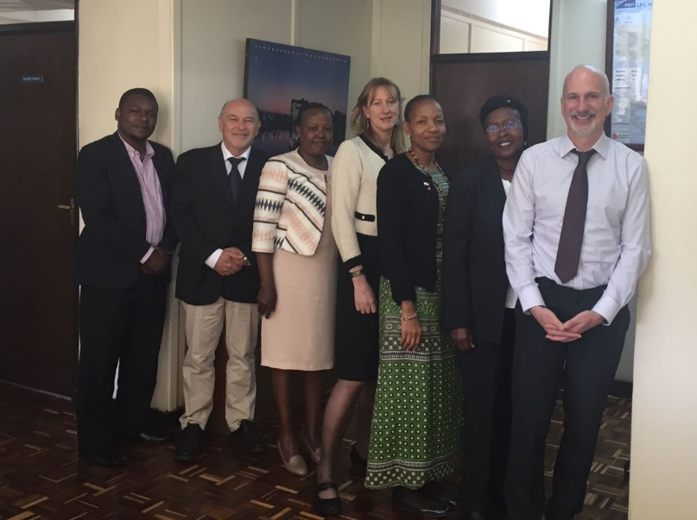
Ms Manyara also has a powerful advocacy role for women and clean energy. She offered us to use of the PIEA publication ‘Insight Quarterly’ for disseminating the work of the CLEAN-Air (Africa) group. This will be extremely useful as the publication is accessed not just by the petroleum industry across East Africa but also more broadly within the energy sector. The first article has now been published, outlining the overall aims of the project. There is also a technical committee within PIEA which meets monthly and includes a wide range of stakeholders working to move forward with the national expansion to achieve the aspirational adoption goal.

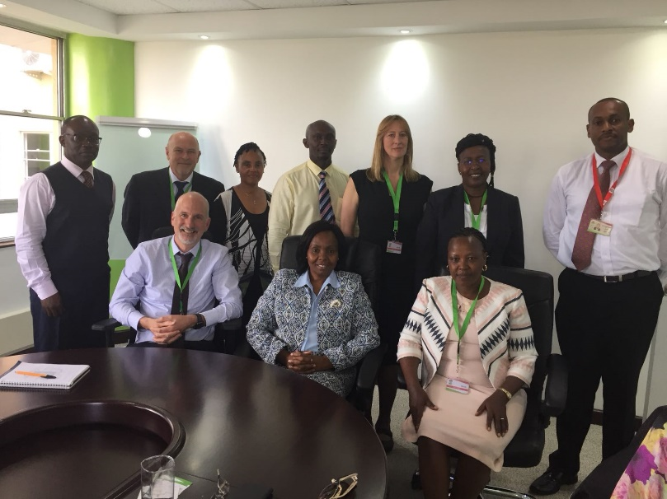
    - Mary Jane Mwangi, CEO, National Oil Corporation of Kenya (NOCK). The meeting aim was set up primarily to find out more about NOCK’s role in delivering the Mwananchi programme. Ms Mwangi and her team provided significantly more detail about the Mwananchi project which began in 2016, and provides a subsidised LPG cylinder package under NOCK’s Gas Yetu brand (meaning ‘our gas’), targeted at first-time users from the lowest income households. The project also includes promoting entrepreneurship, by giving priority to women, youth and people living with disabilities to engage in the supply chain as distributors, retailers and brand ambassadors. It aims to disseminate about 4.8 million 6kg cylinders (with on top burners) over the next three years to reach more than 18 million households. NOCK is now developing a distribution model to ensure LPG access in all counties across the country and is due to extend the initial pilot in two counties to an additional six counties during 2018. The team indicated that one of the next pilots will most likely take place in Western Kenya, Eldoret.

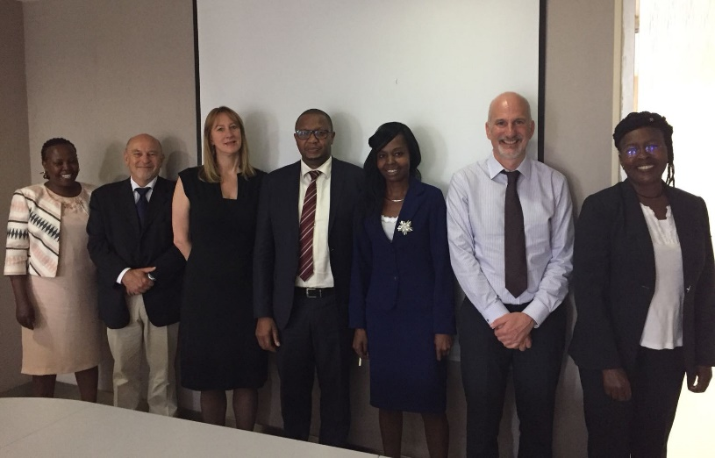
    - Eric Naivasha, the General Manager of the Equity Group Foundation. The purpose of the meeting was to explore the possibility of evaluating a microfinance initiative to support initial purchase of an LPG start-up kit and ongoing fuel costs. The Equity Group Foundation is already working with GLPGP on launching a pilot program in Kinangop, Nyandarua county. The Equity Group Foundation is the charitable arm of the Equity Bank, which has a Department dedicated to projects relating to ‘Energy and Environment,’ promoting clean energy (including clean cooking and lighting) and biogas projects. The loan product allows people to access LPG and clean fuels everywhere in the country. The Equity Group is also working with Progas. Their payment model is based on mobile payment via a phone app.

Tuesday 15th May

    - Director of "Smart Meter" LPG technology at PAYGO Energy. This is a private sector initiative in Nairobi, piloting a ‘Pay-as-you-cook’ LPG scheme in urban temporary housing settlements, using a smart meter to pay LPG in small amounts and make LPG affordable to poorer populations.
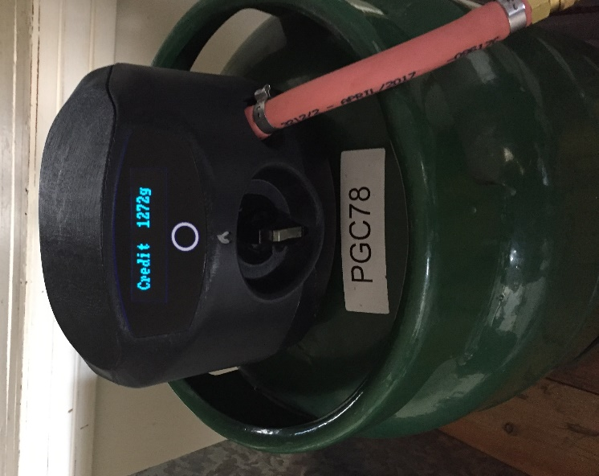
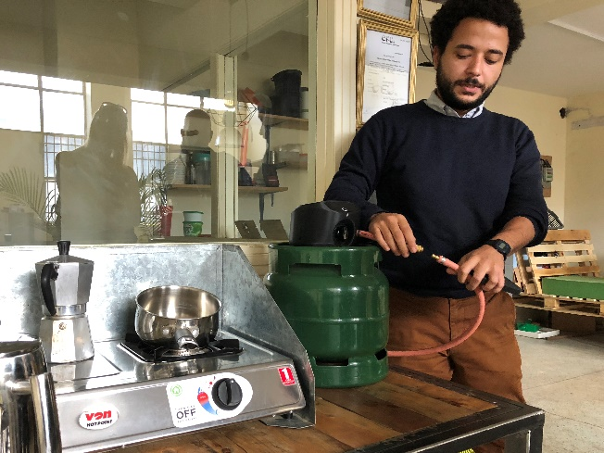
The technology works via a smartphone app and mobile banking and shows considerable promise. Smart meters offer the potential for households to pay per cooking event instead of buying the cylinder refill in bulk, which opens up LPG as a viable fuel for poorer households. PAYGO’s package include an LPG cylinder, burner and accessories in people’s homes. The company is looking into providing a table with adjustable legs to accommodate uneven earth floors for additional safety. The smart meters also notify the company when a cylinder is running low on gas and a replacement cylinder is required. PAYGO works with local marketers to procure and deliver the LPG refills and has a growing customer base, but does not have sufficient meters to meet demand. The company showed us data they can run off the smart meters. They have a data analyst who looks at peak cooking times during the day and variations in cooking patterns according to pay day etc. They are trying to resolve the problem of higher payments when LPG expands in the heat. The company plans to expand its operations and increase smart meter production. PAYGO started off in Solar energy.

    - Director of "Smart Meter" technology at Envirofit. Envirofit is an international company based in Colorado and working in India, Honduras, Mexico and Kenya, with an assembly plant for improved cookstoves in Nairobi. More recently, they have started to promote LPG for cooking through a number of pilot projects in Cameroon, Ghana and India.

Pilot project: They have piloted a PayGo pay as you cook LPG scheme with customers, using a smart meter and standard regulator, gas supply and double burner to low SSE HHs, typically living in 1 room. Colorado State University undertook a pilot study in Kenya in mid December 2017 and earlier in Ghana. As is usual with a pilot, the project encountered some teething problems, as follows. 1) The US underestimated the telecommunications capacity in Kenya, assuming it was 2G, rather than 4G. This meant that payment requests backed up, rather than being real time. 2) The company did not partner with a local mobile money aggregator, like Safari.com, therefore the company had to absorb extra costs to protect the customer. 3) The cost of logistics: Envirofit’s guarantee to customers that LPG would never run out, meant that the cost of delivering to HH was really high. 4) Pricing of the package including smart-meter – around $100. However, customers put down only $20 refundable deposit. It was difficult to establish a product price that was affordable to customers while remaining viable commercially. At present Envirofit is shouldering the majority of the cost.

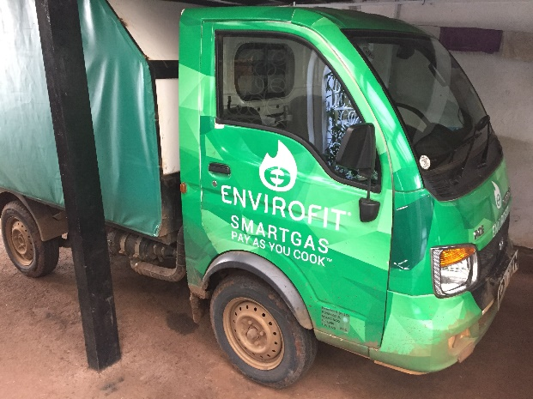
Envirofit partnered with SmartGas to develop their own brand of 13 kg cylinder, manufactured for the venture. The 13 kg cylinder requires a cooker and table top, unlike the 6kg cylinder top burner.
The pilot community comprised 150 HHs, mostly living on a daily wage: exclusive charcoal/kerosene users (mainly low SSE HHs); stackers combining 6kg LPG cylinder with polluting fuels (largest population group); exclusive LPG users (lower and middle income HHs). Some using ethanol. LPG consumption was lower than anticipated.

Second pilot phase planned: Envirofit are moving on to a second pilot phase and have developed a Generation 2 (Gen2) prototype of a smart meter and have written to the Energy Regulation Committee (ERC) in Kenya for approval (soft approval already received). The scheme will target higher SSE gated communities of 5,000 HH and is planned to begin last week May/early June 2018.

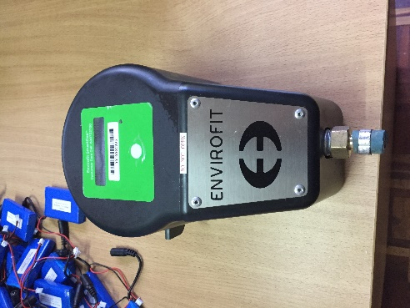
Envirofit products: We viewed Envirofit’s commercial products including improved cookstoves using charcoal and wood (marketed as decreasing wood consumption by 80%), including cylinder top burners, large capacity wood burners, charcoal burners with ventilation control and stacked pots (for steaming etc.)

Future plans for Envirofit: LPG pilot was capital intensive and labour intensive. Smart meters are costly. Company needs an equity partner. Kenya has a centralised depot, so distribution is difficult. Envirofit is looking for an audience with the Energy Secretary.

Energy context in Kenya: Since logging was banned, there has been an increase in charcoal pricing. The Government will impose a triple tax on kerosene, as it is often used to adulterate diesel. The Government introduced the standard LPG valve 12 years ago under LN 121, without anticipating the consequences that this meant – i.e. that it was possible to refill any cylinder from any brand, leading to illegal refilling practices. PIEA have been influential in pushing the Government to move away from the LPG Cylinder Exchange Pool to the Sustainable Market Model with an enforced cylinder recirculation of branded cylinders and individual valves (process still in progress). Under the revised LN12 legislation, the common exchange pool will be banned. The minimum number of cylinders required for a marketer to register and start operations will be increased from the current 5,000 to 30,000. The Govt. made an announcement in the Kenya Gazette, followed by a 40 day consultation process. Over the past years, due to the illegal refilling practices, marketers had stopped importing cylinders, as their investment was quickly lost by the cylinder disappearing in the market (i.e. being taken and refilled by the competitors). Cylinder manufacturers in Kenya include East Africa Spectre, and Petrotech and others companies are becoming operationals.
The Govt will introduce a piped gas system, as in South Africa, and will encourage developers to incorporate LPG storage tank into their design for new housing developments. ZW feels it should be enshrined in law for it to take effect.

  - Health Sector Capacity Building (stakeholders, Nairobi)

Tuesday 15th May

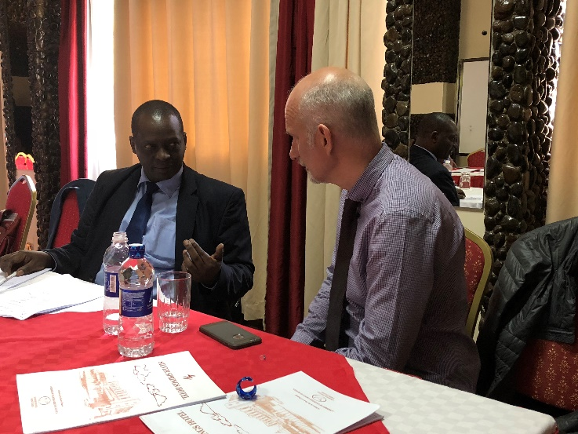
    - Deputy Director of Public Health, Ministry of Health: We approached the Ministry of Health to enquire how best to support health systems to raise awareness of polluting household energy practices as a major contributor to the burden of disease and to highlight clean cooking as an important public health intervention and prevention strategy. Our meeting with Dr James Mwitari helped outline how the CLEAN-Air(Africa) Group might put this into practice. In summary, he proposed working with community health workers (CHWs) and adding new educational content to the public health curriculum for public health professionals.

Dr Mwitari explained that CHWs have an initial training period of ten days and one of the modules covered during this time, (non-communicable disease), could be updated to include content on HAP. Dr Mwitari then accompanied us to a local meeting of CHWs at a nearby hotel so that we could learn more about the CHW role. At the meeting, Dr Mwitari stressed how important it is to understand the agents of change in a community. CHWs are volunteers who are not highly educated but literate, and who understand the community’s needs. CHWs receive KSHS 2,000 ($20) per month to work 1 or 2 days/week sacrificing their time for the community. Dr Mwitari also stressed that the government has committed to four programmes over the next five years, one of which is called ‘Access to Health.’ As part of this, 100,000 CHWs are to be recruited.

    - Meeting with Community Health Workers Forum, Ministry of Health: Dr Mwtari introduced us to a workshop, chaired by the Deputy Director of Community Health. The purpose was to review the Research Agenda for Community Health, therefore an opportune moment to influence the agenda. The timescale for revision is to complete by the end of the year. The CHW Training Manual is also being revised. The Group emphasised the potential of biogas in rural areas and the role of the community in providing messages about health impacts of HAP.

  - Strengthening research collaborations (with Moi University - Eldoret).

A series of meetings were held focusing on strategic development of the Group’s research programme, including our research partners’ institutional leads.

    - The Principal, College of Health Sciences, Moi University in Eldoret: Courtesy visit for introductions, to hear about the College and present the CLEAN-Air(Africa) research programme.

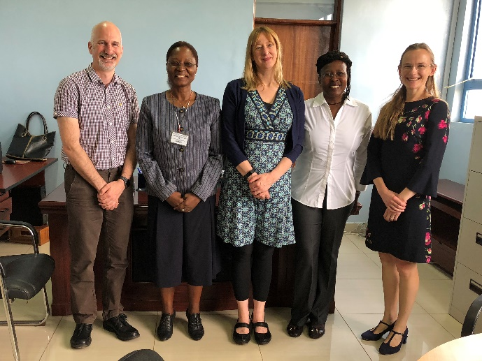
    - Dean of the School of Public Health: Dr Nangami is Associate Professor in the Department of Health Policy and Management in the School of Public Health, and Consultant in Health systems research and management; strategic planning; and quality management; program evaluation; curriculum review and training. The Dean specialises in health policy and management and also has an interest in outdoor air pollution. There are 2 post-doctoral programmes at Masters level: 1) MPH (20-30 students) 2) MSc in Field epidemiology (20 students, funded by MoH). There is 1 undergraduate programme, a BSc in Environmental Health.
In 2 years, the School hopes to develop a Centre of Excellence for Global Health and Infectious Diseases including NCDs. The Centre is looking for support from the University of Liverpool. This could comprise for example visiting professorships, monthly seminars, guest speakers, access to UoL on-line training modules.

DM mentioned opportunities to input HAP into the curriculum/training. The curriculum was currently deficient in HAP. Currently there is a brief mention of air pollution within epidemiology of NCDs and social dimensions of health. The approval of the BSc in Community Health which is currently in process offers an opportunity to introduce a HAP component. Also the MPH curriculum is being revised, so this is also timely. DM emphasised it is important for HAP training to come from the top down as well as the ground up (via CHWs).

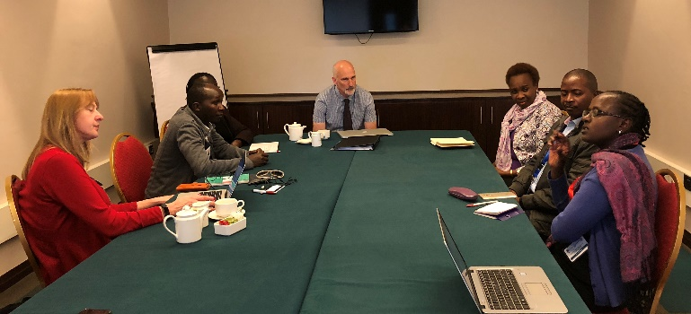
Another opportunity is for core supervision of Lolem Lokolile, WHO Focal Point at MoH, in completing a Masters at Moi. All present agreed there were opportunities for the CLEAN -Air(Africa) group to input into teaching and the developing the curriculum around link between HAP and NCDs.
There is no research strategy as such, however the School’s research priorities are prevention; NCDs and infectious diseases.

    - Moi Teaching and Referral Hospital: DM introduced the team to the Oesophageal Cancer unit, the study site for a large case-control study proposal submitted to the MRC by CLEAN-Air(Africa) together with Moi University, and the International Agency for Research on Cancer.

  - Identification of study communities

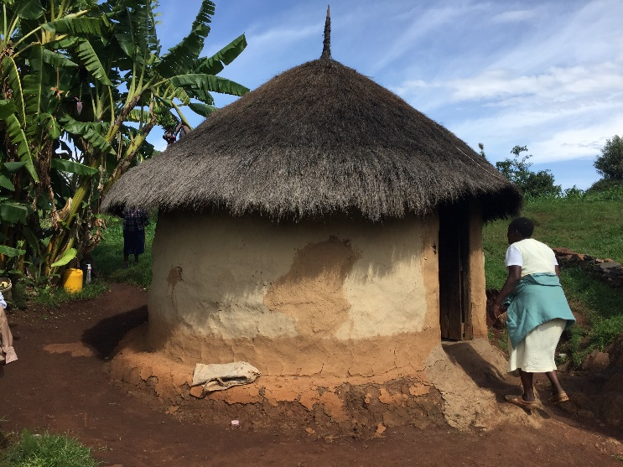
    - Potential Research Sites in Eldoret: Led by Dr Menya (DM), we visited potential rural and peri-urban study sites in two different communities: Kesses, (45 minutes from Eldoret, and close to Moi University agricultural campus); and Keiyo, (a more rural community built high up on the side of the mountain overlooking the Rift valley approximately one hour outside of Eldoret). Eldoret was selected as a potential site of the Mwananchi project second pilot phase, presenting an exciting opportunity to evaluate the roll out of the Government’s pro-poor LPG programme. The households we visited varied considerably in terms of income, cooking practices, type of stove used, access to and views on LPG.

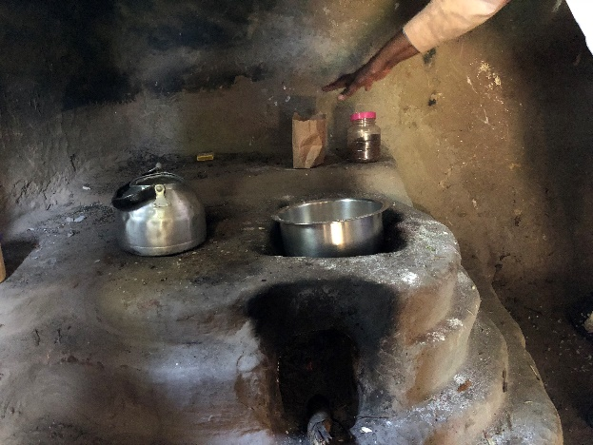
Rural Keiyo: Households in rural Keiyo comprised exclusive biomass users, there was no access to electricity and only kerosene lighting was used. Wood can be gathered freely and households cook only with biomass on homemade clay stoves. In Keiyo families used only biomass for cooking on a homemade clay stove. The households were mainly subsistence farmers and saw LPG as more of an aspirational fuel, believing it to be too expensive for them, particularly as they could freely gather firewood. For families living in rural Keiyo, LPG would have meant a journey into a nearby village at a considerable distance.

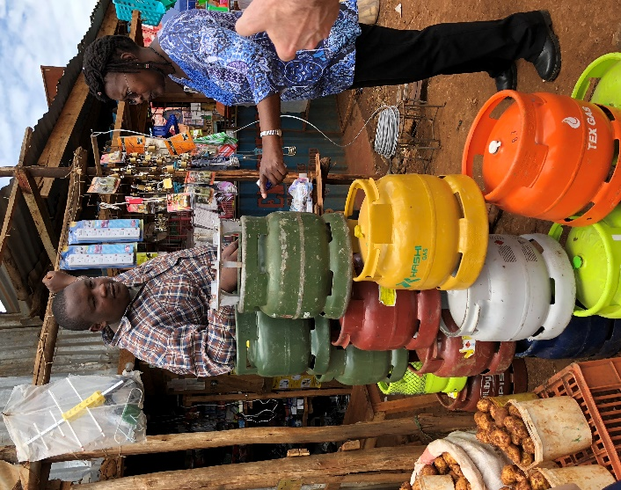
Peri-urban Kesses: HHs in Kesses included mixed LPG/ biomass use. Some families had an LPG stove and reported using LPG on a regular basis, (although we did not find any exclusive users). Secondary fuels included charcoal, and kerosene. Lighting was provided through a combination of mains electricity, and solar. In terms of affordability, there is a significant difference in the living standards between different families in the communities, but even those families living in brick houses in more comfortable circumstances, mentioned the need to save money for gas. Among the LPG users we spoke to, LPG was seen as being convenient and quick, but not necessarily the best way of cooking hard foods, such as ugali that require a long cooking time. For families living in Kesses, access to LPG was relatively convenient, (although there wasn’t always the trust in local distributors). There was some concern about safety among the gas users, and cylinder theft was reported as being fairly common.

  - Scoping visit of LPG/ biomass retailers
We visited a number of LPG retailers near Moi University agricultural campus and Kesses to look at cylinder prices, brands and safety practices. One distributor was a satellite distributor for Tobento Investment. The Tobento distributor kept clear records of each bottle sold, used weighing scales to verify the weight of each filled gas bottle (for safety and price) and offered home delivery to customers.
The other was an unofficial distributor who stated his weighing scales were broken and stored the LPG cylinders outside in the sunlight. He had no records of gas bottle purchases. Students at Moi campus are increasingly using 3kg LPG cylinders. The wood and charcoal sellers said business had slowed.
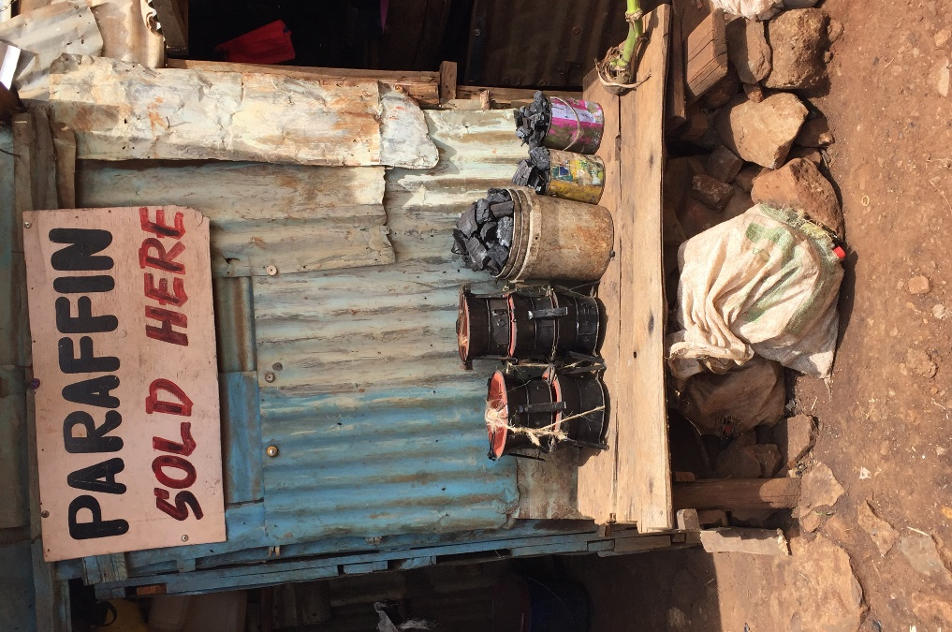
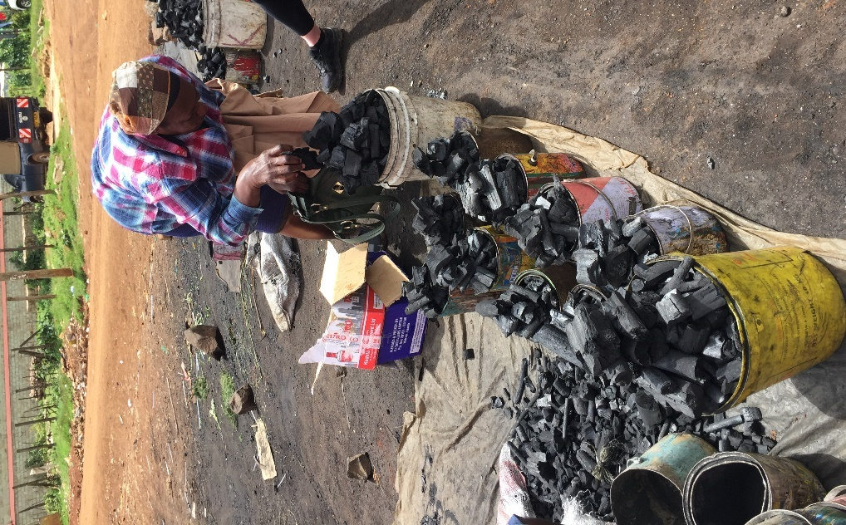

6. Matters arising from the scoping visit:

Andrew Kamau, Permanent Secretary of State Department of Petroleum: Mr Kamau indicated that he would be happy to participate in a high-level stakeholder event to inform policy makers and other stakeholders of our findings, once the study is complete.

Ms Wanjiku Manyara, General Manager of the Petroleum Institute of East Africa (PIEA): Ms Manyara suggested a Skype forum be set up between the PIEA Committee and the CLEAN-Air (Africa) group to appraise them of our work. CAA article in PIEA magazine.

Mary Jane Mwangi, CEO, National Oil Corporation of Kenya (NOCK): NOCK would be willing for the CLEAN-Air (Africa) group to use the Eldoret pilot expansion as a research site if required.

Eric Naivasha, General Manager of the Equity Group Foundation: Eric invited the team to outline the kind of project we would be interested in running once more detail was known and expressed that he would be happy to consider supporting the work through the provision of loans.

Director of "Smart Meter" technologies PAYGO: PAYGO expressed an interest to collaborate with CLEAN Air(Africa) on evaluation of their pilot in Nairobi or a possible extension of the pilot to Eldoret (TBC).

Director of "Smart Meter" technology, Envirofit: They are potentially happy to work with us (put in touch with CEO). They would be interested in attending high level stakeholder meetings to raise awareness of HAP and clean fuel scale up, organised by UoL.

