# CLEAN-Air(Africa) NIHR Global Health Research Group

# Scoping Visit Report: CAMEROON

# Saturday 30 June – Friday 6 July 2018

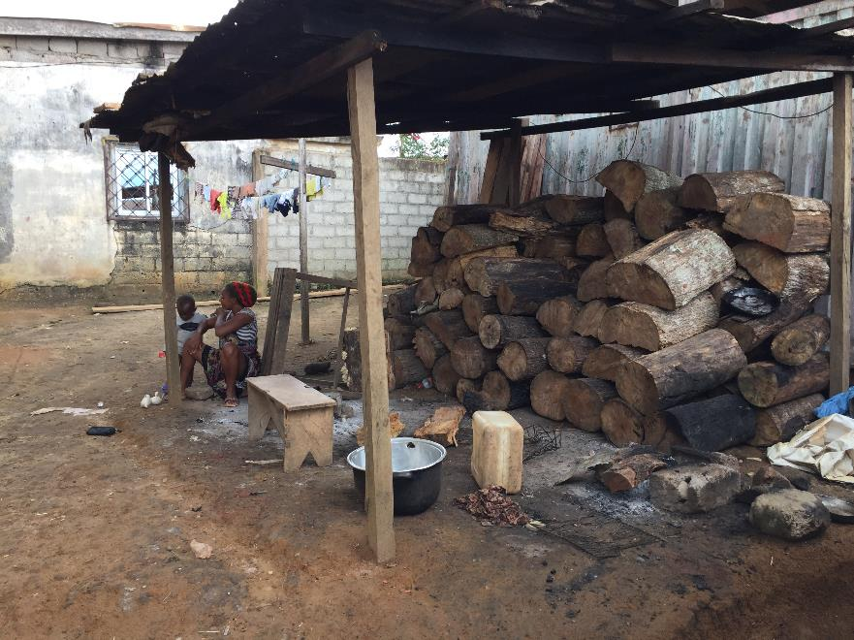

**Summary of the scoping visit to Cameroon involving meetings with stakeholders, research partners and research communities in peri-urban and rural MBalmayo.**

**1. CLEAN-Air(Africa) (CAA) NIHR GHRG Attendees:**

* University of Liverpool: Daniel Pope (DP), Director of CAA NIHR GHRG.
* Douala General Hospital: Bertrand Mbatchou (BM), Cameroon PI.
* GLPGP microfinance project manager and CAA Project Coordinator: Emmanuel Betang (EB).

**2. Stakeholders visited:**

* Ministry of Women's Empowerment and the Family (MINPROFF) - Regional Delegate.
* Ministry of Women's Empowerment and the Family (MINPROFF) - Government Minister
* Ministry of Energy (MINEE) - Director of Petroleum.
* MUFFA microfinance network supporting adoption of LPG equipment - Yaounde Director.
* Ministry of Health - Sub-Division Director.
* Express Union microfinance network potentially expanding into supporting adoption of LPG - Senior Management Team.
* Media Women Impacting Change - Director of National Media Network.
* Global LPG Partnership (GLPGP) – Interim Country Director.

**3. Research communities and leaders visited - MBalmayo:**

* District Mayor.
* Public Health Directorate.
* Women entrepreneurs in commercial cooking.
* Biomass and LPG retail sites.
* Street vendors relying on biomass.
* Peri-urban and Rural communities visited as potential research sites (including pre-research sensitisation).

**4. Programme of activities for the scoping visit:**

|  |  |  |  |
| --- | --- | --- | --- |
| **Location** | **Meetings** | **Attendees** | **Comments** |
| **Yaounde** |  |  |  |
| ***Monday 2th*** |  |  |  |
| 8:30-10.30 | Hotel/ breakfast meeting | DP, BM, EB | Preparatory meeting at the hotel with DP/BM and GLPGP staff, Emmanuel Betang and Sporah Mengot |
| 11:00 – 12:00 | Ministry of Women’s Empowerment and the Family (MINPROFF) | DP, BM, EB | Meeting with Regional Delegate for the Centre Region |
| 12:30 – 2:00 pm | MUFFA Network Yaoundé | DP, BM, EB | Meeting with Director |
| 2:30 - 3:30 pm | Yaoundé, Briquetrie | DP, BM, EB | Street Vendors visit and discussion |
| 4:00 – 5:30 pm | Hotel | DP, BM | Meeting with potential field coordinator - Roland Tchuigoua |
| 5:30 – 6:30 pm | Hotel | DP, BM | Discussion of Project Management Plan submitted to NIHR |
| ***Tuesday 3th*** |  |  |  |
| 10:30 – 12:30 | Ministry of Health | DP, BM, EB | Health promotion (Dr Owono Longang) Director of sub-division. Discussion on capacity building and how to maximise impact from CLEAN-Air(Africa) activities. |
| 1:00 - 2.15 pm | Yaoundé women and childrens' hospital | DP, BM, EB | Meeting with Dr Jean Baptiste Bonge about capacity building. |
| 3:30 – 6:00 pm | Express Union | DP, BM, EB | Potential new lending partner to GLPGP *bottled gas for better life program*. MoU not yet signed. This meeting might help them to take a decision and engage on a new 150HHs pilot (location still to be confirmed.) |
| ***Wednesday 4*** |  |  |  |
| 08:30 – 3:30pm | MBalmayo visit | DP, BM, EB, MH | Program of activities in MBalmayo:  - Visit to Mayor  - Visit to Public Health Directorate  - Visit to fish smoking industry (River Nonge)  - Visit to biomass retailers (charcoal/ wood)  - Visit to LPG retailers  - Visit to rural communities with sensitisation. |
| 4:30 – 5:30 pm | Media Women Impacting Change | DP, BM, EB | Discussion on how to maximise messaging and awareness raising for HAP/ Health and CLEAN-Air(Africa) activities. |
| 5:30 pm | Hotel | DP, BM | PI Meeting to discuss capacity building |
| ***Thursday 21*** |  |  |  |
| 9:15 – 11.00 | Ministry of Women’s Empowerment and the Family (MINPROFF) | DP, BM, EB | Meeting with the Minister! Discussion to secure advocacy for CLEAN-Air(Africa) and clean cooking agenda. How to engage with MINPROFF for awareness raising |
| 11.30 - 2.00pm | Hotel | DP, BM | Discussion of program of activities for research and capacity building based on scoping (template drafted). Review of budget in line with activities. |
| 4.00 - 5.00pm | Hotel | DP, BM, EB | Meeting with MINEE - Mr Bello as Director of Petroleum. Discussion of the Master Plan and implementation. |

**5. Synopsis of scoping visit according to the programme of activities by date:**

**Monday 2nd July**

**Pre-meeting with Dr Mbatchou**

* ***MBalmayo as a research site:***  39 kilometres (1hr 10mins) from Yoaunde - Central region, french-speaking. 60,000 inhabitants of the town - total 292,000 population. Main activities = forestry and agriculture (wood fuel availability). Has a district hospital. MBalmayo was visited by Dr Bruce and Dr Puzzolo in 2015 as a potential location for LACE studies, which then were conducted in the South-West Region.
* ***Ethics*** - Administrative approval was only lodged in Oct 2017 for 2 years as part of the LACE studies, therefore we need to check if that could cover the new activities in MBalmayo. If not we need to submit soon a new application as minimum 3-months time frame for revision.
* The proposed Field Work Coordinator (Roland) has a Masters in Epidemiology.
* ***Discussion around adding spirometry***. $2500/ $3000 to purchase units. For 200 participants in total, need two machines 5-6,000 and disposable mouth pieces etc. Full quote to be obtained.

**8 am: Pre-meeting with GLPGP Cameroon Directorate (Emmanuel Betang and Sporah Mengot) in preparation of stakeholder meetings**

***Sporah Mengot***

* GLPGP delivered workshops with MINEE and other ministries. Investment in cylinders (4 options proposed by GLPGP - collapsed into 2): (i) small increase LPG refill in price or (ii) subsidies. Still under negotiation.
* Micro-loan for LPG equipment. Phase II of Bottled gas for better life kicked off in 2018. 6 communities to date. Due to the crisis in the South West region - slow progress there with micro-loan uptake.
* Good response to microfinance project in Yaounde. Still a lot of households that don't use LPG or need new equipment. Opportunities also for supporting street vendors to switch to LPG.
* Mostly 6kg cylinders used in Yaounde (approx 3,750-4,000 CFA). Idea for them to switch to 12.5kg for more exclusive use of gas.
* Street vendors use 6kg for ease of use. Switch from charcoal to LPG. GLPGP would like to pilot the initiative but is looking for funding.
* Smoking fish - Sporah mentioned they can use LPG for smoking fish.

***Emmanuel Betang***

* MUFFA Yaounde. GLPGP trying to switch numbers from MUFFA Buea to Yaounde due to the SouthWest crisis. Target 100 households (currently 60 already registered).
* TRADEX supplies Yaounde for the microfinance initiative. Fastest growing marketer (started in 2014). SCTM biggest at the moment. GLPGP has advanced the funding for the pilot. GLPGP pay TRADEX and GLOCALGAZ for the equipment and then beneficiaries re-pay MUFFA that will ultimately re- pay GLPGP. This is because LPG microfinance in Cameroon and MUFFA wanted to have the full guarantee of not loosing capital.
* MUFFA register only beneficiaries without outstanding loans. So they do not have excessive debt. Many households interested in getting the LPG equipment through the loan have been turned down because of outstanding loans.
* Express Union confirmed meeting for 4pm on Tuesday. They operate across all 10 regions, with 700 branches across the country. Microloan offered with a 7.5% interest for 6 months. Free hand to choose pilot phase. Atoa Meki is the Director in charge of marketing, communication. *DP spoke with GLPGP country director - she advised we push Express Union to do micro-finance pilot in MBalmayo so that UoL can do the evaluation.*
* Wednesday at 4pm (Media Women Impacting Change). They might bring a lot of their members at the meeting. Share the importance of making the switch from solid fuel to LPG - general aspects of HAP and health.
* Set up visits with street vendors. DP asked to visit street vendors and also LPG and solid fuel retailers. Emmanuel - we can make stop and ask about fuels on the way to MBalmayo. We can combine trip to MUFFA with talks to street vendors.

**11am: Meeting with MINPROFF Regional Delegate (RD).**

* 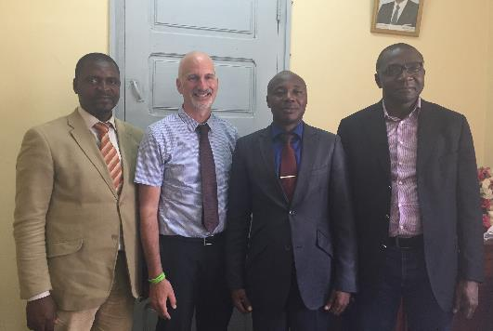DP presented study and stressed option to make research accessible and impactful. How to engage with women - regionally and locally. Women's groups. Know about HAP.
* DP asked whether generally women were concerned about household air pollution. RD explained that he had not received complaints from women about health (low priority of health). BUT women want to change their living conditions inside the home. Cooking gas (LPG) is aspirational to change their living conditions. No information on health. No projects looking at household air population in the region.
* RD - Not easy to bring change in these communities. Need to know the culture of the communities and behaviours. RD asked why choose MBalmayo? EM - proximity/ location. Mixed population (peri-urban and rural). Just a pilot - will be extended. North of the country has a real problem.
* RD - questioned GLPGP on whether the price of microloan scheme was realistic. EB offered a good explanation of microfinance initiative. Members pay back over 6 months. 8,000 CFA every month. Rural areas - not easy for women to give regular amount of money if collect firewood for free.
* RD - What "benefits" do you bring to these women - suggest payments/ incentives needed? BM answer - good health (and information about the health benefits). We are giving women the opportunity to make the change in a simple way. Need to give women incentives to change their habits (argue we are doing research to help communities). Incentives provided to people helping us with the research to remunerate for time.
* RD positive after initial discussions.

***Recommendations from RD***

* Flyers should be used to launch the research program through MINPROFF - also some to be sent to the minister. Two languages in French and English. Information about the proposed study, target population, also results of what we have done (LACE studies) in advance to CAA launch.
* People are happy because they use LPG. ***Need individual case studies*** - ***powerful message to communicate to politicians*** - they talk in generic way (highlighting need for money). Before and after using LPG.
* Highlighting issue what wood/ charcoal can be more-costly than LPG. Women make link between cost of buying biomass fuel and LPG.
* Need progressive research - we are extending (not just carrying out research and leaving).
* RD - MINPROFF has ***Women's Empowerment Centres***. They have some budget to give women loans. RD now thinking how they can help us with micro-credit.
* MBalmayo has women's empowerment centre with this type of loan. This kind of credit is for income generating activities (rather than outlays). Maybe ok for street vendors to make the switch. Money is going out but not coming back. Need to make sure repayments made.
* Crucial dates: ***31st July 2018 - African's Women's Day*** and ***15th October 2018 - Rural Women's Day***.

**12.45pm: Meeting with MUFFA Yaounde (microlending institution)**

* ***Number of women*** registered with the unit - 4,000 members - 2,000 active.
* ***Types of loans*** other than LPG - Loans include building projects and children's schooling.
* ***Method of advertising*** - People ignored fliers. They came forward after seeing other people's equipment. People do not read. Need oral mass communication to communicate the scheme to women. Demonstrations.
* 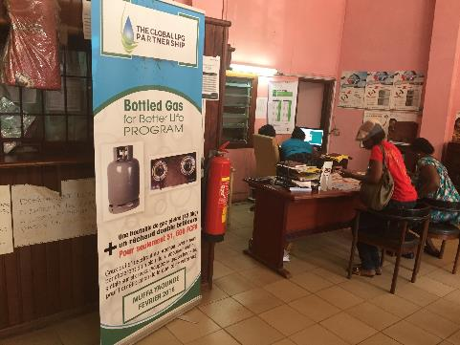Initial adopters stimulate future adoption. GLPGP project really successful through domino effect. More people want to register - capped at 100 HHs.
* 100% repayments so far.
* ***What happens after the pilot***. Open activity for MUFFA to continue as a regular micro lending activity once the pilot is completed. BUT to continue needs to have a partnership with the marketer (TRADEX) and the manufacturer of the burner. GLPGP can bring them into a partnership to ensure the scheme can be maintained. One advantage of TRADEX is that even with LPG shortages, they have a good cylinders supply.
* ***National women's days - can we be represented***? Maybe set something up around women's days. Have stalls - highlight messages. Case study. During the week around women's days we can organise something. Women can come and give testimonies - National - MINPROFF has hold of these activities. Any other organisations can organise their own activities.
* MUFFA general assembly once a year where they all meet. We can present during this assembly. 4 towns in Cameroon have meetings (Yaounde (Central), Douala (Littoral), Buea (South West), Bafoussam (West region) - local meetings closer to the populations. National = September.
* Each local MUFFA has its own specifics (own inputs from what is seen in communities) and then share experiences at National meeting.
* ***Microfinance project is an advantage for MUFFA*** to recruit more women to the organisation (bigger customer base).
* ***We should ask a question in surveys*** - would you be interested in signing up for a loan with (e.g.) MUFFA?
* Want to make it their own project (by women for women)... how can our research help? Target women are those who need credit - any information about loan willingness.
* ***Acceptance of women onto the scheme?*** Can give women credit who have a good credit history. Special programme for those who are very poor - need to pay CFA24,000 to be full MUFFA member (register) but these women can pay 5,000 to join. Before accepted check new people coming forward need to demonstrate credit worthiness (families can refund if the person cannot). Whoever is benefiting should have the ability to repay back. Regular payments demonstrated previously also important to offer a new loan.
* ***Can people pay money on a seasonal basis?*** It needs a pilot study with people with irregular activity. But later, if successful – MUFFA could include seasonal activity but sign an agreement (e.g. with livestock). Can have a period of grace but need to check on a case by case basis (chicken 3 months/ pigs 2 years... as they grow to maturity).
* Pilot phase was needed to understand how loan scheme functioned. Now they can see they can adapt it to see how best to use it.

**2.30pm: VISIT TO STREET VENDORS USING WOOD**

* 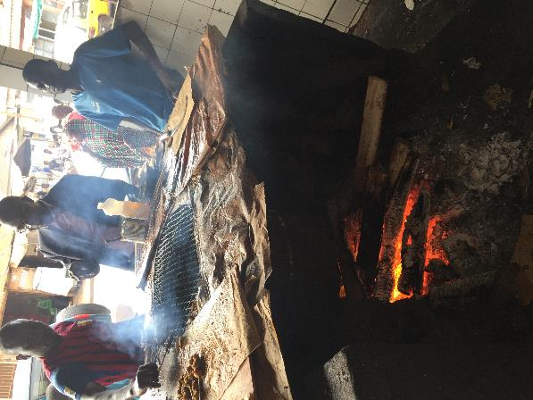Typical setting for grilling meat for snack food - busy street vendor (see photographs).
* The vendor is 28 years old and has been a street vendor for 10 years (the stall was his fathers). The stall is operated from 5am to 4pm (Soosong), 4pm to 8pm and 8pm to 12pm (colleagues).
* A lot of wood is consumed totaling 140,000 CFA per week. This is used to produce (grill) small amounts of meat (liver) on sticks at 50 CFA per unit. Very profitable.
* The vendor said the smoke affected his eyes and his lungs. He said for his lungs he drinks milk (cultured) at 400 CFA per day - this cleans his lungs each day.
* Not clear how LPG could be used for this slow, continued grilling over extended periods.

**4pm: Meeting with potential Field Work Coordinator**

* Roland is a recent graduate from Oschang University. He wants to do a PhD.
* He has conducted community based research as part of his studies looking at the efficacy of vaccination protocols. This involved 329 households. He organised enumeration of households (no census map) with some systematic sampling. The fieldwork included help from classmates. The research was conducted in 4 districts of the West Region. Main findings related to prevalence estimates of infection.
* No direct experience of qualitative research (has received training in qualitative methods from PH training - first three years of medical studies).
* Does not live in MBalmayo - 1 hr travel to community.
* He has worked with health workers previously.
* For previous research he has used smart phones to conduct surveys (ODK software).
* His current work is for PERFAT (US funded project looking at HIV prevention). He is also the monitoring and evaluation officer for a US CDC funded project. The staff are based in Yaounde.
* DP explained management structure and requirements for FW lead. Probably a very efficient team lead for FWs could EB be coordinator? Need someone who can communicate regularly with Bertrand/ UK coordinator. See later notes re: Emmanuel.
* Due to work contracting Roland will need to know if he will be employed by the end of September. BM suggests he will need a permanent contact rather than be paid on a sessional basis.
* Roland has contacts at the general hospital in MBalmayo.
* Note: Fieldworkers will need to be recruited from the community (see follow-up notes).
* email: Tchigouabruno@gmail.com

**Follow-up notes from meeting:**

* DP suggested contacting previous MBalmayo field team (LACE-2). BM called team to set up meetings on the MBalmayo trip. Fieldworkers included:

**- Ndo Marie Hortense (available)**

- Bene Pierre (Infirmier Diplome d’Etot, principal) 674068795

- Mikonlate Suzy Michelle 677269521

- Eboutou Hlate Rose 6550776648

- Abinkeng Tazifua Ebenezer (general practitioner, CMC Douala) 656478316

The only remaining fieldworker was Madam Hortense. BM has arranged for her   
 to meet and guide us on our visit to MBalmayo on Wednesday.

* DP discussed with BM the potential for Emmanuel to have a coordination role for CLEAN-Air(Africa). BM agrees EB has many strengths and would make good lead (will follow-up with discussions/ planning on Thursday). Dr Puzzolo confirmes it should be possible for GLPGP and UoL/ DGH to fund EB each for 50%. Discussions with EB indicate he is happy with such a future arrangement.

**Tuesday 3rd July**

**10.30am: MEETING with Ministry of Public Health (Dr Elise Virginia Owono Longang)**

* Dr Longang is a Director of Health Promotion.
* Dr Longang is very engaged/ supportive and had many ideas. Interestingly she had not thought about HAP from solid fuel for cooking as a Public Health issue before but totally understood the problem through discussion. She mentioned issue of perceived tradition of using solid fuel for cooking (and better taste) and that the men of the household would push for this, but that things needed to change.
* The mission of the health promotion ministry is to provide sensitisation of communities to promote good habits for health. The Directorate works on "community action" as well as health education.
* Dr Longang stressed the ***need to build capacity*** in this area and that she is ***very interested in collaboration***.
* One of their partners is MINPROFF and Dr Longang stressed the potential for them to bring all relevant stakeholders together to harmonise our capacity building activities. MINPROFF has many women's associations we could work with.
* Dr Longang brainstormed with us on potential capacity building activities. She suggested that through the Ministries of Health and MINPROFF we could organise ***workshops to "train the trainers"*** communicating directly to the leaders of the women's groups. This would be facilitated by Dr Longang. We could start locally (Yaounde including MBalmayo) as a pilot training exercise and then extend across national territories (including leaders of women's groups across the country).
* 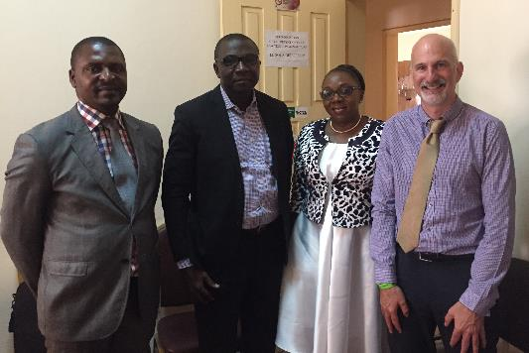We need to find the best way to deliver messages around household air pollution, health and prevention. What is the best method of getting messages to the "common person". Fliers are not useful. Need (i) social messaging, (ii) videos/ pictures, (iii) ***testimonials/ case studies***. We all favour the latter (telling a story from a woman's point of view as she switches from solid fuel to LPG) - maybe this could be something UK anthropological Research Lead could help us with?
* Dr Longang suggested various stages of messaging. (i) Present the topic, (ii) Target people/ what are the messages?, (iii) Use informative/ impactful materials, (iv) leaders go back to groups to provide sensitisation. We could build evaluation into the final stage.
* We can learn from successful health promotion around tobacco smoking (this was one of Dr Longang's priority areas previously - she was very surprised to learn that HAP is the same as ATS (minus the filter in cigarettes). This is a good message (Kirk's packets of cigarettes smoked from cooking in the kitchen).
* Dr Longang stressed that, given the LPG Master Plan intersectoral committee, it would be important to also have representatives from MINEE at the capacity building workshop.
* We discussed eventually working with school children (not in the early stages of CLEAN-Air(Africa)). Agreed this would be a great target group - not just to communicate messages to family but also as future fuel users!
* Contact details (no card): eliselongang@gmail.com (Ministry of Health; 677404751). DP to discuss with BM about organising this workshop.
* Note: BM has found out ***Yaounde has a local ethical committee***. Approval will be much swifter with this committee (rather than the 3 months for the National Committee).

**1.00pm MEETING with Dr Jean Baptiste Bonge (Younde 1 University)**

* Met at the main women's and children's hospital in Yaounde. Dr Bonge is a respiratory physician. He has a teaching load with medical undergraduate students. He also has conducted some research (see below).
* Dr Bonge has an interest in asthma (primarily child but with BM also interested in adult). This is a real problem in Cameroon - very high prevalence (as much as 1 in 4 children at school). Believe it is related to air pollution (ambient as well as HAP).
* Dr Bonge was very receptive to issue of HAP as major respiratory risk factor and to the Group's objectives for research and capacity building. BM suggested the latter was a priority and that we would be looking to train physicians/ medical students to understand HAP as a major risk factor for child ALRI and NCDs.
* Discussions centred around special symposia for clinicians rather than intercepting training. DP to explore this idea with BM.
* Dr Bonge is very happy to be involved in any capacity and awaits our follow-up when we receive official notification of funding.

**Follow-up discussion on capacity building (DP/ BM):**

* DP suggested enhancing ***research capacity building*** as an early objective for CLEAN-Air(Africa) - this came about after discussing paper writing. ***BM keen for us to arrange a training workshop around general research*** (including paper writing and applying for grants) DP to explore this with UK Theme Leads - how to set something up in Douala or other focus countries.

**4.00pm MEETING with Express Union (marketing, legal and loans managers)**

* The remit of the meeting was to encourage progression for Express Union (EU) to sign an MoU with GLPGP to get a microloan pilot study (n=150) in place with TRADEX as a partner (together with a stove manufacturer).
* Express Union was built on a model of transferring money within Cameroon based on the Western Union model of transferring money abroad. People, for example, pay money in Yaounde and this gets paid out in another region to agreed parties where another EU branch resides.
* As a result there are 700 branches of EU across the Cameroon national territories - an exciting prospect given scaling up potential for microfinance of LPG across the country.
* Recently mobile money (which the government has allowed to flourish in Cameroon) has badly hit EU which employs many Cameroonians. This has had a number of negative impacts on profits and jobs. EU is now looking at its own model of mobile money (although later into this market) and other sources of funding.
* DP opened the meeting with an explanation of relevant aspects of our Group's activities (including summarising findings from the microfinance pilots in Batoke). The presentation suggested how we could work with EU and suggested the benefits of working in Mbalmayo (in terms of location for the pilot and the opportunity for evaluation by UoL).
* We will look at the EU branch in MBalmayo on Wednesday.

**Wednesday 4th July**

**8.30am: VISIT TO MBALMAYO**

***1. Meeting with the Mayor of MBalmayo (Town Hall)***

* Managed to arrange a meeting with the Mayor. Explained study (and delays from our last visit as part of LACE studies after funding issues). The Mayor remains fully supportive and will to give all administrative approvals required (when ethical approval for the study is given).
* The Mayor will give us local census maps when all administrative approvals are in place.

***2. Meeting with local Public Health Administrative Authority***

* Approval is needed for research in MBalmayo. The Director was not present but our visit was noted.

***3. Visit to Fish Smoking Industry around the river Nonge.***

* DP asked to visit fish smoking industry after noting the river Nonge route through MBalmayo. Visited roadside industry set up run by a number of women.
* 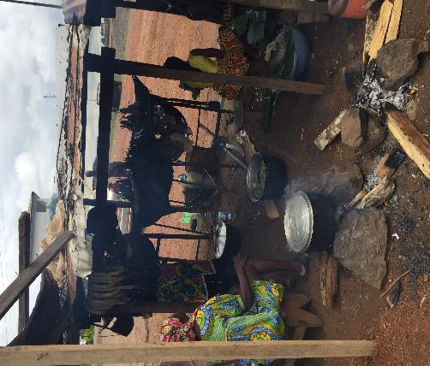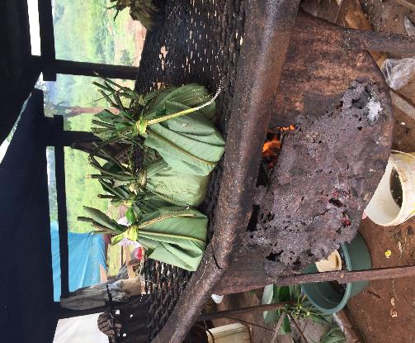The fish are purchased from fisherman who deliver (fish caught from Nonge). They are cleaned, placed in palm leaves and poached on large grills fueled by wood.

The wood costs 35,000 CFA (USD 61) per week. They work 7am to 7pm - preparing, smoking and selling fish at the roadside.

* The women complained of the smoke affecting their health (lungs and eyes). They want to use gas for the process and stated it would have no impact on taste. What they need is an oven (technology to cook fish using gas) and then they would buy for their business. This is a ***good model for change*** (motivated population).

***4. Visit to biomass fuel (wood and charcoal) retailers in MBalmayo***

* ***Charcoal retailer***. Costs: small bucket 200 CFA (feeds 5 people for one meal). Larger bucket 500 CFA (3x the size - 3 meals). 4,000-5,000 CFA for a big bag (right photograph). Note 2 types of charcoal (light for quick cooking - e.g. to get wood ready for fish smoking and heavy for normal cooking). The retailer had been selling for 5 years. Charcoal delivered to the retailer.

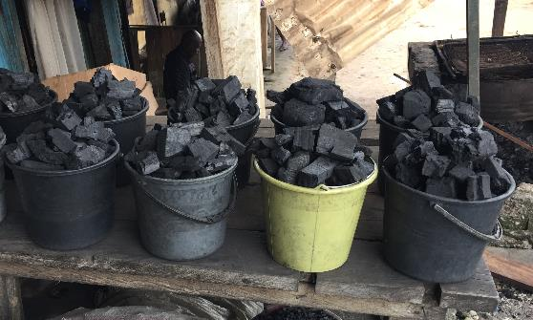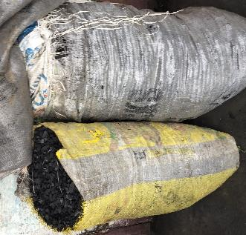

* ***Wood retailer 1***. This included interviews with two mothers who discussed cooking with wood vs gas.
* 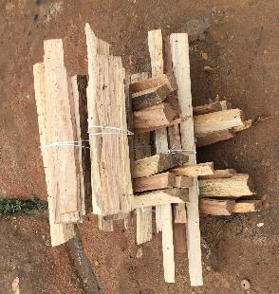Costs 100 CFA for a bundle of wood (see photo) - note this would costs 300 in Yaounde. Enough for one cooking event. The retailer buys wood from the bush and has it delivered before having it chopped into smaller pieces for retail.
* Woman 1 would never use gas. She has been using wood since she was a small girl. She thinks the food tastes better after being cooked on wood.
* Woman 2 does use LPG as a secondary fuel (for reheating food). She noted barriers to use include (i) safety - her daughter likes to switch gas on and light to be like her mother and (ii) cost (this is 7,500 CFA plus 200 to deliver on a motorbike). The cost of 7,500 up front is a concern - this competes with other more pressing expenditure including school fees and emergencies. She would rather pay in small amounts for wood.
* ***Wood retailer 2*** (see photograph). This included an interview with one woman about cooking. LPG is expensive (7500 CFA for 12.5kg). She wants to use gas - is aware of benefits. Her concern was that if the gas runs out she will not have enough money to replace/ carry on cooking. Availability and convenience of wood means she will still use it.
* If the govt could properly subsidise LPG she would use continuously. When pushed she suggested the price should by 3k. 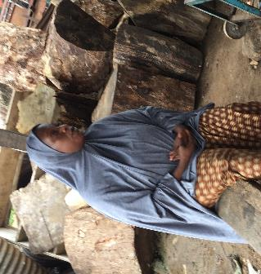
* She uses LPG for reheating - she would not use it for 'long cooking' due to cost/ waste.
* Her husband is a businessman with uncertain wage - sometimes he returns from market with no money - therefore it is not possible to plan budget required by LPG.

***5. Visit to LPG retailers***

* Without stopping we walked past a number of small LPG retailers (mainly SCTM and Star Gas. We noted that ***some of the cylinders were in very poor condition*** (looked dangerous). This should not be the case under CRM.

***6. Meeting with Express Union***

* 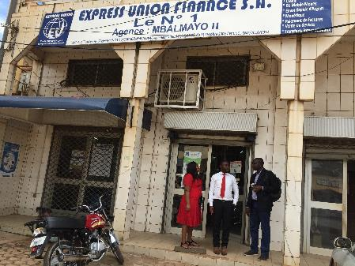There are four Express Union branches in Mbalmayo. We visited two of them including the financial branch that gives credit (and can approve for other branches).
* The branch manager was very supportive and open to work with us. We explained what we were planning and he said he would engage with us as soon as head office gives approval.
* Contact details: M Kanga 698009794; 694593135; 676156765.

***7. Visit to the Rural Community (see photographs)***

* We drove to a suitable rural community for CLEAN-Air(Africa) on the outskirts of MBalmayo - Akomnyada 2 rural village (note there is also Akomnyada 1 village) - each has approximately 800 adults. We spent the afternoon with the villagers talking and visiting homes and kitchens.
* There is no electricity and all rely on wood fuel for cooking (lighting is kerosene and some solar powered LEDs). Main livelihoods are around agriculture, fishing and livestock.
* Most people manage farms up to 5km from the village. They work the farms from 5am to 10am daily and collect fuel wood after farming to bring back to the village. They use baskets and motorbikes to do this.
* Villagers noted that they recognise deforestation as an issue with reduced fuel stocks. One farmer noted the increased winds that have arisen from trees being felled meaning damage to roofs.
* Some of the men smoke in the village.
* 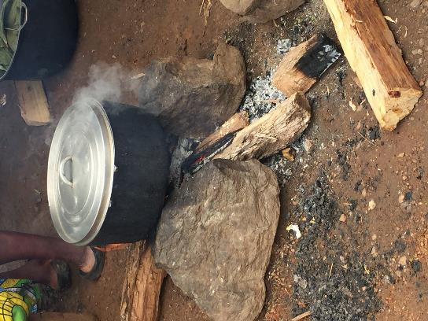There is no health centre. Traditional birth attendants help expectant mothers can have no time/ money to make it to hospital in MBalmayo some 7km away.
* We visited a number of kitchens and homes. Large stock piles of wood for the rainy season gathered from their farms. One women stated that the smoke did not affect her health (she was in her sixties and had used wood all her life). Another stressed smoke was a problem but had no choice but to use wood.
* This community is unlikely to be shifting to LPG in the near future (cost vs free wood is the main issue/ along with supply and lack of retail points). Improved cookstoves might help (at least reduce the amount of wood used with some HAP reduction).
* We could follow this community to determine prevalence of HAP related illness and burns? We could do spirometry and exposure analysis to document problem?
* The community were very receptive/ responsive and engaged. We bought the village all refreshments to cement relationship.

**6.00pm: Visit by Media Women Impacting Change**

* Contact details: Tabe Enoegbe - 00237 690520083.
* Discussions around (i) capacity building/ getting message of HAP and health out to women via media and (ii) disseminating work from CLEAN-Air(Africa) via national media. Tabe has a very senior role in the national media/ highly respected. She organised the GLPGP presence at the rural women's day in 2017.
* Tabe will arrange an interview with Dr Mbatchou as a physician from DGH around HAP and health to air on television. We will plan this tomorrow as we want it to happen as soon as possible. We can follow this up with additional interviews (e.g. LACE findings and launch of CLEAN-Air(Africa).

**Post meeting discussions**

* The minister from MINPROFF has confirmed a meeting on Thursday 5th at 10am - this is a key meeting with someone who is engaged with the topic and is close to the president's wife (highly engaged with women and children's issues). We need to carefully present the capacity building focus of the Group to her (outside and within the health system).

**Thursday 5th July**

**9.30am: Meeting with MINPROFF to meet with Mme Abena Ondoa nee OBAMA Marie-Therese (Minister)**

* DP - Overview of aspirations of the Group (stressed capacity building around HAP and health and MINPROFF advocacy role).
* 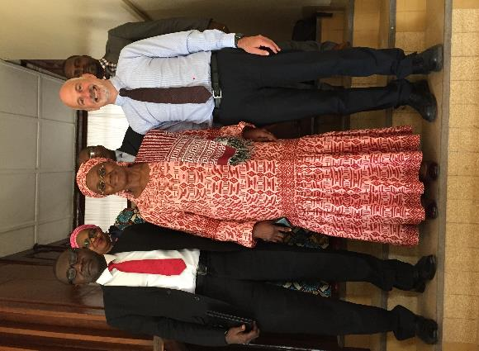BM - Discussed details of his role as a physician, seeing cases of Lung cancer and COPD in non-smoking women. Research interests in addressing biomass smoke.
* EB - Reinforced advocacy role and need to push/ support women for change.
* Mme Ondoa - very receptive, discussed the issue and traditions around solid fuels. She is fully aware of health impacts and our work (and has close links to Media Women Impact for Change who has explained UoL, GLPGP and DGH work).
* She has recommended two contacts to work with (one, attending the meeting) - Martin Ongola Atangana (Director of women's empowerment). She also gave us her personal number to contact - unusual.
* Feedback from the team was that she is a great Minister to work with.
* DP explained initial work on capacity building (workshop, local with women's group leads, possible to begin this year). Mme Ondoa stressed the opportunity presented by linking to National women's days activities.
* We passed on the briefs (health and impact modelling and BGFBL pilot study) to the Minister. DP briefly summarised impacts.
* After pre-discussion with EB we felt it was best not to push for links/ advocacy with/ from the First Lady and CERAC at this stage.

**11.00am: Meeting to review program of activities between DP/ BM (including budget)**

* Using program of activities template produced by DP after scoping visit we discussed all aspects of the proposed program.
* Ethical approval will take 2 months (local approval via Yaounde). ***We need to start working on protocols as soon as possible***.
* ***Workshop - women's group leaders*** (working with MINPROFF and MoH (health promotion). This will be the first activity of CLEAN-Air(Africa) to be conducted ***to coincide with Rural Woman's Day on October 15th***. We will hold this in MBalmayo as first sensitisation activity - invite Mayor etc. Communication around HAP and health and clean cooking. Testimonials/ case studies/ Sara's photovoice etc. UoL will have to pay for this as we will not have the budget from NIHR until the end of the year. *BM will devise a budget as soon as possible and DP will discuss with PHIS at UoL and NIHR*.
* ***Awareness raising/ capacity building in the health sector.*** BM will start to look into setting up capacity building symposia for clinicians and medical students/ practitioners. This will be built around current models of symposia (e.g. monthly presentations and discussions on health topics at DGH) - approximately 500 staff at DGH. Participants to the symposia could be given questionnaires before and after in relation to HAP as evaluation.
* The symposia could be extended to other regions (e.g. Baoussam - Capital of the West Region). A special event could be held around health conditions related to HAP (central theme) with prevention as part of the symposium. 1/2 day event (similar to those sponsored by Pharma companies). We would initially be sponsored by DGH but BM has registered to become an Association/ organisation nationally recognised - Environmental and Respiratory Health Foundation (EREHF) - when this is authorised we can use to set up events.
* Once clinicians at DGH have received training/ instruction in HAP and health conditions relevant to their disciplines (e.g. Cardiovascular Disease) they could deliver symposia/ presentations. BM could provide training - we need to provide evidence base and training materials around each health condition.
* BM will be giving an interview to CRTV (to arrange with Ms Tabe from Douala General Hospital). CRTV is government media (public tv and radio). We need to pass onto BM some simple public health messaging that he can present in the interview as a public health physician (e.g. pack of cigarettes smoked with each cooking event etc.).

**4.30pm: MEETING with MINEE (Mr Bello; Director in charge of petroleum)**

* Mr Bello is the head of service in charge of gas (met with Dr Puzzolo in 2015). He is part of the implementing committee for the National LPG Masterplan.
* There is very good demand for LPG but the main problem is the lack of cylinders (e.g. in Yaounde and Douala as many at 80% of the population use LPG and a short journey outside the cities sees very low usage).
* There is also currently a problem with storage capacity (in Yoaunde currently only 1000T and in Douala 2000T).
* Transport is also an issue. Rail transport is good but limited. More trucks are needed (few marketers have their own trucks).
* Master Plan Implementation is currently stalling over identification of suitable financing for the required increase in the number of cylinders into the market. Options being discussed include (i) adding 300 CFA to the price of LPG (currently 6,500 CFA for a 12.5 kg), (ii) organising duty on imports (currently 80%), (iii) asking government to assist with funding, (iv) reduce the margins of LPG marketeering companies. Discussions are ongoing about the right investment strategy.
* Marketers are currently not investing in cylinders (each cylinder costs the marketer CFA 20,000-25,000b (USD 34-44) as they are imported from Portugal or China). GLPGP are advising about bulk purchasing combining marketers to reduce cost but marketers have no external capital. They are tied by long term contracts/ agreements with banks (some of which involve links with suppliers in the import countries) - difficult to release capital.
* A viable option would be to produce cylinders in Cameroon - this would save a lot of money from imports. Need to make such a business attractive (for example with reduced taxes). Mr Bello will be discussing this further on Friday at a meeting with the implementation committee.
* We explained to Mr Bello that we had seen inflated prices in MBalmayo of 7,500 CFA for refills. This should not happen (max 250 CFA transport cost to be added) and the regulation should be monitored by Ministry of Trade. Mr Bello was not aware of this and will follow-up. We also discussed poor quality cylinders observed in MBalmayo. Mr Bello is aware of this (some are in circulation from 1960's) - this needs closer attention.

**6. Matters arising from the scoping visit:**

1. We will host an event (public engagement workshop) in MBalmayo to coincide with Cameroon International Women's Day on 15th October. This is supported by MINPROFF (Regional Delegate will be in attendance). The event will be covered by the National TV and news media. It will also serve to sensitise the community to the forthcoming research and raise awareness on the issue of using solid fuel for cooking on health and the environment.
2. Prof Mbatchou will be interviewed by National Media (Media Women for Change) to describe, from his perspective as a respiratory physician, the health impacts of household air pollution from cooking with wood. UoL will assist by providing evidence for the interview.