CLEAN-Air (Africa)
NIHR Global Health Research Group

Scoping Visit Report:
GHANA

18th to 25th June 2018

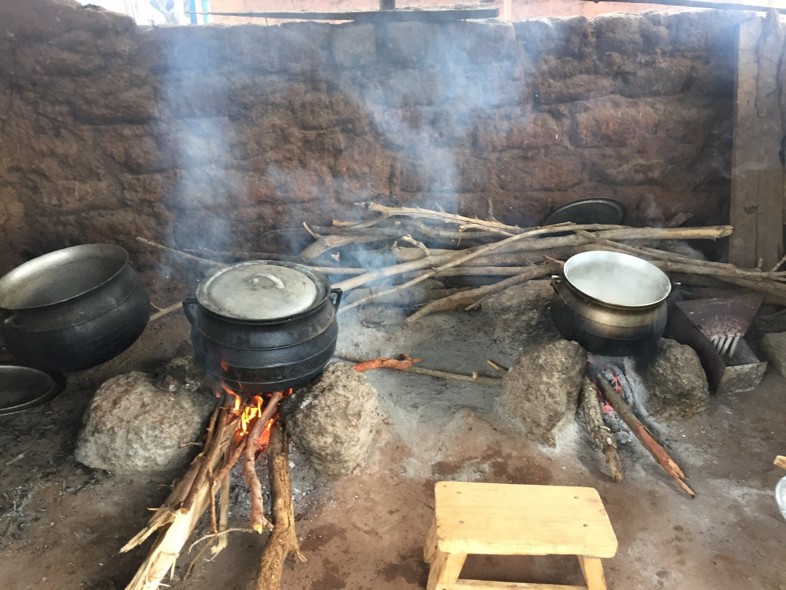

Summary of the scoping visit to Ghana involving meetings with stakeholders, research partners and research communities in peri-urban and rural areas

Brief overview

Productive joint working took place between the University of Liverpool, Ghana research and academic leads and the GLPGP Country Director throughout the week, with ongoing knowledge exchange, joint attendance at stakeholder meetings and visits to the Kintampo Health Research Centre and the University of Ghana. We discussed the budget ceiling of $250,000 for a 3 year funded programme in Ghana and what would constitute a reasonable working budget to enable completion of the programme activities. We identified a candidate study site with suitable peri-urban and rural communities, some LPG penetration and substantial biomass use. The site is the location of an imminent pilot to introduce the Cylinder Recirculation Model (CRM) by XpressGas, one of the largest suppliers, distributors and marketers of LPG.

The discussions led to the co-production of a draft Project Plan, outlining suggested research and capacity building activities, which was reviewed and finalised after the visit.

1. CLEAN-Air (Africa) NIHR GHRG Attendees:
- Kintampo Health Research Centre: Kwaku Poku Asante (KPA)
- University of Ghana: Reginald Quansah (RQ),
- University of Liverpool (UoL): Daniel Pope (DP), Martin O'Flaherty (MoF) and Rachel Anderson De Cuevas (RAdC)
- Global LPG Partnership (GLPGP): Charles Kinyanjui (CK), Country Director, Ghana

2. Stakeholders visited:
- Ghana Health Service/ Ministry of Health: Head of Research Capacity Building and Deputy Programme Manager, Occupational & Environmental Health
- National Petroleum Authority (NPA): Head of Research and Technical Aide to CEO; Research Manager
- Ministry of Energy: Deputy Minister (Finance Infrastructure); Director of Petroleum Downstream
- Kintampo Health Research Centre, Ghana Health Service: Director; senior faculty and research staff
- University of Ghana: Dean of School of Public Health and Director of Masters in Public Health (MPH) programme
- WHO Country Office for Ghana, WHO Ghana: WHO Country Representative and National Professional Officer, Guinea Worm Program
- XpressGas LPG distribution company, headquarters: CEO and team
XpressGas Filling Station in Techiman: Forecourt attendants, delivery team

3. Research communities visited:

Two peri-urban communities, Yabraso and Zongo Dagi, in Ashanti and Brong-Ahafo regions.

4. Programme of activities for the scoping visit:

 | Name, position | Organisation | Location | Brief descriptor

Accra

Tues 19
7:00 - 9:00 | Dr Kwaku Poku Asante;  Dr Reginald Quansah;  Charles Kinyanjui | Kintampo Health Research Centre (KHRC); University of Ghana; GLPGP Ghana | La Villa Boutique Hotel,  13th Lane Osu Ringway | Planning meeting with Ghana research, academic and NFP partners to discuss meeting objectives
12:00 – 13:00 | Edward Gyepi-Garbrah, National Professional Officer; Guinea Worm Program & WHO Country Representative | WHO Country Office for Ghana, WHO Ghana | 29 Volta Street, Airport Residential Area | Discussion of Health Systems Capacity Building objectives, synergies between WHO objectives
14:00 – 15.00 | Mr Kofi Nketsia-Tabiri, CEO | XpressGas | Head Office,  West Legon | Discussion about collaboration on expansion of recirculation model.
16:00 – 17:00 | Carl Osei, Deputy Programme Manager, Occupational & Environmental Health | Ghana Health Service |  | Discussion about research capacity building and collaboration with UoL.

Wed 20
10:00 - 11.00 | Hassan Tampuli, CEO;  Sheila Abiemo, Head, Research and Technical Aide to CE;  Joseph Wilson, Research Manager | National Petroleum Authority (NPA) | George Bush Highway, Dzorwulu | Established in 2005 to regulate the petroleum downstream industry. Have the remit to implement the National LPG recirculation model. Discussion of how CAA research might assist policy.
13.00 - 14.00 | Ivy Osei, Research Capacity Building | Ghana Health Service/ Ministry of Health |  | Discussion about research capacity building and collaboration with UoL.
16:00 - 17:00 | Joseph Cudjoe (MP), Deputy Minister (Finance Infrastructure);  Jacob Amuah, Director, Petroleum Downstream | Ministry of Energy | Ministry of Energy | Discussion on barriers and enablers to expansion of recirculation model and how CAA can assist by providing community perspectives.

Thurs 21
09.30 - 10:30 | Prof Richard Adanu, Dean, School of Public Health | University of Ghana | Legon Campus | Discussion on potential collaboration for teaching and health systems capacity building.

Kintampo
 | Forecourt attendants, delivery team | Xpress Gas Filling Station | Visit to Techiman on the way to Kintampo – deepening on meeting outcome with Xpress Gas | Potential site for expansion of XpressGas activities that CAA could evaluate (working in Techimen community).
 | Dr Kwaku Poku Asante | Kintampo Health Research Centre, Ghana Health Service |  | No. 8 KHRC residential area  Dr. Saunders road  Kintampo-North  Contacts: +233 (0) 20 2814 206

Fri 22
08:30 - 17:00 | KHRC planning meeting (including senior faculty/ research teams) |  |  | Detailed planning for research (KPA) and capacity building (RQ) activities including necessary capacity and budget discussion.

Sat 23
09:00 - 12.00 | Rebecca Dwommoh, Health Economist; Mujtaba , Population Health |  | Further planning; visit to communities (photographs) | Visit to local communities around Kintampo with fieldworker coordinators and fieldworkers.

5. Synopsis of scoping visit according to the programme of activities by date

Tuesday 19th June

Planning meeting with Ghana partners: Director of Kintampo Health Research Centre; Director of Master of Public Health (MPH) programme, University of Ghana; GLPGP Ghana Country Director

A planning meeting was held with project partners to discuss objectives for the week.

Research programme

The Group outlined the scope and funding for the CLEAN-Air (Africa) (CAA) project. The remit is to expand the research group through further collaborations with experts in the field and to create UK capacity. The allocated budget is £250,000 for Ghana. This was followed by an overview of previous research undertaken by the Group, including recent on HAP and clean household energy in Cameroon (LPG Adoption in Cameroon and Evaluation Studies). MoF presented his expertise in Public Health and policy modelling and particular interest in CVD and food. Chris Kypridemos at the UoL is re-implementing the HAPIT tool to model the eventual health impact of a policy approach. There is potential to add health impact and cost benefit to the tool. CAA activities could include capacity building in policy modelling with training activities.

Study scope

KPA emphasised that ministries are not keen on localised studies, therefore the implementation study should be generalizable/national. The government wants to see something that is nationally representative, to have policy relevance, otherwise research projects are side-lined for science. DP explained that we do not have sufficient funds to carry out nationally representative work, however, selecting and comparing peri-urban and rural areas communities near Kintampo will be valuable. Some gaps include range of times spent collecting fuel. Important to monitor personal exposure measurements (women and children), not just kitchen.

Academic collaboration, University of Ghana

Dr Reginald Quansah, Lecturer, directs the Masters in Public Health at the UoG (http://www.ug.edu.gh/beohs/staff/dr-quansah-reginald). His research on HAP focuses on children and women’s environmental health and, more broadly, assessing environmental exposures and their potential health effects in highly vulnerable populations including mothers, children, low-income/underserved communities, and occupational populations. He has a specific interest in assessing the impact of environmental exposures in homes and at schools; and the health impacts of indoor biomass, outdoor air pollution and climate change on vulnerable populations. Current projects include: ‘The Traditional Smokehouses studies among Fish smokers at Aboadze/Abuesi’ the Central and Volta regions.

a) WHO Ghana Country Representative meeting: National Professional Officer; Guinea Worm Program & WHO Country Representative
Discussion centred around the remit and activities of the WHO in Ghana (3 people working on the environment sector.) Gordon Dakuu, WHO Focal Point for HAP was unable to attend. Mr Dakuu is national focal point for the Urban Health Initiative. KP outlined collaboration between Kintampo, Ghana Health Service, Uni of Ghana and UoL, NIHR. Plans for future collaboration were discussed. This will be under the Urban Health Initiative, and piloting of training material for the health sector will be coordinate trough WHO Headquarters. | 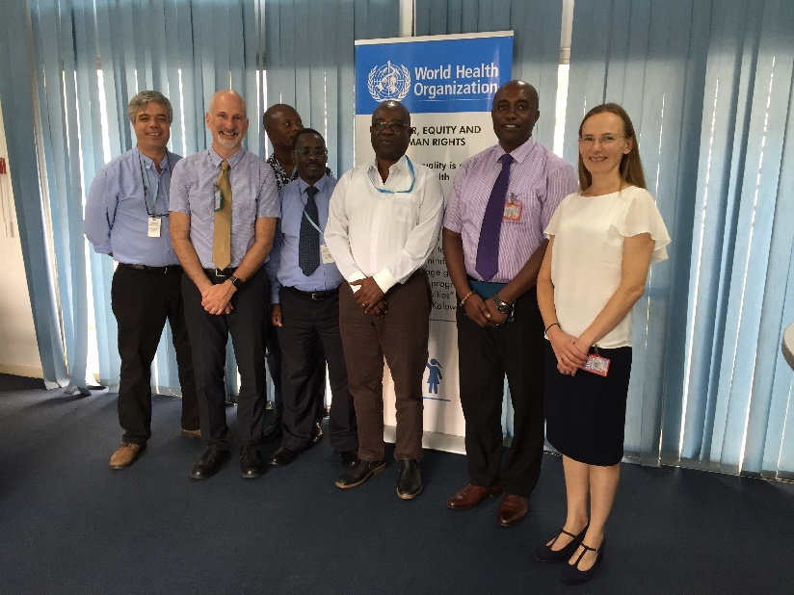

b) Meeting with Mr Kofi Nketsia-Tabiri, CEO, XpressGas, Accra

XpressGas operates in four areas outside Accra, including Techiman in the Brong Ahafa Region. DP explored the potential for developing a research partnership, to evaluate expansion of their customer model which utilises the LPG Cylinder Recirculation Model and would be directly relevant to National policy involving implementation of the RCM across the country. Discussion confirmed there is scope for joint work and evaluation and KNT recommended visiting the filling site in Techimen (a market they are planning to expand the RCM to).

c) Meeting with Deputy Programme Manager, Occupational & Environmental Health, Ghana Health Service: Attending: Carl Osei: Acting Programme Manager, HAP, epidemiologist; Occupational Psychologist (intern).

Brief introductions and overview of CAA research aims and focus. CO presented key environmental issues, policy for occupational health of health sector in Ghana. Currently collaborates with institutions working in area of environment to partner in implementation of environment-related projects, and participates in research. The environmental health division of local government has regulatory powers. However, it focuses more on food hygiene rather than on HAP. | 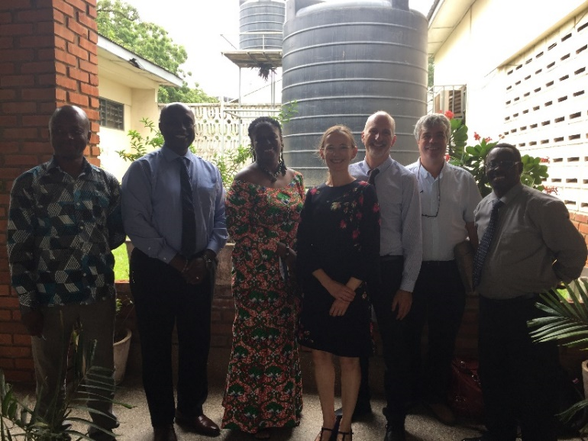

CO reported that environmental health is no longer under public health, and has decentralized units in all the regions and that LPG national policy was popular as long as it was free/ subsidised, but cost is a barrier. There are no subsidies and many competing policies. It is therefore important to have donor support. The perceived risk among population relates to gas explosions, and the government is trying to regulate the issue. The next Ghana Health and Disease Survey is in 2019 (household energy use questions have been added).

Involvement and representation of Ghana Health Service (GHS) in shaping Government policy on moving to clean fuel was discussed: CO reported that it is part of the Energy commission, and participated representing the health sector. This was raised in the Paris climate talks, the focus on HAP was more on deforestation and climate, and there should be more a health focus. Need to cost health impacts of diseases related to HAP to make strong case.

Awareness of HAP among medical/public health staff
CO reported that medical/public health staff have access to Global Alliance for Clean Cookstoves training, and accredited training. CO mentioned some CPD guidelines and urban health initiative. Important to link with the Director of Public Health. KP mentioned that current CHW training is on lifestyle changes to reduce hypertension. In order to change that, it would need a strong policy direction. The possibility for GHS to train CHWs to spread messages on HAP was discussed. From top down in GHS, to Community Health Planning Services, to CHWs. Discussion around guidelines used on management of COPD.

Steps to make HAP as a priority
It was stressed that there was a need to meet the Minister of Environment: Health and Pollution. KO introduced the United Nations Industrial Development Organization UNIDO. There is need for a regional approach to tackle HAP (West Africa) but using national solutions.

Wednesday 20th June

Meeting at the National Petroleum Authority (NPA), Head of Research and technical aid to CEO; research manager
Attending: Sheila Addo (SA), Head of Research and Technical aid to CEO; JW, Research Manager. CK, MOF, KP, DP, RMA, RQ. CEO sent apologies.

DP introduced the CCA Group and synergies with NPA were discussed. SA emphasised the importance of research and activities that are policy relevant. Joseph Wilson stated that CCA research could inform their interventions.

Ghana policy for LPG scale up
It was discussed how best to drive Ghana’s needs around the cylinder recirculation model (CRM). NPA was confident this is feasible by 2030 or earlier. However, it is important to engage with relevant stakeholders. Aspects discussed included: how can people use LPG; importance of microfinance, and interventions to adapt to cultural preferences; understanding of how these models are working.

SA explained that there are 5 key targets in national LPG promotion policy, which include health and climate impacts. Beyond health, they are targeting penetration, adoption, and access. This will translate to M&E.

DP presented possible activities/focus areas within CCA that would be relevant to NPA and extension of the RCM. KP reported that KHRC is looking at LPG use among pregnant women in rural areas. Women used LPG consistently but LPG was provided for free. However, once women had to pay for refills, women stopped using LPG. Barriers were not maintenance of cylinder, but access and cost. Complete shift to exclusive use is difficult to achieve. CK raised the importance to distinguish between access to LPG but not using it as a primary cooking fuel.

LPG Working group
The NPA indicated they were keen to set up a structured working group and that CAA could contribute. This would be important in developing an implementation plan. Based on targets, the group could start to develop a Monitoring & Evaluation (M&E) framework. SA also suggested to bring the Energy Commission in and emphasised the importance to work together, as a partnership.

KHRC, GACC, and UoL have developed health indicators from previous research. DP stressed that the CAA work will be in the context of changes to the recirculation model and described potentially relevant research activities. The possibility to add questions to capture indicators of clean energy use to Ghana Health Survey 2019 (e.g. fuel costs, cylinder size) was also explored.

National LPG recirculation programme
SA explained the license requirements to build cylinder filling bottling plants. Once bottling plants are operational, phase out current unbranded cylinders from the market owned by end-users. Within 2.5 year period, hope to develop survey to evaluate impact of the national roll out. DP suggested to follow their phased approach. Start impact assessment of first areas undergoing the transition to the recirculation model. The econometric evaluation of LPG has been used to make a projection of demand.

Health Sector capacity building
It was discussed how best to develop research capacity building. KP suggested using ‘health champions’ that can raise awareness of HAP.

Next steps
Discussion confirmed there is scope for joint work and collaboration. It was agreed to develop and circulate a list of ideas for research activities and timelines.

Meeting with Ivy Osei (IO), Deputy Director, Research and Development, Ghana Health Service (GHS). Director sent apologies. Attending: KP, MOF, DP, RQ, CK, and RMA.

HAP in GHS and Research Capacity Building
The importance of HAP as a subject area was emphasised and that LPG has a place in the GHS, and that NCDs, would sit well with their remit. IO highlighted the importance of research collaborations like this, since funding is limited, and was very happy to hear the focus on capacity building, and that this would benefit local researchers. DP introduced possible training opportunities, including bespoke workshops around grant writing, paper writing, and epidemiological methods around HAP.

Health systems strengthening, health education, sensitisation
Discussion around HAP training needs and plans for clinicians and CHWs. DP introduced previous work conducted by the Group on HA, and linking to WHO, implementing Indoor Air Quality 2014 guidelines. Physicians are not aware of HAP; CHWs engage with women in their communities.

SA stated that will discuss with NCD programme of GHS to coordinate work. KP reported to have contacted the NCD programme manager, but not available (Dennis Late). A manual is being produced by Health Promotion Unit, and there is the aspiration to include HAP. MOF stressed the importance to communicate the issue effectively to clinicians, politicians and officials. It was discussed the need of: ‘champions’ of HAP agenda; tailoring training to specific needs; and creating a regional network of experts who can talk to each other.

Communications
IO explained the various publications/communications channels, including Annual GHS report, weekly bulletin of surveillance data; reports produced by the various directorates.

Meeting with Joseph Cudjoe MP, Deputy Minister, Finance Infrastructure, Ministry of Energy (DMoE); Jacob Amuah, Director of Downstream Petroleum (DPD); Director, Renewable Energy (DRE)

Minister of Petroleum sent apologies.

Director of Downstream Petroleum works with GLPGP. He explained that the goal is to move from 25% to 50% LPG penetration. The Implementation committee is headed by NPA, but there are a number of sub-committees: (i) one dealing with health and safety and environmental issues (ii) one dealing with commercial and pricing issues, (iii) one for licencing issues. Requirements for bottling plants issued. Currently dealing with pricing structure and cylinder ownership and marketing side. Debate over whether bottling plant should own cylinders, or marketers should own cylinders and take to bottling plant to fill. All under consideration, but no decision. Some LPG ‘microfillers’ operators are agitating against the policy. JA is having discussions with GLPGP to seek sponsorship to organise a workshop to discuss plans for the cylinder recirculation model (CRM).There are some operators opposing the policy, as they fear it will negatively impact their operations.

Director, Renewable Energy reported that 60% HH fuel is wood, then charcoal. Within directorate, the technology for charcoal production is primitive. He suggested to place charcoal tax to encourage switch to LPG. Population does not feel burning charcoal has health impact.

Plans for CCA research to contribute and inform the CRM model
It was discussed how CCA research activities can inform the CRM model. DMoE suggested identifying enabling factors that would facilitate increased uptake of LPG (e.g. LPG pricing structure as an enabling factor).
With regards to fuel pricing, charcoal is cheaper than LPG in rural areas but more expensive in Accra and other urban areas. In rural areas, charcoal is cheaper than LPG, which becomes costly to transport. Then issue of subsidy has to play bigger roll. Under the CRM, users will have to pay for a cylinder deposit. If it can be proved a reduction in health burden from use of solid fuels by adoption of LPG, this could be passed on in as a tax on solid fuels. The current LPG price in Ghana contains VAT

In terms if safety aspects, due to the existing LPG model (including decanting) many accidents have occurred, mainly in transportation stage and at decantation phase. Sometimes transporters did not adhere to safety regulations/standards. You could extend research scope. DP suggested to include a desk-based review work of media coverage and safety of LPG and solid biomass and pass it to MoE.

Thursday 21st June

Prof Richard Adanu, Dean, School of Public Health, University of Ghana
Courtesy visit to Dean. There is great potential for collaboration in the field of Global Public Health. Opportunity to develop strong links between institutions.

Forecourt attendants, Xpress Gas Filling Station
Visit to filling station in Techimen to see equipment, weighting scales, delivery vehicle. At present, fill any brand of cylinder. Will implement CRM and deliver cylinders to homes.

KHRC planning meeting - Kintampo Health Research Centre (KHRC), Ghana Health Service (GHS)

Team Name | Email address | Position/Specialty
Kwaku Poku Asante | kwakupoku.asante@kintampo-hrc.org | Director KHRC
Rebecca Dwommoh | rebecca.dwommoh@kintampo-hrc.org | Health Economist
Mujtaba Mohammed | mohammed.mujtaba@kintampo-hrc.org | Public Health
Charles Zandoh | charles.zandoh@kintampo-hrc.org | Demography  (DSS survey)
Samuel Afari-Asiedu | samuel.afari-asiedu@kintampo-hrc.org | Sociologist
Jacob Saah | jacob.saah@kintampo-hrc.org | Administrator General

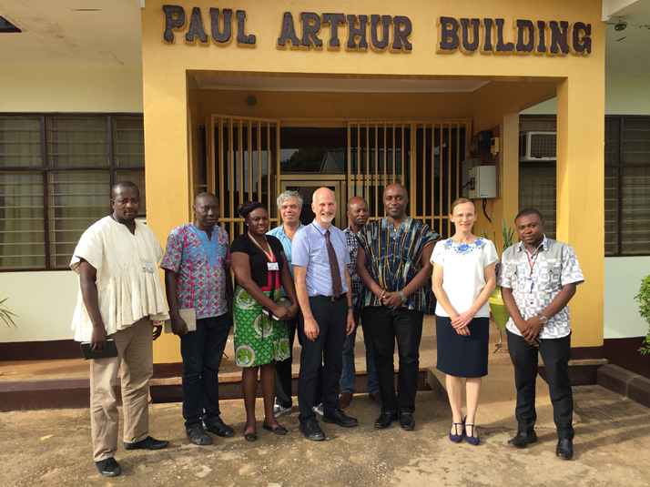

KHRC research capacity include social scientists, anthropologists, Samuel (working on social sciences, clean cook stoves’ barriers and enablers) health economists; researchers working in health systems research.

Health information systems/routine health data
Demographic Surveillance System includes cooking patterns. District health information system DIHMS. GBD data 2017 is coming out.

KHRC research on HAP to date
There has been a focus on understanding adoption of clean cookstoves (through the work undertaken by Samuel, Columbia University). Two approaches to encourage stove use: behaviour change intervention and convenient access. Current community engagement activities include community heads to KHRC before study and to discuss findings, and media communications.

Ideas for qualitative work for CLEAN-Air (Africa)
Possible aspects to look at include “What do women and female children do with their freed up time? How to improve access; How to overcome cost barriers; Cultural food preferences; Prevalence of food stacking and reluctant for exclusive LPG use”. The Group also discussed plans of conducting anthropological studies and to work with sociologists at KHRC.

Discussion about possible CAA research activities
Government’s plans include scaling up LPG to 50% by 2030 and change to RCM within one year. Xpress Gas wants to introduce cylinder exchange model in Techimen, peri-urban community. Aspects that emerged from the discussions include: important to consider the link between men and HAP (men control household finances, but are missed out from exposure data); monitoring cooking events (household cooking diaries are unreliable); opportunity to evaluate the EnviroFit smart meter technology to record cooking events; how to facilitate low SES to use LPG; commercial biomass users; and obtain perspectives of LPG marketers.

The Group introduced possible research activities such as exposure measurements; health outcomes; barriers/enablers to LPG adoption and sustained use; community-based participatory research ‘photovoice’; and microfinance interventions. Concerning microfinance, GN Bank has a social arm and very present in the rural areas. There is a Rotating Credit and Savings Association (ROSCA). This is a rotational scheme for financing commercial activities. Important to discuss with women’s lending group. Regarding the evaluation of rural LPG adoption scheme, Rebecca reported that they will interview the men and ask about household financial management and how resources are managed. Possibility that CAA activities can be complimentary.

Plans for Research Capacity Building
It was discussed how best to strengthen capacity building for researchers, but also plans for more formalised training for ‘health champions’ to access. This would include: training in research methods, through bespoke training workshops, summer schools, workshops, to cover complete set of skills needed for HAP research (e.g. exposure measurement, how to approach the community, what is health impact modelling, data analysis). Link to GACC to run HAP workshops, modelling, Uni of Liverpool, qualitative training. Proposal development for planning a summer school that students (including MPH students) could attend. Important to plan the summer school with Kenya and Cameroon partners.

Ideas for awareness raising around HAP and Health Sector Capacity Building
Discussion around the needs of community based volunteers and CHWs in terms of in HAP, NCDs and child health. Workshops could be held with CHWs, community-based volunteers to develop best way of communicating health messages around HAP to communities. Rebecca suggested to take adopters to promote LPG, e.g. community-based volunteers. They could promote the benefits of switching to clean fuels (health, economy, etc.). Introduction to WASH mode to facilitate adoption to LPG: role play, which included community chiefs, heads, discussions (examples from Brasil, Indonesia, India).

Next steps
Discussion confirmed there is scope for joint work and collaboration. It was agreed to develop and circulate a list of research activities and HSCB activities, including budget, operations, field team, and organisational structure. Make contacts with Laurence Gyabah, sociologist with interest social anthropologist (working with Samuel, PhD student).

