Invitation to Tender for

COLLECTIVE LEADERSHIP@ LIVERPOOL PROGRAMME

Procurement Reference: | Collective Leadership@ Liverpool programme
Procurement Lead: | Hilary Clarke
Tender Issue Date: | Wednesday 26th October 2022
Tender Return Deadline: | Wednesday 16th November 2022

CONTENTS
- University of Liverpool requirements/specification
- Contract dates
- Return of tender and raising queries
- Evaluation of tender
- Freedom of information and confidentiality
- Cost of Tender Preparation

SUBMISSION
Schedule 1 - Supplier/Contact Information
Schedule 2 - Reference
Schedule 3 - Response to the Specification
Schedule 4 - Pricing Schedule
Schedule 5 - Sign off

1 UNIVERSITY OF LIVERPOOL REQUIREMENTS/SPECIFICATION

The University is seeking tenders from highly experienced facilitators to deliver a new COLLECTIVE LEADERSHIP@LIVERPOOL PROGRAMME under the terms set out in this document.

SPECIFICATION
Programme Context and Requirements

Programme Overview

The programme aims to give participants critical leadership skills to empower, inspire and challenge them through a range of activities that will equip them with the knowledge, skills and mindset required by University leaders and enable them to develop as a leadership community. It will give both practising and aspiring leaders critical reflection and evaluative skills by developing their leadership skills and knowledge.
The proposed programme structure comprises a number of elements designed to both support and challenge the thinking of participants, recognising their role as colleagues within the institution, within their specialism and within their faculty.

Within the programme it is proposed that there are 4 core thematic areas (see Appendix 2 for visual and more detail):

- Leading in the HE Environment
- Leading Authentically
- Leading in an Inclusive Culture
- Leading Impactful Teams

Within each area of the programme, there will be 2 key elements:

- Collective Leadership Session – where leaders come together to develop collectively, irrespective of traditional roles or areas of work. This session will include content and discussion relevant for all institutional leaders.

- Lens on Leadership session – a context specific session to support leaders in applying their leadership learning to the context they are working within. Using a reflective style of facilitation and It is envisaged that this element may draw in speakers, examples, interactive exercises and/or case studies specific to research, education, professional services or technical teams (depending on the nature of participants’ roles) to help colleagues consider the topic in their own context.

We require a cohesive and expertly-facilitated programme, designed to enhance the leadership practice of aspiring leaders who wish to progress their leadership roles.
This new programme will drive culture change, facilitating an environment where leaders are engaged in and accountable for the successful delivery of the University’s strategic objectives through the impact and quality of their approach.

The core programme should be delivered across approximately six days and articulate the central elements of our Leadership Commitment Framework (Appendix 1). It should provide opportunities for participants to think, act and communicate as aspiring leaders, in a challenging yet supportive environment of collaborative learning and development.

It should enable participants to recognise, engage with and learn from excellent leadership practice, encouraging deep reflection and purposeful self-development. The programme should become the benchmark for high-quality leadership development in the H.E. sector, gaining a reputation for excellence both internally and externally. The perceived value and status of the programme and the associated credibility of those who participate, will contribute to a growing culture of leadership excellence at the University.

In addition to the core facilitated programme, there are ‘Lens on Leadership sessions to enable wider participation from those staff in the areas who are not on the cohort. Resources will be made available internally to participants. Participants on the core programme will complete the Spotlight performance profiling exercise as part of the Leading Authentically session, and the Resilience Leadership and MTQ Mental Toughness profiling as part of the Impactful Leadership session. While the tender does not incorporate these elements, the successful applicant would be expected to effectively reference opportunities for continued learning throughout the programme design. In particular, effective use of the Spotlight psychometric tool and MTQ 48 Mental Toughness/resilience leadership, should be embedded to maximise the benefit to participants’ development.

Participants will also be supported through the programme by our newly established pool of Internal accredited coaches during and after the programme.

Participants

There will be 20-24 places on each programme. Places will be awarded to staff to the basis of their application against a series of criteria plus nomination from a senior management team sponsor. Cohorts will consist of staff from both academic and professional services roles, emphasising the importance of working across organisational boundaries and silos when engaging in effective leadership. We will proactively encourage applications from under-represented groups.

The programme should be designed for people operating at grade 6-8 across a range of roles from Research Leaders, Academic Leaders, Professional Services Leads and Technical leads. These will be aspiring leaders, or colleagues who have recently taken on a leadership role at departmental or School level, so are potentially our future Heads of Departments.

Leadership Expectations

Our expectations of all leaders at the University of Liverpool are set out in our Leadership Commitment Framework. This is based on the four themes below, underpinned by effective communication and networking.

Our leaders should be:

- Credible Leaders
Accountable, resilient, confident and self-aware. They inspire confidence in their ability, not only as a leader, but in their ability within their chosen field.
- Ambassadorial Leaders
Outward-facing and innovatively seeking strategic partnerships and collaboration opportunities to raise the institution’s profile. They continually horizon-scan to see what’s ahead, and plan accordingly to ensure sustainability.
- Inclusive Leaders
Embed equality and role model the university’s values. They are collegial in their approach, involving and engaging others to build strong relationships. They coach and develop others so they can reach their full potential.
- Impactful Leaders
Deliver results and can evidence the difference they make. They problem solve to overcome challenges, and use strong influence and negotiation skills to lead change and continuous improvement.

The full framework is attached (Appendix 1).

Programme Outline and Approach

The programme will be framed by Induction and introduction of profiling psychometrics and closing with a Reflective Leadership session in addition to the core 4 days of activity on the programme. These will be designed to set the tone for the learning and engagement that follows, outlining the significance of the programme and the importance of commitment to the opportunities provided. The closing event will enable participants to highlight the impact of the programme on the issue of Collective leadership at Liverpool. We would expect the successful tenderer to support the design and facilitation of these events.

Tenderers are asked to design and facilitate the six sessions to achieve the broad objectives set out below, while putting forward innovative and original proposals that will maximise the positive impact on participants’ leadership practice. Content should be articulated against our Leadership Commitment Framework, both the four areas outlined above plus the underpinning themes of effective communication and networking. We anticipate that the core sessions will be face to face (cohort only) where active learning from peers will be encouraged. Sessions being spaced at roughly four-week intervals over a six-month period. Each Lens on Leadership session (approximately ¼ of the cohort at each lens session plus additional participants who can book on 1 or multiple sessions) to be delivered virtually and between each core programme session. Supplemented with asynchronous material as necessary to support development and enable the time participants spend together to be optimised.

We envisage that each session will have a similar format, however we welcome tenderers bringing their own ideas and expertise to the design. Each session to include a masterclass element from an external speaker, who is able to provide genuine insights of leading in complex organisational contexts and in relation to themes from our Framework. We will work with facilitators to identify and approach appropriate speakers, able to present genuinely engaging case studies of practice. The Lens of Leadership element of each session would ideally be open to a wider audience within each relevant area, maximising the impact and return on investment.

‘Lens on Leadership’ sessions with key members of the university’s Subject Matter Experts, Senior Leaders in their field, picking up on themes from the masterclass by reflecting on their own learning in that area, may also be a feature of session design.

A significant period of time in each session will focus on facilitated discussions and other suitable activities, supporting the development of reflection and professional learning that builds on the input elements of each session. Please note that we expect minimal presentation-type input during this time.

The indicative foci of each session and broad learning objectives are outlined below. Again, we welcome tenderers views and alternative designs. Similarly, although we have set them out in this structured way, we are open to ideas on the framing and the running order of the workshops.

Introduction Session

Introduction to the Collective Leadership Programme

The aim on this session would be as an introduction to enable delegates to get to know each other and the format of the programme.
- Introduce the Leadership Commitment Framework
- Enable understanding of the profiling tools being used throughout the programme
- Enable delegates to understand their development plan during the programme and post reflective inputs
- Signpost delegates to asynchronous learning, additional support and resources

Session 1: Leading in the HE Environment
The aim of this session is to bring together leaders from all contexts, to explore the environment in which we lead and the key factors that influence this locally, nationally and globally

This session has the following learning outcomes:
- To introduce the concept of leadership
- To enhance understanding of the opportunities and challenges within the HE sector
- To increase knowledge of the University’s strategy, focus areas and strategic growth priorities, and how these link with government and research funder priorities (e.g. sustainability and civic engagement)
- To relate this knowledge back to the role of leaders within the institution, and consider how this impacts on decisions/influence/limitations within the context of own role

Lens on Leadership (Session 1)

Learning Outcomes:
- To explore the HE environment further in the context of a research/education/PS/technical leadership role, using appropriate examples and documents to facilitate the discussion

Session 2: Leading Authentically

The aim of this module is to encourage the exploration of leadership values, purpose, style and impact encouraging self-reflection to create a greater awareness of personal leadership strengths and areas for further development

This module has the following learning outcomes:
- To embed a shared understanding of leadership within the institution
- To reflect on own leadership values, purpose and strengths
- Understand their strengths, drivers, motivation and mindset to enable effective leadership and understand their teams using the Spotlight psychometric profiling

This session will include input from a Licensed Spotlight Practitioner and delegates will undertake their 1-1 profiling and coaching around their Spotlight report alongside this input.
Lens on Leadership (Session 2)

Learning Outcomes:
- To hear from leadership role models within colleagues’ own context about their career experiences and trajectory
- To consider strengths and development for career enhancement

Session 3: Leading in an Inclusive Culture

The aim of this module is to encourage leaders to learn more about inclusive cultures, acknowledging existing challenges and barriers and identify changes to leadership practice that can enhance and embed inclusion

This module has the following learning outcomes:
- To consider the influence of different cultures and consider steps leaders can take to promote inclusivity within their teams
- To recognise the importance of effective communication, increase confidence in initiating open discussions and encourage the sharing of different viewpoints / opinions
- To encourage colleagues to consider their own impact on others, and the steps they can take to build a more inclusive culture in their sphere of influence

Lens on Leadership (Session 3)

Learning Outcomes:

- For participants to consider the barriers they may have experienced, and the steps they can actively take to reduce the barriers for others
- For participants to reflect on their own inclusive practice through a practical exercise or case study with facilitated de-brief

Session 4: Leading Impactful Teams

The aim of this session is to enable leaders to consider their leadership style in influencing, motivating, and fostering impactful team dynamics. Understanding the impact of inclusivity, resilience and coaching and how that can drive collaboration and effective team working to achieve success

This session has the following learning outcomes:

- To enhance understanding of the components of effective team working and the influence of team dynamics
- To increase confidence and ability in adapting leadership style and approach depending on the situation
- To learn how to identify individual drivers, and consider how to motivate team members towards a common, shared goal using coaching / influencing and other techniques as appropriate
- How to lead by collaboration
- To understand the concept of personal resilience and why it is important in building stronger and more impactful teams and undertaking the Resilience Leadership programme as appropriate.

This session will also reflect on the outcomes of the Spotlight psychometric profiling covered earlier in the programme and bring through the themes of team dynamics and behaviours in leading impactfully with the self-awareness gained from the coaching.

Lens on Leadership (Session 4)

Learning Outcomes core for each lens:

- To consider what is unique about leading a PS/Research/Education/Technical team
- To give colleagues an opportunity to consider how to overcome some of the challenges of leading in a research/education/PS/technical environment
- To share experiences of leading teams in context and consider the unique aspects of leading in a research/education/professional services/technical environment

Reflective Leadership Session at End of Programme

It has been suggested through focus groups feedback that Leaders may be coming to their roles with subject matter expertise but the potential to further develop the confidence, self-awareness, contextual sensitivity, interpersonal skills and adaptability needed to effectively lead their teams.

This additional session at the end of the programme would bring together the delegates from across the cohort to share best practice, identify and share key lessons learned, reflect on the impact of their learning within the realities of their working context and to commit to next steps in their development.

Appendix 2 shows the visual for the Programme,

2 CONTRACT DATES

We anticipate that design and development work may start before the end of 2022 and anticipated Programme delivery will commence early 2023 with workshop dates to be agreed with the successful provider. The anticipated overall timeframe is roughly six months.

3 RETURN OF TENDER AND RAISING QUERIES

This tender has been made available to potential tenderers directly and any responses or questions should be made directly to theacademy@liverpool.ac.uk and clearly marked as TENDER for COLLECTIVE LEADERSHIP@LIVERPOOL PROGRAMME

Procurement Schedule Dates:

Reference: | SAME AS LISTED ON FRONT COVER
Project Title: | Collective Leadership Programme
 | Date | Date Status
TENDER issue date | Wednesday 26th October 2022 | Fixed
TENDER deadline | Wednesday 16th November | Fixed
Interview (if required) | w/c 28th November | TBC
Successful/unsuccessful tender letters issued | w/c 5th December | Best estimate
Contract start date | January 2023 | Best estimate

4 EVALUATION OF TENDER

All aspects of a tenderer’s response will contribute to the overall conclusion of the tender evaluation for this contract. The importance of each criterion can be determined by the weight attributed to it.

The University may if necessary ask tenderers to make presentations. Should this be required, tenderers will be given guidance on content and advice on how it will be assessed.

Tender submissions are marked using Most Economically Advantageous Tender (MEAT) criteria.

The interpretations of the non-pricing scorings are:-

Quality 50%

Score | Description
10% | Not acceptable: The response does not address all the requirements and/or does not meet the criteria specified.
20% | Poor: Whilst the requirements/criteria are addressed, the response/solution indicates there is a limited or poor understanding of the requirements/criteria, and/or there is a lack of convincing evidence of experience/performance/ability to deliver. High risk that the solution proposed is not completely viable / will not meet the requirements.
30% | Acceptable: The requirements/criteria are addressed. The response/solution indicates there is an acceptable understanding of the requirements/criteria, and/or there is acceptable evidence of experience/performance/ability to deliver. Medium risk that the solution proposed is not completely viable / will not meet the requirements.
40% | Good: The requirements/criteria are addressed. The response/solution indicates there is a good understanding of the requirements/criteria, and/or there is good evidence of experience/performance/ability to deliver. Low risk that the solution proposed is not completely viable / will not meet the requirements.
50% | Excellent: The requirements/criteria are addressed. The response/solution indicates there is an excellent understanding of the requirements/criteria, and/or there is excellent evidence of experience/performance/ability to deliver. Very low risk that the solution proposed is not completely viable / will not meet the requirements.

Reference 10%

Score | Description
10% | if your reference is from within Higher Education
5% | if similar activity but not from within Higher Education
0% | if no reference is available

Price 40%

The most competitive price will be awarded the full weight available within the pricing criteria. The formula to calculate the price score is carried out as described below;

% price score awarded = Weight of price criteria x Most competitive bid
Price bid

5 FREEDOM OF INFORMATION AND CONFIDENTIALITY

The University of Liverpool is a Public Authority within the meaning of the Freedom of Information Act 2000 or the Environmental Information Regulations 2004 (together, the “Act”) and therefore subjected to the Act’s provisions. The University of Liverpool therefore reserves the right to disclose any information provided by any tenderer unless such information is deemed by the University to be exempt under the Act or other legislation or codes governing access to information.
Tenderers should state if and why any of the information supplied by them in response to this invitation to bid is confidential or commercially sensitive or should not be disclosed in response to a request for information under the Act. This will not guarantee that the information will not be disclosed in response to Freedom of Information requests but it will be examined in the light of the exemptions provided for in the Act before a decision to disclose or not is made.

This Invitation to bid must be treated as private and confidential. Tenderers must not release details of the invitation other than on an “In Confidence” basis to those who have a legitimate need to know or whom they need to consult for the purposes of preparing a tender.

All data collected by completing this form will be processed in line with General Data Protection Regulations (GDPR) and will never be shared with 3rd parties. Companies/individuals that complete the invitation to bid paperwork and give us consent are added to a database that we may use in the future to contact in relation to new opportunities.

☐ | Please check this box to give us your consent to hold your personal data on our Supplier Database.

6 COST OF TENDER PREPARATION

The University will not be responsible for any expenses that may be incurred by the Tenderer in the preparation of the Tender.

Appendix 1
Leadership Commitment Framework

The Academy’s approach to leadership development continues to be underpinned by the University’s Leadership Commitment Framework - this framework was developed through engagement with colleagues across the institution and outlines the attributes that were collectively agreed as helping University of Liverpool leaders be most effective in their leadership roles.

Appendix 2 - Collective Leadership@ Liverpool Programme
. 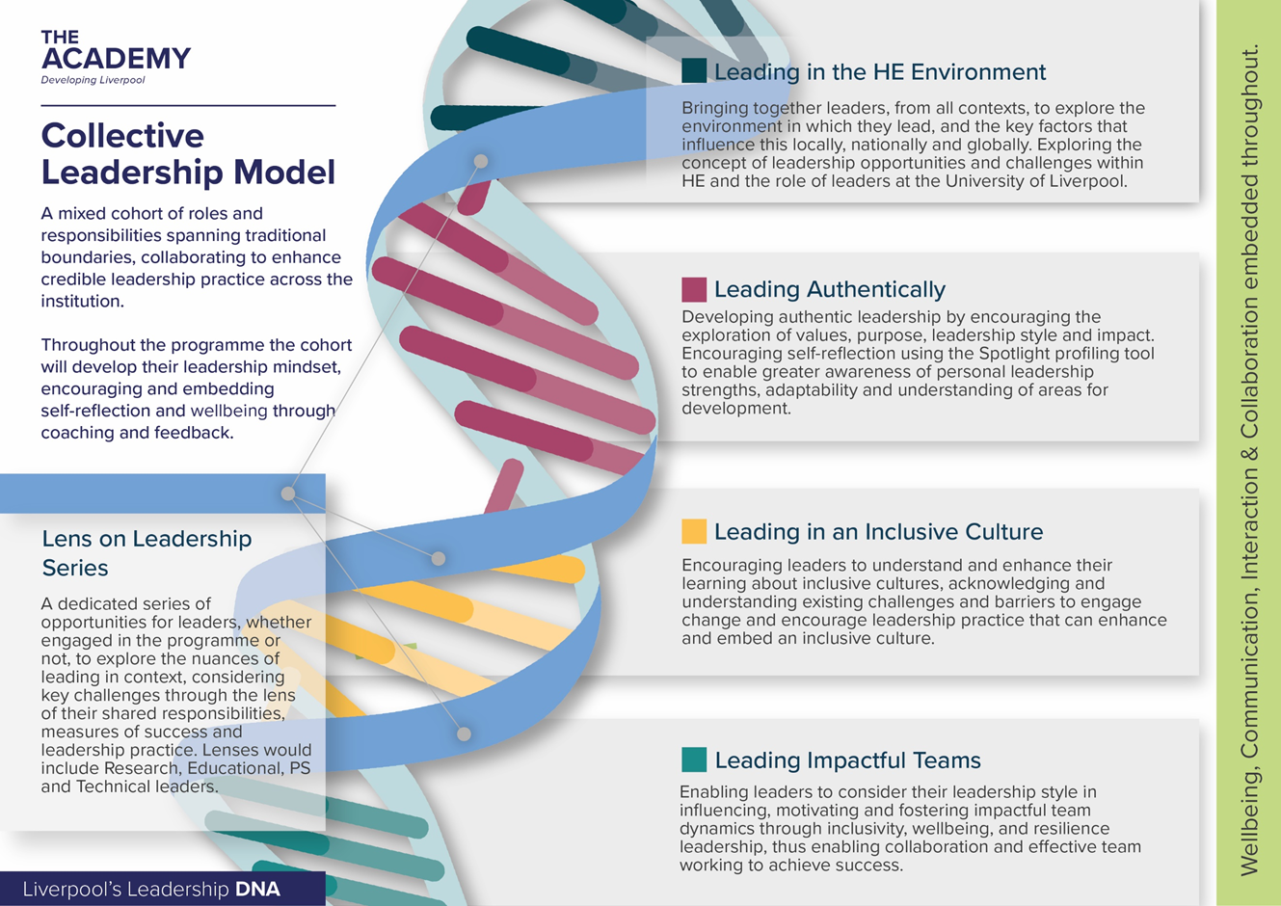

SUBMISSION
Please ensure that all questions are completed in full, and in the format requested. Failure to do so may result in your submission being disqualified. If the question does not apply to you, please state clearly ‘N/A’. For example, some questions will not be applicable to sole traders.

SCHEDULE 1: SUPPLIER/CONTACT INFORMATION (not scored)

Supplier details | Answer (Please state N/A if not applicable)
Full Name of Supplier
Registered company address
Contact Name
Contact Telephone Number

Contact Email Address

Website Address
Social Media Accounts | Facebook:  Twitter :  Linked In :  Instagram :

SCHEDULE 2: REFERENCE

Relevant experience or contract examples
Please use the space below to provide details of an example showcasing your experience or contracts undertaken, preferably from Higher Education Institutions, which are relevant to the University’s requirement and preferably using contracts undertaken in the past 5 years.

Name of customer organisation
Point of contact in customer organisation
Position in the organisation
E-mail address
Telephone
Dates (to and from)

SCHEDULE 3: RESPONSE TO THE SPECIFICATION

Please provide your response below

SCHEDULE 4: PRICING SCHEDULE

All prices quoted must be in sterling, to two decimal places, inclusive of travel & expenses, and inclusive of VAT*.

Travel and expenses will not be paid separately by the University and shall be included within the various day rate/session rates etc.

The University cannot guarantee acceptance of any changes in costs beyond the aforementioned increases in line with CPI.

*If you are not VAT registered, please make this clear on the pricing schedule.

Please provide your price below
Core Programme As Described Above

Total Price inclusive of VAT

SCHEDULE 5: SIGN OFF

I confirm that all information provided is current and accurate at the date below:

COMPLETED BY
Name

Role in Organisation

Date

Signature

