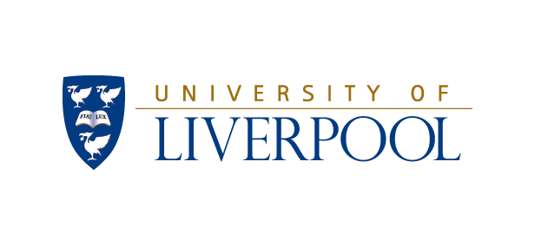
Diversity and Equality
Annual Report
2017-2018

Contents

Contents 2
1. Introduction 3
2. Executive Summary 3
3. Equality Data Summary 4
3.1. Student Equality Data 4
3.2. Staff Equality Data 7
4. New Policies and Services 11
4.1. Equality Framework Action Plan 11
4.2. The Academy Learning Zone 12
4.3. University Muslim Adviser 12
4.4. Family Friendly Advisers 12
4.5. Fertility Treatment Policy 13
4.6. Staff Carers’ Network and the Carers’ Framework 13
4.7. Sexual Misconduct Framework 13
5. Athena SWAN 16
6. Training and Development 19
6.3. Human Resources 19
6.4. Student Administration & Support 22
7. Looking forward 2018-2019: Key Activity 23

Introduction

“The University values diversity; we are an inclusive institution, committed to the provision of opportunity for those with the capacity to benefit as individuals but also as members of a wider community dedicated to a sustainable and just society … We respect difference, but will look for consistency and sharing of good practice to ensure that fairness and equality of opportunity inform our organisational structures and processes.”
Strategy 2026
“The University is committed to providing an environment which recognises and values people's differences, capitalises on the strengths that those differences bring to the institution and supports all staff and students in maximising their potential to succeed.”
Equality Framework 2016-2026
  - As expressed in the quotes above, the University of Liverpool is committed to the equality of opportunity for our staff, students and wider community. Each year we welcome, develop and support a diverse community of students and staff to the University. New policies are developed, practices changed, conversations started and new ideas formulated.
  - In this report, we provide information on some of the key activities that have taken place in the academic year September 2017 to August 2018. These activities implement the principles and commitments set out in our Diversity and Equality of Opportunity Policy, our Dignity at Work and Study Policy, and other supporting policies, services, and commitments. It should also be noted that other equality compliance requirements are enshrined in other aspects of governance reporting including the need to report on equality impact through the front sheets of reports. The governance structures for overseeing the recently approved action plan and objectives (see section…) will also go to strengthen the scrutiny given to progress in this area. Future reports will contain updates on progress against the new objectives.

Executive Summary
  - The University of Liverpool has continued its commitment to diversity and equality in 2017-2018. This report highlights some key achievements including:

- The approval and publication of the Equality Framework Action Plan in February 2018.
- The first two schools from the Faculty of Humanities and Social Sciences achieved their first Athena SWAN awards.
- A project on sexual consent was delivered with a focus on student behaviour.

Equality Data Summary

Student Equality Data

    - Here we provide a summary of key student equality and diversity data and statistics covering either the academic years 2017/18, the source of which is the University data warehouse Explorer, or national data sourced from the Higher Education Statistics Agency which is for 2016/17. Both sets of data will be headcounts (a.k.a Full Person Equivalent) and HESA data will only be for First Degree students.
    - The total student population (undergraduate, postgraduate taught, postgraduate research) (excluding Foundation Year) for the 2017/18 academic year is presented in the ‘Student Equality Profile’ infographic below. All data has been sourced from Explorer:
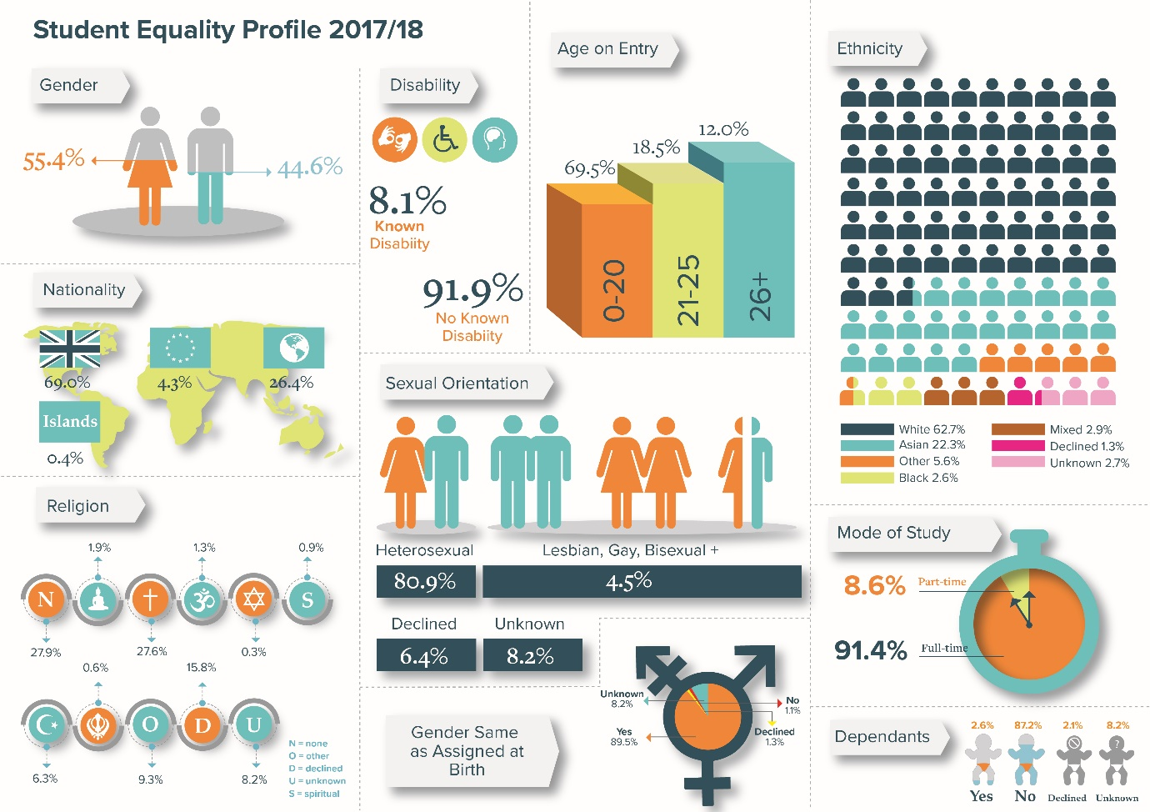
    - Age (Home/UK)
90.7% | The percentage of Home/UK undergraduate first year, first degree students at Liverpool who were aged 18 to 20 years old when they started their degree in 2016/17 (HESA).
3.3% | The percentage of Home/UK undergraduate first year, first degree students who were aged 25 or over in 2016/17, compared to 16.3% of all students in the HE sector (HESA).

    - Disability
2251 | The total number of disabled students at Liverpool in 2017/18, an increase from 2097 in 2016/17. 84.3% were Undergraduates, 9.9% were Postgraduate Taught (PGT) students, and 5.9% were Postgraduate Research (PGR) students (Explorer).
11.1% | The percentage of Home/UK undergraduate first degree students who had disclosed a disability at Liverpool, an increase from 10.5% in 2015/16. If we include EU/OSI students the proportion is 8.5% because only 2.7% of disabled students are EU/OSI but 28% of all students are EU/OSI (HESA).
82.7% | The percentage of Home/UK, undergraduate, first degree disabled students who achieved a 1st or 2(i) in 2016/17, an increase from 82.6%. This compared to 87.1% for non-disabled students (HESA).

    - Gender Reassignment
90.4% | The percentage of Home/UK students who have disclosed if their gender identity is the same as the one they were assigned at birth or whether their identify differs. This is an increase from 87.8% in 2016/17 (Explorer).
121 | The number of Home/UK students in 2017/18 saying that their gender identity is not the same of the one they were assigned at birth, a drop from 137 in 2016/17 (Explorer).
81.8% | The percentage of Trans* students who were undergraduates in 2017/18. 14.9% were Postgraduate Taught students and 3.3% were Postgraduate Research students (Explorer).

    - Race and Ethnicity (Home/UK)
2444 | The number of undergraduate first degree, students who are known to be Black, Asian or Minority Ethnic (BAME) or 15.9%, an increase from 2206 or 15.7% in 2015/6 (HESA).
2.67% | The percentage of Black undergraduate, first degree students at Liverpool. A drop from 2.74% in 2015/17 (HESA).
74.8% | The percentage of BAME students who achieved a 1st or 2(i) in 2016/17 compared to 88.3% of White students. This was an increase from 73.4% in 2015/16 (HESA).
61.5% | The percentage of Black students who achieved a 1st or 2(i) in 2016/17, an increase from 59.7% in 2015/16. Black African and Black Caribbean have the lowest proportion of 1st/2(i) out of all the ethnic groups (HESA).

    - Nationality
5755 | The number of EU and Overseas/International (OSI) undergraduate, first degree students at Liverpool in 2016/17 or 28.2%. This was an increase from 5660 in 2015/16 although a proportional decrease from 29.6% (HESA).
86.5% | The percentage of Home/UK student who achieved a 1st or 2(i) in 2016/17, an increase from 83.3% in 2015/16 (HESA).
78.2% | The percentage of EU students who achieved a 1st or 2(i) in 2016/17, a drop from 79.4% in 2015/16 (HESA).
67.1% | The percentage of OSI students who achieved a 1st or 2(i) in 2016/17, an increase from 66.3% in 2015/16 (HESA).

    - Religious belief and non-belief
81.9% | The percentage of undergraduate students who have disclosed their religious belief or non-belief in 2017/18, an increase from 77.7% (Explorer).
63.5% | The percentage of undergraduate students who identify as having a religious belief (Explorer).
1373 | The number of Muslim undergraduate students in 2017/18, the largest non-Christian religious group, or 6.1% of disclosed students (Explorer).
    - Sex / Gender
11,305 | The number of female undergraduate, first degree students in 2016/17 or 54.9%, and increase from 10,505 or 54.7% in 2015/16 (HESA).
<20% F | Less than 20% of students are female in the subject areas I1) Computer Science, H6) Electronic and Electrical Engineering, H1) General Engineering, H3) Mechanical Engineering, H4) Aerospace Engineering and F3) Physics (HESA).
<20% M | Less than 20% of students are male in the subject areas (4) Veterinary Sciences (5) Agriculture and related subjects, and (J) Combined Studies (HESA).
73.5% | The percentage of Male students (All) who achieved a 1st or 2(i) in 2016/17, compared to 84% of Female students. For Home/UK domiciled students, 81.4% of Male student achieved a 1st or 2(i) compared to 90.7% of Female students (HESA).
739 | The number of students saying that they have a caring responsibility for a child or an adult, an increase from 686 in 2015/16. 300 were Undergraduates, 194 Postgraduate Taught students, and 245 were Postgraduate Research students (Explorer).

    - Sexual Orientation
91.6% | The percentage of undergraduate students who have disclosed their sexual orientation in 2017/18, an increase from 88.9% in 2016/17 (Explorer).
4.7% | The percentage of undergraduate students who identified as Lesbian, Gay, Bisexual or Other sexuality in 2017/18 (Explorer).
8.7% | The percentage of Postgraduate Taught (PGT) students who identified as LGB+ in 2017/18 (Explorer).
7.2% | The percentage of Postgraduate Research (PGR) students who identified as LGB+ in 2017/18 (Explorer).

Staff Equality Data

    - Here we provide a summary of key staff equality and diversity data and statistics covering either the snapshot date of January 2018, the source of which is the University data warehouse Explorer, or national data sourced from the Higher Education Statistics Agency which is for 2016/17. Both sets of data will be headcounts (a.k.a Full Person Equivalent).
    - In January 2018 there were 6387 members of staff at the University (excluding casuals). A summary is presented in the ‘Staff Equality Profile’ infographic below:
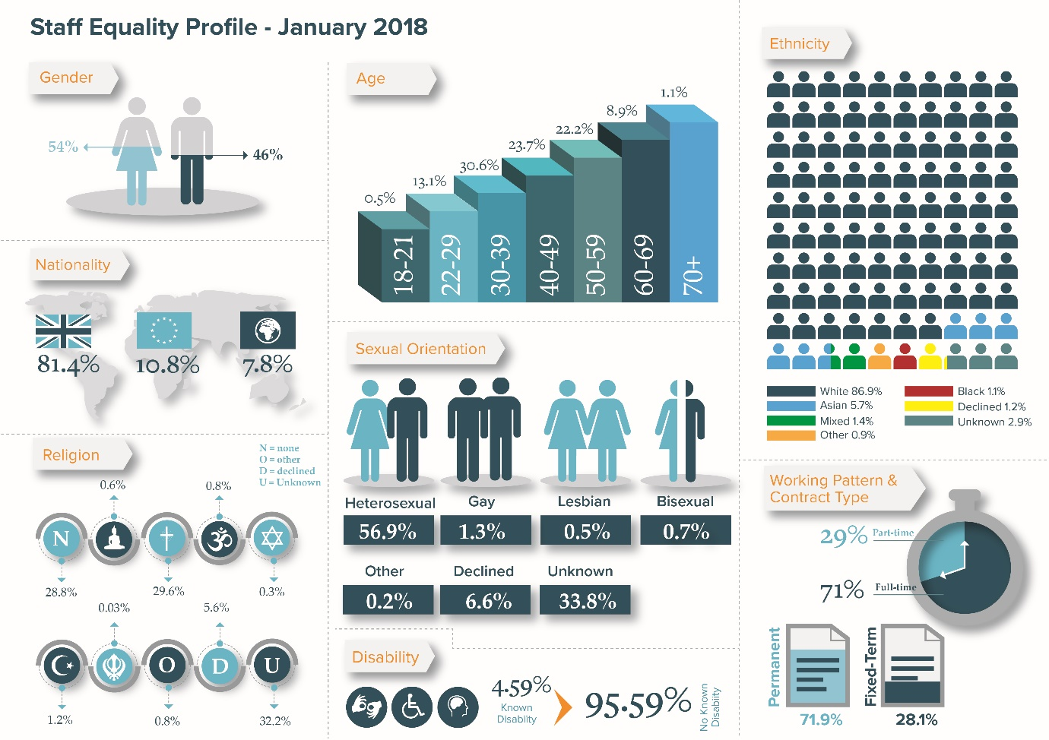

    - Age
35-44 | The age range with the highest proportion of staff at 27.7%, followed by 25-34 year olds on 25.1% (Explorer).
2.8% | The percentage of staff aged 66+ in January 2018, the same proportion as in January 2017 (Explorer).

    - Disability
4.7% | The percentage of staff (excluding atypical) who had disclosed a disability to the University in 2016/17, an increase from 3.4% in 2015/16 (HESA). This compared to 4% for the HE Sector, and 4% in the Russell Group (HESA).
Longstanding | The most common type of disability amongst staff at 33% (of staff who had disclosed a disability), followed by a Specific Learning Difficulty (SpLD) at 29.2%.

    - Race and Ethnicity
24.3% | The percentage of staff who identify as being Black, Asian or Minority Ethnic (including White Irish and White Other) in January 2018, a slight drop from 24.6% in January 2017 (Explorer).
9.5% | The percentage of staff who identify as “People of Colour” (Black, Asian, Mixed or Other ethnic group excluding white categories) in January 2018, this was a drop from 9.8% in January 2017 (Explorer).
1.2% | The percentage of Black staff in January 2018, this was a slight drop from 1.26% in January 2017 (Explorer).
8.8% | The percentage of Home/UK staff who identify as being Black, Asian or Minority Ethnic (including White Irish and White Other) in January 2018. This was a drop from 9.1% in January 2017 (Explorer).
5.9% | The percentage of Home/UK staff who identify as “People of Colour” (Black, Asian, Mixed or Other ethnic group excluding “white” categories) in January 2018. This was a drop from 6.1% in January 2017 (Explorer).
0.9% | The percentage of Home/UK Black staff in January 2018, this was a slight drop from 0.96% in January 2017 (Explorer).

    - Nationality
7.8% | The percentage of staff who are Overseas/International, an increase from 7.6% in January 2017 (Explorer).
10.7% | The percentage of staff who are from the European Union, an increase from 10.5% in January 2017 (Explorer).

    - Religious belief and non-belief
62% | The percentage of staff who have disclosed whether they have a religious belief or none in January 2018. This was an increase from 59.7% in January 2017 (Explorer).
46% | The percentage of staff who said that they have no religious belief in January 2018, an increase from 43.9% in January 2017 (Explorer).
    - Sex / Gender
54% | The percentage of female staff in January 2018, a slight increase from 53.9% in January 2017 (Explorer).
32.2% | The percentage of male Support Staff in January 2018, an increase from 31.1% in January 2017 (Explorer).
40.4% | The percentage of female Academic staff in January 2018, an increase from 39.5% in January 2017 (Explorer).
25% | The percentage of female professors in January 2018, an increase from 24% in January 2017 (Explorer)

    - Sexual Orientation
59.6% | The percentage of staff that had disclosed their sexual orientation in January 2018. An increase from 56.6% in January 2017 (Explorer).
4.6% | The percentage of staff who identified as lesbian, gay, bisexual or other (LGB+) in January 2018, an increase from 3.9% in January 2017 (Explorer).

New Policies and Services

Equality Framework Action Plan

    - The University Council approved the new Equality Framework Action Plan which sets out specific activity and objectives to implement the Equality Framework 2016-2026 on 7th February 2018. The action plan covers the 6 student and 6 staff strategic priority areas of the Framework:
Student Objectives
- Make significant and sustained improvements in the participation rates for the most disadvantaged and underrepresented groups, and in the diversity of the student population
- Improve student retention and progression rates for the most disadvantaged and underrepresented groups
- Improve degree attainment outcomes and reduce any unexplained degree gap differentials for different student groups
- Improve progression to postgraduate study for people from disadvantaged groups and narrow the gap between advantaged and disadvantaged groups
- Reduce inequalities in graduate level employment outcomes from different groups and narrow the gap in employment outcomes between advantaged and disadvantaged groups
- Foster good relations between different communities by providing opportunities to come together, learn and understand one another
Staff Objectives
- Make significant and sustained improvements in the recruitment (application and appointment) rates for the most underrepresented groups in the workforce
- Make sustained improvements in the retention and progression rates of underrepresented groups in the workforce
- Make sustained improvements in the diversity of the University’s Management and Governance boards by ensuring fair, transparent and equitable processes
- To be a sector leading employer of choice for underrepresented groups within the workforce
- To be a sector leading Family Friendly employer
- Embed the principles of diversity and equality leadership practices, and to improve the diversity of our people in leadership positions

    - The Equality Framework 2016-2026 and the Action Plan are available on the Diversity & Equality website. The activity outlined below relates to 2017-18 and was in train as the new action plan and objctives were being consulted and agreed. From 2019 new governance structures have been designed to focus on the objectives and related action and ensure progress is made. Further planned engagement with key bodies in the University including Senate will continue to inform activity.

The Academy Learning Zone

    - The Academy launched a new suite of online development modules for all members of staff, provided by Learning Heroes, called The Academy Learning Zone. It includes over 150 online development modules and resources ranging in length from 60 Second Skills to 40 minute modules.
    - Diversity and Equality modules included Harassment in the Workplace, Sexual Harassment Prevention in the Workplace, Tackling Hate Crime, and Unconscious Bias.
    - Mental Health and Wellbeing modules included Mental Health in Work, Introduction to Cognitive Behavioural Therapy, Managing Stress, and Developing Resilience. Further detail of engagement with the development in 2017-18 available can be seen in section 6.

University Muslim Adviser

    - In July 2017, the University appointed a Muslim Adviser to provide chaplaincy support and specialist advice and guidance. This is a shared post with Liverpool John Moores University building on our multi-faith chaplaincy provision through Faith Express.
    - Following a transition period, the management of the Muslim Prayer Room was transferred over to the Muslim Adviser from the Diversity and Equality team to provide direct support to Muslim staff and students.

Family Friendly Advisers

    - Building on the development of departmental maternity contacts, a pilot was completed in 2017/18 on the utility of Family Friendly Advisers. Following the completion of this pilot, 19 advisors have bene recruited across the University to provide an initial point of contact for staff with questions on maternity, paternity, adoption and shared parental leave and advice on managing this process.

Fertility Treatment Policy

    - A new policy statement was introduced outlining the entitlement of staff to paid time off for fertility treatment. It introduced the right for 5 days of paid leave per cycle (maximum of 3 cycles) for each female employees; up to 2 days of fertility treatment leave per cycle; and the right of partners who are not receiving treatment to attend two appointments per cycle akin to antenatal appointments. See webpage.

Staff Carers’ Network and the Carers’ Framework

    - A new carers’ network was established in 2017. The network provides an opportunity for carers to meet and socialise for peer support as well as an opportunity to feedback and inform the support the University provides for carers.
    - A new Carers’ Framework was launched bringing together a central resource for carers along with new guidance for managers and employees. See webpage.
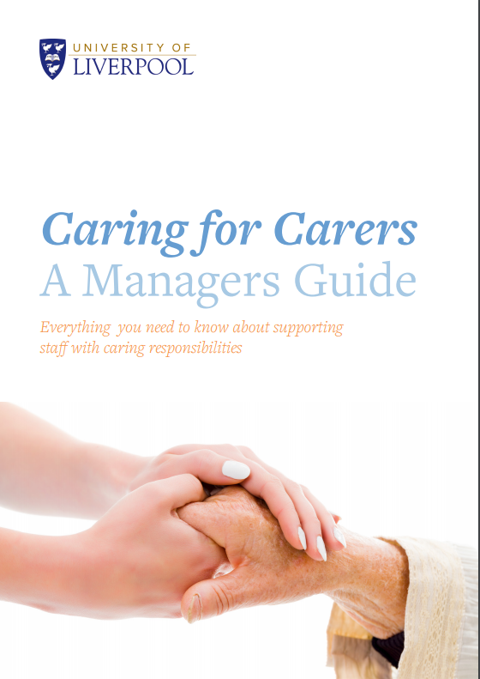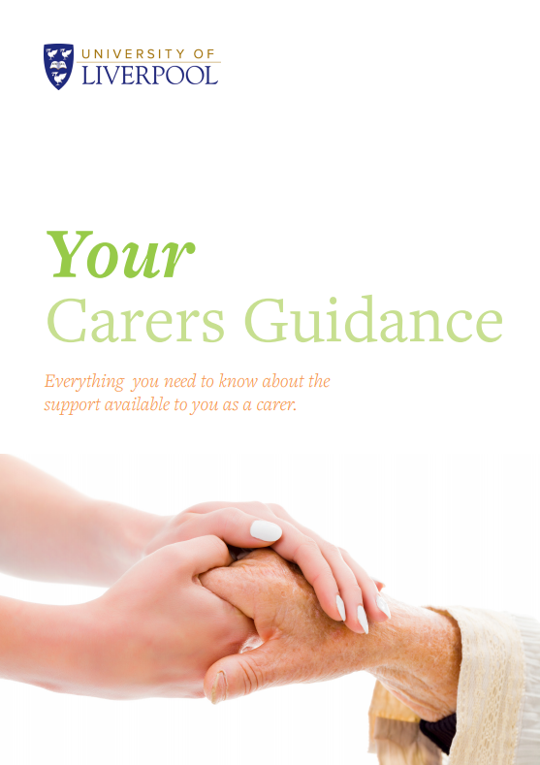

Sexual Misconduct Framework

    - In 2015 a Universities UK taskforce examined the issues of violence against women, harassment and hate crime affecting university students, with a focus on sexual violence and sexual harassment.
    - In response, the University has adopted a comprehensive framework to address sexual assault, harassment and hate crime against students. Specific actions have included:

- Significant amendments to the Policy on Student Conduct and Discipline,
- Guidance for staff on responding to disclosures of sexual assault, harassment and hate crimes, including an escalating response strategy,
- Advice and guidance for students who have been accused of sexual assault, harassment or hate crime,
- Rolling out Consent Training with key student leaders,
- Introduction of online Consent Matters training which is available to all students,
- Introduction of online Consent Matters, and Responding to Disclosures training for all members of staff.
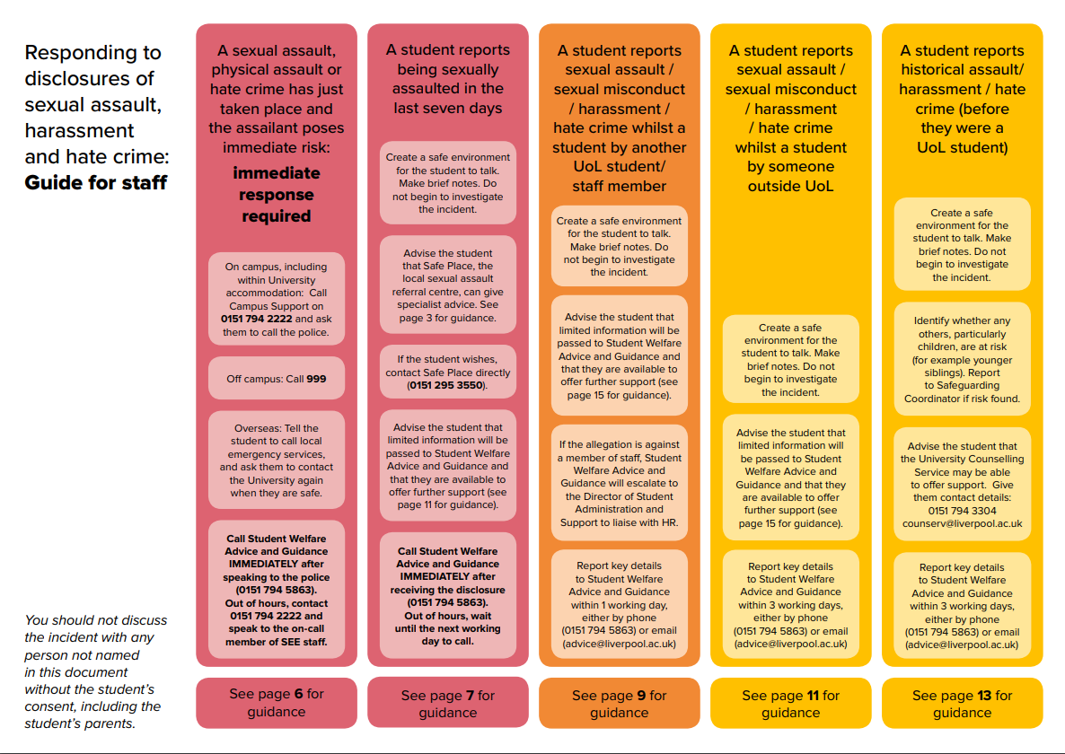
    - See Student Advice webpage, and Staff Hub webpage on the Student Welfare, Advice and Guidance website.
4.8 Project work: BAME students and graduate outcomes; Disabled Students’ satisfaction with Assessment & Feedback and Academic Support
4.8.1 Following on from the equality analysis of NSS results it was identified that further work needed to be carried out to understand the differential experience of BAME students in relation to graduate employment and further study, and experiences of disabled students in relation to their experience of academic support and advice. Education Committee received these reports and approved the proposed recommendations in June 2018.
4.9 Statutory Gender Pay Gap
4.9.1 In March 2017 the Government introduced The Equality Act 2010 (Specific Duties and Public Authorities) Regulations 2017 instructing the University to publish its Gender Pay Gap by the 31st March 2018. These regulations outlined what data should be published and the methodology of the calculation. Since this time, the University’s Council, Senate and SEG have received full reports on the Gender Pay Gap (and recently pay gaps relating to other Protected Characteristics). The pay gap was widely communicated and engagement promoted through web materials, roadshows, presentations and twitter. The full report on the Gender Pay Gap, its causes, and actions taking place to address it can be found in the “Report on the University of Liverpool’s Statutory Gender Pay Gap 2017”.

Athena SWAN

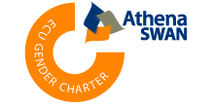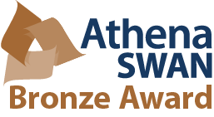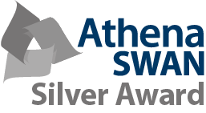
  - In 2016/17 the University was successfully awarded an Institutional Silver award in the November 2016 Athena SWAN application round. In addition during 2016/17 the following departmental awards were successful:
Table 1
Bronze | - Institute of Clinical Sciences (Renewal)  - Institute of Life & Human Sciences (Renewal)  - Institute of Veterinary Sciences (Renewal)  - School of Engineering (Renewal)
Silver | - Institute of Ageing & Chronic Disease (Renewal)  - Institute of Translational Medicine  - School of Physical Sciences
Gold | - Institute of Integrative Biology

    - The Institute of Learning & Teaching was reformed in 2016/17 into the Institutes of Clinical Sciences, Life & Human Sciences, and Veterinary Sciences. These three institutes were required to submit a Departmental Restructuring Interim award application in order to continue to hold the Bronze award. All were successful.

  - In the 2017/18 academic year, the following departmental awards were successful:
Table 2
Bronze | - School of Histories, Languages and Cultures  - School of Law and Social Justice
Silver | - Institute of Psychology, Health and Society (Renewal)

  - The School of Electrical Engineering, Electronics and Computer Sciences applied for a Silver Award. Unfortunately this application was unsuccessful and the school has been given a 1 year extension period to reapply.
  - The full list of current awards is outlined in Table 4:
Table 3
School / Institute | Level of Award
Institute of Ageing and Chronic Disease | Silver (R) | April 2017
Institute of Clinical Sciences | Bronze (R) | October 2017
Institute of Infection and Global Health | Silver | April 2016
Institute of Integrative Biology | Gold | April 2017
Institute of Life & Human Sciences | Bronze (R) | October 2017
Institute of Psychology, Health & Society | Silver | April 2018
Institute of Translational Medicine | Silver (R) | November 2017
Institute of Veterinary Sciences | Bronze (R) | October 2017
School of the Arts | - | -
School of Histories, Languages & Cultures | Bronze | April 2018
School of Law & Social Justice | Bronze | April 2018
Management School | -
School of Electrical Engineering, Electronics and Computer Science | Bronze | November 2014
School of Engineering | Bronze (R) | April 2017
School of Environmental Science | Bronze | November 2015
School of Physical Sciences | Silver | November 2016

  - Key gender equality achievements in 2017-2018 included:

- A new Parents’ Network and a Carers’ Network were launched to provide a space where staff can share experiences, network, and raise issues with HR,
- In November 2017, Sports Liverpool ran a week of free activities to support the national ‘This Girl Can’ campaign to get more girls and women interested in sport,
- There was an increase in the number of female academic promotions; from 37 in 2016 to 41 in 2017 (inclusive of Senior Lecturer, Reader and Chair promotions),
- University computer scientists, Dr Floriana Grasso and Dr Louise Dennis chaired the UK’s longest running Artificial Intelligence convention in March 2018,
- Trialled x1 member of staff on the Leadership Foundations “Leadership Matters” programme, designed for women in senior academic and professional service roles such as professors, heads of department, deputy directors and directors (grade 9 and above),
- In March 2018 the University published its Statutory Gender Pay Gap Report.
- U.S. District Judge and alumna Wendy Beetlestone delivered the University’s Annual Law School and Alumni Association Lecture in March 2018.
- In June 2018 the University launched a new Carers Framework which included new staff and manager’s guidance. The guidance included information for employees, providing signposting to useful policies, advice on work life balance, supporting networks and facilities for carers on campus.
- To mark the seventieth anniversary of the NHS, Professor Sally Sheard was commissioned to write and present the twenty part BBC Radio 4 series, National Health Stories.

  - The full progress against the Athena SWAN Action Plan is reported separately via the Athena SWAN Steering Group.
Website: https://www.liv.ac.uk/intranet/hr/diversity-equality/gender/athenaswan/

Training and Development

  - Over the course of 2017-18, a full review of training related to Diversity and Equality was completed. This included consideration of development activity designed to increase the skills and knowledge of staff and development aimed at staff with specific protected characteristics. A number of new training and development resources were made available to staff in 2017-2018. These additional resources complimented the existing programmes delivered by Human Resources, The Academy, and Student Services. External programmes were also supported through a competitive application processes.
  - Below is a detailed report on engagement with training and development resources available to staff in 2017/2018. A date in brackets means that the session was delivered before this date but the records are not in CORE/available at the time of the report being written. Please note, not all face-face sessions may have been captured.

Human Resources

Via Obligatory Training and Role Related Training (Online)
Table 4
Title | Attendance/  Completed in 2017/18 | Commentary
Introduction to Diversity & Equality  (Online, Obligatory) | 2613 | Target: 95% (Equality Action Plan)  Completed to date: 5340 (current staff) or 83.1% / 88% (Excluding Zero Hour)
NEW Understanding Modern Slavery  (Online, Role Related) | 73 | Target: All budget holders  Completed to date: 73
A Brief Guide to the Prevent Duty at the University of Liverpool  (Online, Role Related) | 103 | Target: Staff who have contact with students  Completed to date: 119
The Prevent Duty in Higher Education: An Introduction (Online, Role Related) | 31 | Target: Staff who have contact with students  Completed to date: 31  NB: an additional 238 people received face-to-face training in this area in 2017-2018

Via the Diversity & Equality Team
Table 5
Title | Attendance/  Completed in 2017/18 | Commentary
Equality Impact Assessment Training | 25 | Target: Key Staff/Policy Developers (Equality Action Plan)  Completed to date: 164  Including x10 School Director of Operations; x5 Deans; x2 Professional Services Directors
Unconscious Bias Training | 80 | Target: 200 Staff by December 2018 (Equality Action Plan)  Target: All Level 1, 2 and 3 heads by 2019  Complete to date: 353  Including x13 School Director of Operations; x3 Deans; x2 Professional Services Directors

Via The Academy – Organisational Development
Table 6
Title | Attendance/  Completed in 2017/18 | Commentary
Springboard Development Programme for Women | 26  (registered on programme) | Target: 150 women (Equal Pay Action Plan)  Completed to date: 65
Aurora Leadership Programme for Women (External) | 13  (registered on programme) | Target: 150 women (Equal Pay Action Plan)  Completed to date: 85
StellarHE BAME Leadership Programme (External) | No applications | There is no target for this programme. The University offers x1 place per year.  Completed to date: 3
Stonewall Leadership Programme (LGBT) (External) | 2 | There is no target for this programme. The University centrally offers x1 place per year.  Completed to date: 5
Planning for Retirement | 56 | There is no target for this programme, it is open to anyone to attend if relevant to their role/career.  Completed to date: 397 (since 2010/11)
Having Difficult Conversations | 32 | There is no target for this programme, it is open to anyone to attend if relevant to their role/career.  Completed to date: 234 (since 2010/11)

Via The Academy – Academic Development
Table 7
Title | Attendance/  Completed in 2017/18 | Commentary
Inclusion and Diversity in HE | 90 | This course forms part of the PGCert and CPD programme for academics.  Completed to date: 230 (since 2015/16)
Introduction to Chinese Academic Culture | 20 | This is an optional course aimed at academic staff.  Completed to date: 30 (since 2016/17)

Via the Academy - The Academy Learning Zone Online Modules
Table 8
Title | Attendance/  Completed in 2017/18 | Commentary
NEW Harassment and Bullying in the Workplace | 18 | There is no target for this programme. All staff can complete online.  Completed to date: 18
NEW Sexual Harassment Prevention in the Workplace | 0 | There is no target for this programme. All staff can complete online.  Completed to date: 0
NEW Tackling Hate Crime | 0 | There is no target for this programme. All staff can complete online.  Completed to date: 0
NEW Unconscious Bias | 23 | There is no target for this programme. All staff can complete online. Departments may use this as an introductory session to the face to face Unconscious Bias training.  Completed to date: 23
NEW Mental Health at Work | 0 | There is no target for this programme. All staff can complete online.  Completed to date: 0
NEW Whistleblowing | 3 | There is no target for this programme. All staff can complete online.  Completed to date: 3
NEW Managing Stress | 8 | There is no target for this programme. All staff can complete online.  Completed to date: 8
NEW Conflict Management | 10 | There is no target for this programme. All staff can complete online.  Completed to date: 10
    - Other NEW short (1-5 minutes) resources are available on: Introduction to Cognitive Behavioural Therapy (CBT), CBT & Mental Health: Anxiety & Panic Attacks, CBT & Mental Health: Borderline Personality Disorder, Bipolar Disorder, Developing Resilience, Health & Wellbeing: Letting things go, Health & Wellbeing: Work/Life Balance, Health & Wellbeing: Relaxation Techniques, and Management & Leadership: Inclusive Leadership.

Student Administration & Support

Table 9
Title | Attendance/  Completed in 2017/18 | Commentary
Mental Health First Aid (Half Day and 2 Day) | 68 | Target: Staff who have contact with students  Completed to date: 256
NEW Initial Disclosure Training (Sexual Assault) | 118 | Target: Staff who have contact with students  Completed to date: 118
Workshop Raising Awareness of Prevent (WRAP) | 122 | Target: Staff who have contact with students  Completed to date: 356

Via SilverCloud Health (Online)
Table 10
Title | Attendance/  Completed in 2017/18 | Commentary
NEW Space from Anxiety | Unknown External Provider | There is no target for this programme. All staff can complete online.
NEW Space from Depression | Unknown  External Provider | There is no target for this programme. All staff can complete online.
NEW Space from Stress | Unknown  External Provider | There is no target for this programme. All staff can complete online.
NEW Space for Positive Body Image | Unknown  External Provider | There is no target for this programme. All staff can complete online.

    - The University of Liverpool has partnered with SilverCloud Health to offer a suite of free online self-help modules for any student or member of staff. Programme content is based on Cognitive Behavioural Therapy (CBT).

Looking forward 2018-2019: Key Activity

  - Building on the progress of 2017-2018 and within the new structure of the Equality Framework and associated objectives, the University will continue to develop its approach to diversity and equality. The key areas of activity are:
Equality Action Plan implementation
  - Work will continue to implement the Equality Action Plan which sets out a wide range of activities and targets to achieve and will be monitored through the revised governance structure, led by the SMT lead for Equality.
Athena SWAN
  - Preparation work will begin on the University’s Gold Application with the aim to submit for the 2019/20 assessment round. Work will continue in the Faculty of Humanities and Social Sciences to achieve Athena SWAN awards for all schools; and a number of schools/institute are due for renewal including “going for Gold”. Advance HE are currently reviewing Athena SWAN. This review is being led by Dame Julia Buckingham who will be hosting a consultation event at the University in January 2019. It is relevant to note that following this review, a review of the Race Equality Chartermark is due. The University will also engage in this review.
Trans Policy Review
  - The University’s guidance and policy on supporting Trans and Gender Non-Binary staff and students will be reviewed and updated to bring it into line with current sector best practice.
Pay Gap Action Plan
7.5 Through consultation with the Trade Unions, specific actions to understand further and address causes of the pay gaps identified have been agreed. Work will continue to progress these important actions and build on the engagement with stakeholder groups to assist the University in taking this forward.
Accessibility
7.6 The University is committed to improving the experiences of disabled staff and students both in relation to improvements in the process of identifying and implementing reasonable adjustments but also through the design of the accessibility of our environment. Work is currently taking place to identify a vision for accessibility improved processes and consultation forums, and long term plan to address inaccessibility.
Research Excellence Framework
7.7 Work is currently taking place to identify where and how equality considerations and improvement to practice can be integrated into all aspects of the University’s approach to REF. This includes impact assessment, data analysis, training and development, process review and communication plans.

