Example Learning Outcomes Aligned with the UN’s Sustainable Development Goals
Author: Nick Bunyan

Introduction
The following example learning outcomes have been extracted from:
Education for Sustainable Development Goals Learning Objectives, UNESCO (2017)

Key
The cognitive domain comprises knowledge and thinking skills necessary to better understand the SDG and the challenges in achieving it.
The socio-emotional domain includes social skills that enable learners to collaborate, negotiate and communicate to promote the SDGs as well as self-reflection skills, values, attitudes and motivations that enable learners to develop themselves.
The behavioural domain describes action competencies.

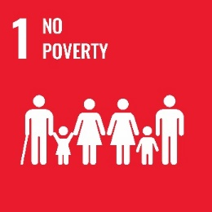

SDG 1 No Poverty
End poverty in all its forms everywhere.

Cognitive learning outcomes
- The learner understands the concepts of extreme and relative poverty and is able to critically reflect on their underlying cultural and normative assumptions and practices.
- The learner knows about the local, national and global distribution of extreme poverty and extreme wealth.
- The learner knows about causes and impacts of poverty such as unequal distribution of resources and power, colonization, conflicts, disasters caused by natural hazards and other climate change-induced impacts, environmental degradation and technological disasters, and the lack of social protection systems and measures.
- The learner understands how extremes of poverty and extremes of wealth affect basic human rights and needs.
- The learner knows about poverty reduction strategies and measures and is able to distinguish between deficit-based and strength-based approaches to addressing poverty.

Socio-emotional learning outcomes
- The learner is able to collaborate with others to empower individuals and communities to affect change in the distribution of power and resources in the community and beyond.
- The learner is able to raise awareness about extremes of poverty and wealth and encourage dialogue about solutions.
- The learner is able to show sensitivity to the issues of poverty as well as empathy and solidarity with poor people and those in vulnerable situations.
- The learner is able to identify their personal experiences and biases with respect to poverty.
- The learner is able to reflect critically on their own role in maintaining global structures of inequality.

Behavioural learning outcomes
- The learner is able to plan, implement, evaluate and replicate activities that contribute to poverty reduction.
- The learner is able to publicly demand and support the development and integration of policies that promote social and economic justice, risk reduction strategies and poverty eradication actions.
- The learner is able to evaluate, participate in and influence decision-making related to management strategies of local, national and international enterprises concerning poverty generation and eradication.
- The learner is able to include poverty reduction, social justice and anti-corruption considerations in their consumption activities.
- The learner is able to propose solutions to address systemic problems related to poverty.

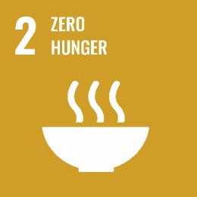

SDG 2 Zero Hunger
End hunger, achieve food security and improved nutrition and promote sustainable agriculture.

Cognitive learning outcomes
- The learner knows about hunger and malnutrition and their main physical and psychological effects on human life, and about specific vulnerable groups.
- The learner knows about the amount and distribution of hunger and malnutrition locally, nationally and globally, currently as well as historically.
- The learner knows the main drivers and root causes for hunger at the individual, local, national and global level.
- The learner knows principles of sustainable agriculture and understands the need for legal rights to have land and property as necessary conditions to promote it.
- The learner understands the need for sustainable agriculture to combat hunger and malnutrition worldwide and knows about other strategies to combat hunger, malnutrition and poor diets.

Socio-emotional learning objectives
- The learner is able to communicate on the issues and connections between combating hunger and promoting sustainable agriculture and improved nutrition.
- The learner is able to collaborate with others to encourage and to empower them to combat hunger and to promote sustainable agriculture and improved nutrition.
- The learner is able to create a vision for a world without hunger and malnutrition.
- The learner is able to reflect on their own values and deal with diverging values, attitudes and strategies in relation to combating hunger and malnutrition and promoting sustainable agriculture.
- The learner is able to feel empathy, responsibility and solidarity for and with people suffering from hunger and malnutrition.

Behavioural learning objectives
- The learner is able to evaluate and implement actions personally and locally to combat hunger and to promote sustainable agriculture.
- The learner is able to evaluate, participate in and influence decision-making related to public policies concerning the combat against hunger and malnutrition and the promotion of sustainable agriculture.
- The learner is able to evaluate, participate in and influence decision-making related to management strategies of local, national and international enterprises concerning the combat against hunger and malnutrition and the promotion of sustainable agriculture.
- The learner is able to take on critically their role as an active global citizen in the challenge of combating hunger.
- The learner is able to change their production and consumption practices in order to contribute to the combat against hunger and the promotion of sustainable agriculture.

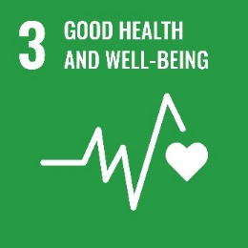

SDG 3 Good Health and Well-being
Ensure healthy lives and promote well-being for all at all ages.

Cognitive learning outcomes
- The learner knows conceptions of health, hygiene and well-being and can critically reflect on them, including an understanding of the importance of gender in health and well-being.
- The learner knows facts and figures about the most severe communicable and noncommunicable diseases, and the most vulnerable groups and regions concerning illness, disease and premature death.
- The learner understands the socio-political-economic dimensions of health and wellbeing and knows about the effects of advertising and about strategies to promote health and well-being.
- The learner understands the importance of mental health. The learner understands the negative impacts of behaviours like xenophobia, discrimination and bullying on mental health and emotional well-being and how addictions to alcohol, tobacco or other drugs cause harm to health and well-being.
- The learner knows relevant prevention strategies to foster positive physical and mental health and well-being, including sexual and reproductive health and information as well as early warning and risk reduction.

Socio-emotional learning outcomes
- The learner is able to interact with people suffering from illnesses, and feel empathy for their situation and feelings.
- The learner is able to communicate about issues of health, including sexual and reproductive health, and well-being, especially to argue in favour of prevention strategies to promote health and well-being.
- The learner is able to encourage others to decide and act in favour of promoting health and well-being for all.
- The learner is able to create a holistic understanding of a life of health and well-being, and to clarify related values, beliefs and attitudes.
- The learner is able to develop a personal commitment to promoting health and well-being for themselves, their family and others, including considering volunteer or professional work in health and social care.

Behavioural learning outcomes
- The learner is able to include health promoting behaviours in their daily routines.
- The learner is able to plan, implement, evaluate and replicate strategies that promote health, including sexual and reproductive health, and well-being for themselves, their families and others.
- The learner has the capacity to perceive when others need help and to seek help for themselves and others.
- The learner is able to publicly demand and support the development of policies promoting health and well-being.
- The learner is able to propose ways to address possible conflicts between the public interest in offering medicine at affordable prices and private interests within the pharmaceutical industry.

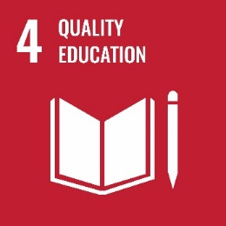

SDG 4 Quality Education
Ensure inclusive and equitable quality education and promote lifelong learning opportunities for all.

Cognitive learning outcomes
- The learner understands the important role of education and lifelong learning opportunities for all (formal, non-formal and informal learning) as main drivers of sustainable development, for improving people’s lives and in achieving the SDGs.
- The learner understands education as a public good, a global common good, a fundamental human right and a basis for guaranteeing the realization of other rights.
- The learner knows about inequality in access to and attainment of education, particularly between girls and boys and in rural areas, and about reasons for a lack of equitable access to quality education and lifelong learning opportunities.
- The learner understands the important role of culture in achieving sustainability.
- The learner understands that education can help create a more sustainable, equitable and peaceful world.

Socio-emotional learning outcomes
- The learner is able to raise awareness of the importance of quality education for all, a humanistic and holistic approach to education, ESD and related approaches.
- The learner is able through participatory methods to motivate and empower others to demand and use educational opportunities.
- The learner is able to recognize the intrinsic value of education and to analyse and identify their own learning needs in their personal development.
- The learner is able to recognize the importance of their own skills for improving their life, in particular for employment and entrepreneurship.
- The learner is able to engage personally with ESD.

Behavioural learning outcomes
- The learner is able to contribute to facilitating and implementing quality education for all, ESD and related approaches at different levels.
- The learner is able to promote gender equality in education.
- The learner is able to publicly demand and support the development of policies promoting free, equitable and quality education for all, ESD and related approaches as well as aiming at safe, accessible and inclusive educational facilities.
- The learner is able to promote the empowerment of young people.
- The learner is able to use all opportunities for their own education throughout their life, and to apply the acquired knowledge in everyday situations to promote sustainable development.

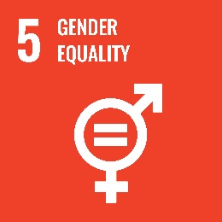

SDG 5 Gender Equality
Achieve gender equality and empower all women and girls.

Cognitive learning outcomes
- The learner understands the concept of gender, gender equality and gender discrimination and knows about all forms of gender discrimination, violence and inequality (e.g. harmful practices such as female genital mutilation, honour killings and child marriage, unequal employment opportunities and pay, language construction, traditional gender roles, gendered impact of natural hazards) and understands the current and historical causes of gender inequality.
- The learner understands the basic rights of women and girls, including their right to freedom from exploitation and violence and their reproductive rights.
- The learner understands levels of gender equality within their own country and culture in comparison to global norms (while respecting cultural sensitivity), including the intersectionality of gender with other social categories such as ability, religion and race.
- The learner knows the opportunities and benefits provided by full gender equality and participation in legislation and governance, including public budget allocation, the labour market and public and private decision-making.
- The learner understands the role of education, enabling technology and legislation in empowering and ensuring the full participation of all genders.

Socio-emotional learning outcomes
- The learner is able to recognize and question traditional perception of gender roles in a critical approach, while respecting cultural sensitivity.
- The learner is able to identify and speak up against all forms of gender discrimination and debate the benefits of full empowerment of all genders.
- The learner is able to connect with others who work to end gender discrimination and violence, empower those who may still be disempowered and promote respect and full equality on all levels.
- The learner is able to reflect on their own gender identity and gender roles.
- The learner is able to feel empathy and solidarity with those who differ from personal or community gender expectations and roles.

Behavioural learning outcomes
- The learner is able to take the measure of their surroundings to empower themselves or others who are discriminated against because of their gender.
- The learner is able to evaluate, participate in and influence decision-making about gender equality and participation.
- The learner is able to support others in developing empathy across genders and breaking down gender discrimination and violence.
- The learner is able to observe and identify gender discrimination.
- The learner is able to plan, implement, support and evaluate strategies for gender equality.

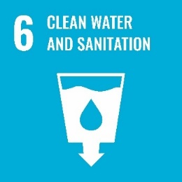

SDG 6 Clean Water and Sanitation
Ensure availability and sustainable management of water and sanitation for all.

Cognitive learning outcomes
- The learner understands water as a fundamental condition of life itself, the importance of water quality and quantity, and the causes, effects and consequences of water pollution and water scarcity.
- The learner understands that water is part of many different complex global interrelationships and systems.
- The learner knows about the global unequal distribution of access to safe drinking water and sanitation facilities.
- The learner understands the concept of “virtual water”.
- The learner understands the concept of Integrated Water Resources Management (IWRM) and other strategies for ensuring the availability and sustainable management of water and sanitation, including flood and drought risk management.

Socio-emotional learning objectives
- The learner is able to participate in activities of improving water and sanitation management in local communities.
- The learner is able to communicate about water pollution, water access and water saving measures and to create visibility about success stories.
- The learner is able to feel responsible for their water use.
- The learner is able to see the value in good sanitation and hygiene standards.
- The learner is able to question socio-economic differences as well as gender disparities in the access to safe drinking water and sanitation facilities.

Behavioural learning outcomes
- The learner is able to cooperate with local authorities in the improvement of local capacity for self-sufficiency.
- The learner is able to contribute to water resources management at the local level.
- The learner is able to reduce their individual water footprint and to save water practicing their daily habits.
- The learner is able to plan, implement, evaluate and replicate activities that contribute to increasing water quality and safety.
- The learner is able to evaluate, participate in and influence decision-making on management strategies of local, national and international enterprises related to water pollution.

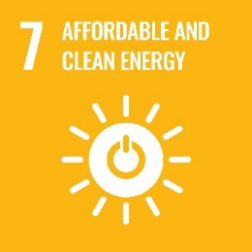

SDG 7 Affordable and Clean Energy
Ensure access to affordable, reliable, sustainable and clean energy for all.

Cognitive learning outcomes
- The learner knows about different energy resources – renewable and non-renewable – and their respective advantages and disadvantages including environmental impacts, health issues, usage, safety and energy security, and their share in the energy mix at the local, national and global level.
- The learner knows what energy is primarily used for in different regions of the world.
- The learner understands the concept of energy efficiency and sufficiency and knows socio-technical strategies and policies to achieve efficiency and sufficiency.
- The learner understands how policies can influence the development of energy production, supply, demand and usage.
- The learner knows about harmful impacts of unsustainable energy production, understands how renewable energy technologies can help to drive sustainable development and understands the need for new and innovative technologies and especially technology transfer in collaborations between countries.

Socio-emotional learning outcomes
- The learner is able to communicate the need for energy efficiency and sufficiency.
- The learner is able to assess and understand the need for affordable, reliable, sustainable and clean energy of other people/other countries or regions.
- The learner is able to cooperate and collaborate with others to transfer and adapt energy technologies to different contexts and to share energy best practices of their communities.
- The learner is able to clarify personal norms and values related to energy production and usage as well as to reflect and evaluate their own energy usage in terms of efficiency and sufficiency.
- The learner is able to develop a vision of a reliable, sustainable energy production, supply and usage in their country.

Behavioural learning outcomes
- The learner is able to apply and evaluate measures in order to increase energy efficiency and sufficiency in their personal sphere and to increase the share of renewable energy in their local energy mix.
- The learner is able to apply basic principles to determine the most appropriate renewable energy strategy in a given situation.
- The learner is able to analyse the impact and long-term effects of big energy projects (e.g. constructing an off-shore wind park) and energy related policies on different stakeholder groups (including nature).
- The learner is able to influence public policies related to energy production, supply and usage.
- The learner is able to compare and assess different business models and their suitability for different energy solutions and to influence energy suppliers to produce safe, reliable and sustainable energy.

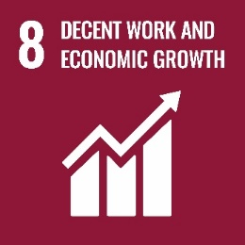

SDG 8 Decent Work and Economic Growth
Promote sustained, inclusive and sustainable economic growth, full and productive employment and decent work for all.

Cognitive learning outcomes
- The learner understands the concepts of sustained, inclusive and sustainable economic growth, full and productive employment, and decent work, including the advancement of gender parity and equality, and knows about alternative economic models and indicators.
- The learner has knowledge about the distribution of formal employment rates per sector, informal employment, and unemployment in different world regions or nations, and which social groups are especially affected by unemployment.
- The learner understands the relation between employment and economic growth, and knows about other moderating factors like a growing labour force or new technologies that substitute jobs.
- The learner understands how low and decreasing wages for the labour force and very high wages and profits of managers and owners or shareholders are leading to inequalities, poverty, civil unrest, etc.
- The learner understands how innovation, entrepreneurship and new job creation can contribute to decent work and a sustainability-driven economy and to the decoupling of economic growth from the impacts of natural hazards and environmental degradation.

Socio-emotional learning outcomes
- The learner is able to discuss economic models and future visions of economy and society critically and to communicate them in public spheres.
- The learner is able to collaborate with others to demand fair wages, equal pay for equal work and labour rights from politicians and from their employer.
- The learner is able to understand how one’s own consumption affects working conditions of others in the global economy.
- The learner is able to identify their individual rights and clarify their needs and values related to work.
- The learner is able to develop a vision and plans for their own economic life based on an analysis of their competencies and contexts.

Behavioural learning outcomes
- The learner is able to engage with new visions and models of a sustainable, inclusive economy and decent work.
- The learner is able to facilitate improvements related to unfair wages, unequal pay for equal work and bad working conditions.
- The learner is able to develop and evaluate ideas for sustainability-driven innovation and entrepreneurship.
- The learner is able to plan and implement entrepreneurial projects.
- The learner is able to develop criteria and make responsible consumption choices as a means to support fair working conditions and efforts to decouple production from the impact of natural hazards and environmental degradation.

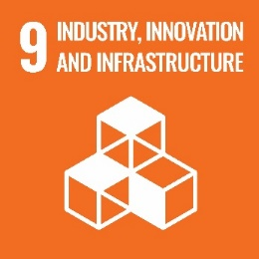

SDG 9 Industry, Innovation, and Infrastructure
Build infrastructure, promote inclusive and sustainable industrialization and foster innovation.

Cognitive learning outcomes
- The learner understands the concepts of sustainable infrastructure and industrialization and society’s needs for a systemic approach to their development.
- The learner understands the local, national and global challenges and conflicts in achieving sustainability in infrastructure and industrialization.
- The learner can define the term resilience in the context of infrastructure and spatial planning, understanding key concepts such as modularity and diversity, and apply it to their local community and nationwide.
- The learner knows the pitfalls of unsustainable industrialization and in contrast knows examples of resilient, inclusive, sustainable industrial development and the need for contingency planning.
- The learner is aware of new opportunities and markets for sustainability innovation, resilient infrastructure and industrial development.

Socio-emotional learning outcomes
- The learner is able to argue for sustainable, resilient and inclusive infrastructure in their local area.
- The learner is able to encourage their communities to shift their infrastructure and industrial development toward more resilient and sustainable forms.
- The learner is able to find collaborators to develop sustainable and contextual industries that respond to our shifting challenges and also to reach new markets.
- The learner is able to recognize and reflect on their own personal demands on the local infrastructure such as their carbon and water footprints and food miles.
- The learner is able to understand that with changing resource availability (e. g. peak oil, peak everything) and other external shocks and stresses (e. g. natural hazards, conflicts) their own perspective and demands on infrastructure may need to shift radically regarding availability of renewable energy for ICT, transport options, sanitation options, etc.

Behavioural learning outcomes
- The learner is able to identify opportunities in their own culture and nation for greener and more resilient approaches to infrastructure, understanding their overall benefits for societies, especially with regard to disaster risk reduction.
- The learner is able to evaluate various forms of industrialization and compare their resilience.
- The learner is able to innovate and develop sustainable enterprises to respond to their countries’ industrial needs.
- The learner is able to access financial services such as loans or microfinance to support their own enterprises.
- The learner is able to work with decision-makers to improve the uptake of sustainable infrastructure (including internet access).

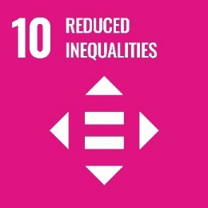

SDG 10 Reduced Inequalities
Reduce inequality within and among countries.

Cognitive learning outcomes
- The learner knows different dimensions of inequality, their interrelations and applicable statistics.
- The learner knows indicators that measure and describe inequalities and understands their relevance for decision-making.
- The learner understands that inequality is a major driver for societal problems and individual dissatisfaction.
- The learner understands local, national and global processes that both promote and hinder equality (fiscal, wage, and social protection policies, corporate activities, etc. ).
- The learner understands ethical principles concerning equality and is aware of psychological processes that foster discriminative behaviour and decision making.

Socio-emotional learning outcomes
- The learner is able to raise awareness about inequalities.
- The learner is able to feel empathy for and to show solidarity with people who are discriminated against.
- The learner is able to negotiate the rights of different groups based on shared values and ethical principles.
- The learner becomes aware of inequalities in their surroundings as well as in the wider world and is able to recognize the problematic consequences.
- The learner is able to maintain a vision of a just and equal world.

Behavioural learning outcomes
- The learner is able to evaluate inequalities in their local environment in terms of quality (different dimensions, qualitative impact on individuals) and quantity (indicators, quantitative impact on individuals).
- The learner is able to identify or develop an objective indicator to compare different groups, nations, etc. with respect to inequalities.
- The learner is able to identify and analyse different types of causes and reasons for inequalities.
- The learner is able to plan, implement and evaluate strategies to reduce inequalities.
- The learner is able to engage in the development of public policies and corporate activities that reduce inequalities.

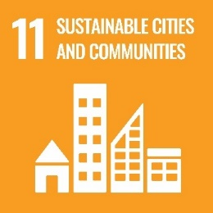

SDG 11 Sustainable Cities and Communities
Make cities and human settlements inclusive, safe, resilient and sustainable.

Cognitive learning outcomes
- The learner understands basic physical, social and psychological human needs and is able to identify how these needs are currently addressed in their own physical urban, peri-urban and rural settlements.
- The learner is able to evaluate and compare the sustainability of their and other settlements’ systems in meeting their needs particularly in the areas of food, energy, transport, water, safety, waste treatment, inclusion and accessibility, education, integration of green spaces and disaster risk reduction.
- The learner understands the historical reasons for settlement patterns and while respecting cultural heritage, understands the need to find compromises to develop improved sustainable systems.
- The learner knows the basic principles of sustainable planning and building, and can identify opportunities for making their own area more sustainable and inclusive.
- The learner understands the role of local decision-makers and participatory governance and the importance of representing a sustainable voice in planning and policy for their area.

Socio-emotional learning outcomes
- The learner is able to use their voice, to identify and use entry points for the public in the local planning systems, to call for the investment in sustainable infrastructure, buildings and parks in their area and to debate the merits of long-term planning.
- The learner is able to connect with and help community groups locally and online in developing a sustainable future vision of their community.
- The learner is able to reflect on their region in the development of their own identity, understanding the roles that the natural, social and technical environments have had in building their identity and culture.
- The learner is able to contextualize their needs within the needs of the greater surrounding ecosystems, both locally and globally, for more sustainable human settlements.
- The learner is able to feel responsible for the environmental and social impacts of their own individual lifestyle.

Behavioural learning outcomes
- The learner is able to plan, implement and evaluate community-based sustainability projects.
- The learner is able to participate in and influence decision processes about their community.
- The learner is able to speak against/for and to organize their voice against/for decisions made for their community.
- The learner is able to co-create an inclusive, safe, resilient and sustainable community.
- The learner is able to promote low carbon approaches at the local level.

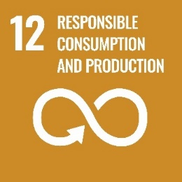

SDG 12: Responsible Consumption and Production
Ensure sustainable consumption and production patterns.

Cognitive learning outcomes
- The learner understands how individual lifestyle choices influence social, economic and environmental development.
- The learner understands production and consumption patterns and value chains and the interrelatedness of production and consumption (supply and demand, toxics, CO2 emissions, waste generation, health, working conditions, poverty, etc.).
- The learner knows roles, rights and duties of different actors in production and consumption (media and advertising, enterprises, municipalities, legislation, consumers, etc.).
- The learner knows about strategies and practices of sustainable production and consumption.
- The learner understands dilemmas/trade-offs related to and system changes necessary for achieving sustainable consumption and production.

Socio-emotional learning outcomes
- The learner is able to communicate the need for sustainable practices in production and consumption.
- The learner is able to encourage others to engage in sustainable practices in consumption and production.
- The learner is able to differentiate between needs and wants and to reflect on their own individual consumer behaviour in light of the needs of the natural world, other people, cultures and countries, and future generations.
- The learner is able to envision sustainable lifestyles.
- The learner is able to feel responsible for the environmental and social impacts of their own individual behaviour as a producer or consumer.

Behavioural learning outcomes
- The learner is able to plan, implement and evaluate consumption-related activities using existing sustainability criteria.
- The learner is able to evaluate, participate in and influence decision-making processes about acquisitions in the public sector.
- The learner is able to promote sustainable production patterns.
- The learner is able take on critically on their role as an active stakeholder in the market.
- The learner is able to challenge cultural and societal orientations in consumption and production.

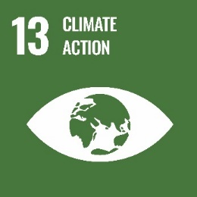

SDG 13: Climate Action
Take urgent action to combat climate change and its impacts.

Cognitive learning outcomes
- The learner understands the greenhouse effect as a natural phenomenon caused by an insulating layer of greenhouse gases.
- The learner understands the current climate change as an anthropogenic phenomenon resulting from increased greenhouse gas emissions.
- The learner knows which human activities – on a global, national, local and individual level – contribute most to climate change.
- The learner knows about the main ecological, social, cultural and economic consequences of climate change locally, nationally and globally and understands how these can themselves become catalysing, reinforcing factors for climate change.
- The learner knows about prevention, mitigation and adaptation strategies at different levels (global to individual) and for different contexts and their connections with disaster response and disaster risk reduction.

Socio-emotional learning outcomes
- The learner is able to explain ecosystem dynamics and the environmental, social, economic and ethical impact of climate change.
- The learner is able to encourage others to protect the climate.
- The learner is able to collaborate with others and to develop commonly agreed-upon strategies to deal with climate change.
- The learner is able to understand their personal impact on the world’s climate, from a local to a global perspective.
- The learner is able to recognize that the protection of the global climate is an essential task for everyone and that we need to completely re-evaluate our worldview and everyday behaviours in light of this.

Behavioural learning outcomes
- The learner is able to evaluate whether their private and job activities are climate friendly and – where not – to revise them.
- The learner is able to act in favour of people threatened by climate change.
- The learner is able to anticipate, estimate and assess the impact of personal, local and national decisions or activities on other people and world regions.
- The learner is able to promote climate-protecting public policies.
- The learner is able to support climate-friendly economic activities.

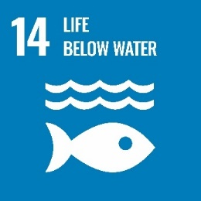

SDG 14: Life below Water
Conserve and sustainably use the oceans, seas and marine resources for sustainable development.

Cognitive learning outcomes
- The learner understands basic marine ecology, ecosystems, predator-prey relationships, etc.
- The learner understands the connection of many people to the sea and the life it holds, including the sea’s role as a provider of food, jobs and exciting opportunities.
- The learner knows the basic premise of climate change and the role of the oceans in moderating our climate.
- The learner understands threats to ocean systems such as pollution and overfishing and recognizes and can explain the relative fragility of many ocean ecosystems including coral reefs and hypoxic dead zones.
- The learner knows about opportunities for the sustainable use of living marine resources.

Socio-emotional learning outcomes
- The learner is able to argue for sustainable fishing practices.
- The learner is able to show people the impact humanity is having on the oceans (biomass loss, acidification, pollution, etc.) and the value of clean healthy oceans.
- The learner is able to influence groups that engage in unsustainable production and consumption of ocean products.
- The learner is able to reflect on their own dietary needs and question whether their dietary habits make sustainable use of limited resources of seafood.
- The learner is able to empathize with people whose livelihoods are affected by changing fishing practices.

Behavioural learning outcomes
- The learner is able to research their country’s dependence on the sea.
- The learner is able to debate sustainable methods such as strict fishing quotas and moratoriums on species in danger of extinction.
- The learner is able to identify, access and buy sustainably harvested marine life, e.g. ecolabel certified products.
- The learner is able to contact their representatives to discuss overfishing as a threat to local livelihoods.
- The learner is able to campaign for expanding no-fish zones and marine reserves and for their protection on a scientific basis.

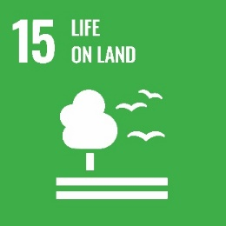

SDG 15: Life on Land
Protect, restore and promote sustainable use of terrestrial ecosystems, sustainably manage forests, combat desertification, and halt and reverse land degradation and halt biodiversity loss

Cognitive learning outcomes
- The learner understands basic ecology with reference to local and global ecosystems, identifying local species and understanding the measure of biodiversity.
- The learner understands the manifold threats posed to biodiversity, including habitat loss, deforestation, fragmentation, overexploitation and invasive species, and can relate these threats to their local biodiversity.
- The learner is able to classify the ecosystem services of the local ecosystems including supporting, provisioning, regulating and cultural services and ecosystems services for disaster risk reduction.
- The learner understands the slow regeneration of soil and the multiple threats that are destroying and removing it much faster than it can replenish itself, such as poor farming or forestry practice.
- The learner understands that realistic conservation strategies work outside pure nature reserves to also improve legislation, restore degraded habitats and soils, connect wildlife corridors, sustainable agriculture and forestry, and redress humanity’s relationship to wildlife.

Socio-emotional learning outcomes
- The learner is able to argue against destructive environmental practices that cause biodiversity loss.
- The learner is able to argue for the conservation of biodiversity on multiple grounds including ecosystems services and intrinsic value.
- The learner is able to connect with their local natural areas and feel empathy with nonhuman life on Earth.
- The learner is able to question the dualism of human/nature and realizes that we are a part of nature and not apart from nature.
- The learner is able to create a vision of a life in harmony with nature.

Behavioural learning outcomes
- The learner is able to connect with local groups working toward biodiversity conservation in their area.
- The learner is able to effectively use their voice effectively in decision-making processes to help urban and rural areas become more permeable to wildlife through the establishment of wildlife corridors, agro-environmental schemes, restoration ecology and more.
- The learner is able to work with policy-makers to improve legislation for biodiversity and nature conservation, and its implementation.
- The learner is able to highlight the importance of soil as our growing material for all food and the importance of remediating or stopping the erosion of our soils.
- The learner is able to campaign for international awareness of species exploitation and work for the implementation and development of CITES (Convention on International Trade in Endangered Species of Wild Fauna and Flora) regulations.

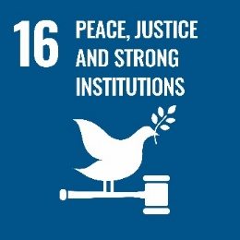

SDG 16: Peace, Justice and Strong Institutions
Promote peaceful and inclusive societies for sustainable development, provide access to justice for all and build effective, accountable and inclusive institutions at all levels.

Cognitive learning outcomes
- The learner understands concepts of justice, inclusion and peace and their relationship to law.
- The learner understands their local and national legislative and governance systems, how they represent them and that they can be abused through corruption.
- The learner is able to compare their system of justice with those of other countries.
- The learner understands the importance of individuals and groups in upholding justice, inclusion and peace and supporting strong institutions in their country and globally.
- The learner understands the importance of the international human rights framework.

Socio-emotional learning outcomes
- The learner is able to connect with others who can help them in facilitating peace, justice, inclusion and strong institutions in their country.
- The learner is able to debate local and global issues of peace, justice, inclusion and strong institutions.
- The learner is able to show empathy with and solidarity for those suffering from injustice in their own country as well as in other countries.
- The learner is able to reflect on their role in issues of peace, justice, inclusion and strong institutions.
- The learner is able to reflect on their own personal belonging to diverse groups (gender, social, economic, political, ethnical, national, ability, sexual orientation etc.) their access to justice and their shared sense of humanity.

Behavioural learning outcomes
- The learner is able to critically assess issues of peace, justice, inclusion and strong institutions in their region, nationally and globally.
- The learner is able to publicly demand and support the development of policies promoting peace, justice, inclusion and strong institutions.
- The learner is able to collaborate with groups that are currently experiencing injustice and/or conflicts.
- The learner is able to become an agent of change in local decision-making, speaking up against injustice.
- The learner is able to contribute to conflict resolution at the local and national level.

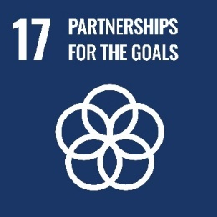

SDG 17: Partnerships for the Goals
Strengthen the implementation and revitalize the global partnership for sustainable development.

Cognitive learning outcomes
- The learner understands global issues, including issues of financing for development, taxation, debt and trade policies, and the interconnectedness and interdependency of different countries and populations.
- The learner understands the importance of global multi-stakeholder partnerships and the shared accountability for sustainable development and knows examples of networks, institutions, campaigns of global partnerships.
- The learner knows the concepts of global governance and global citizenship.
- The learner recognizes the importance of cooperation on and access to science, technology and innovation, and knowledge sharing.
- The learner knows concepts for measuring progress on sustainable development.

Socio-emotional learning outcomes
- The learner is able to raise awareness about the importance of global partnerships for sustainable development.
- The learner is able to work with others to promote global partnerships for sustainable development and demand governments’ accountability for the SDGs.
- The learner is able to take ownership of the SDGs.
- The learner is able to create a vision for a sustainable global society.
- The learner is able to experience a sense of belonging to a common humanity, sharing values and responsibilities, based on human rights.

Behavioural learning outcomes
- The learner is able to become a change agent to realize the SDGs and to take on their role as an active, critical and global and sustainability citizen.
- The learner is able to contribute to facilitating and implementing local, national and global partnerships for sustainable development.
- The learner is able to publicly demand and support the development of policies promoting global partnerships for sustainable development.
- The learner is able to support development cooperation activities.
- The learner is able to influence companies to become part of global partnerships for sustainable development.
© 2024 by the University of Liverpool, Centre for Innovation in Education.
Example Learning Outcomes Aligned with the UN’s Sustainable Development Goals by Nick Bunyan is made available under a Creative Commons Attribution-NonCommercial 4.0 International License.

