Scanning documents and uploading them to VLE
You may have been asked to submit a scanned document to VITAL or Canvas for submission for an assignment; what follows is some guidance on how to do this whether you are using a smartphone, or whether you have access to a scanner, computer, laptop or tablet. If you are using a smartphone or tablet, follow sections 1 and 2/4. If you are using a PC or laptop, follow sections 1 and 3/5.

Contents
Scanning documents and uploading them to VITAL or Canvas 1
1. Scanning your documents 3
2. Using your smartphone or tablet to upload your file to VITAL 5
3. Using a computer or laptop to upload your documents to VITAL 8
4. Using your smartphone or tablet to upload your file to Canvas 10
5. Using a computer or laptop to upload your documents to Canvas 14

Quick Start: Install OneDrive on your smartphone and/or computer, tablet etc. Use the OneDrive camera tool on your phone to create a PDF of all your pages.

Download on Google Play
Download from the Windows Phone Store
Download on the App Store

If asked, you will need to give permission for the App to access your camera. Once the OneDrive App is downloaded, installed, and you have accepted camera permissions, you will need to log in using your University of Liverpool account. Remember to enter your username in the format username@liverpool.ac.uk.
It is worth setting up a Folder on the device you plan to use, where you will store your scanned documents; this will make it easier to locate the documents later on. To do this, locate the “+”. It is on the top right of the screen.

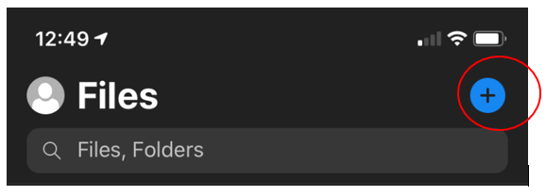

When you click on it, you will be shown a menu where you can ‘create folder’:

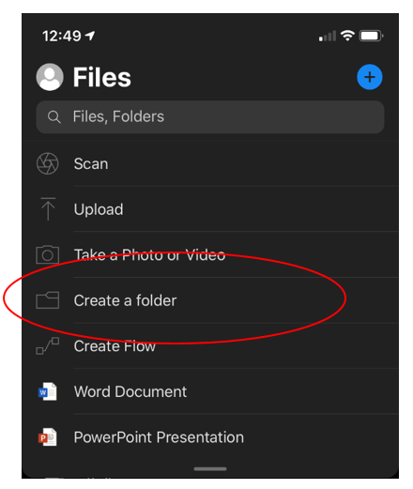

Click on this, name your folder and then click on create in the top right:

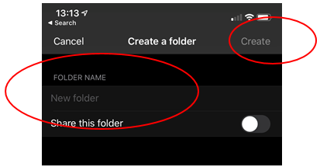

Now you have your folder set up, it’s time to scan the documents.

Scanning your documents
If you have access to a scanner, please ensure that all pages are scanned into a single document for submission. If you do not, the following documentation from Microsoft gives instructions on how to Scan and Save documents using the OneDrive camera function -

For Android devices
For Apple devices running iOS

When scanning, we recommend making sure ‘Document’ is selected.

Please use multi-page scanning, which will allow you to combine multiple scans into a single PDF. To use this option, click ‘Add’ or ‘+’ then scan your next document:

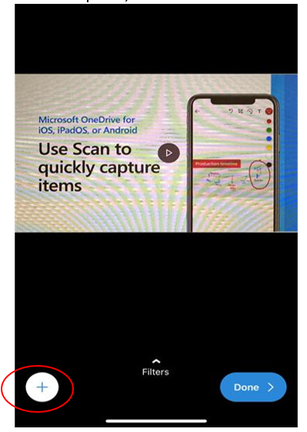

Once you have scanned in all your documents you will be prompted to name the file and save it. This is the document you will be uploading to VITAL, so it is a good idea to choose a sensible name. Navigate to the folder you have just created, and save your scanned document here.
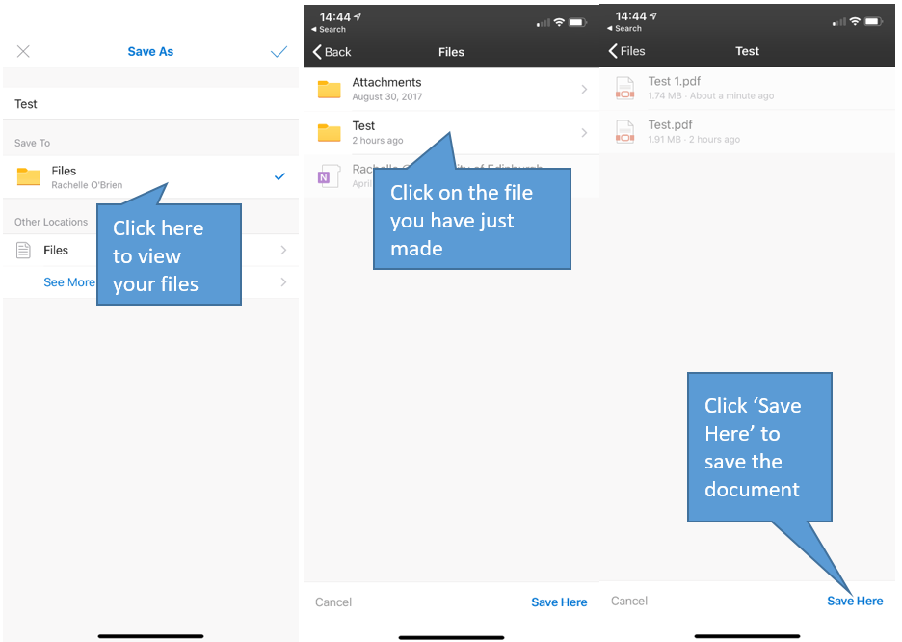

If you struggle to navigate to the folder you have created, don’t worry, you can always drag and drop documents, by clicking on them and moving them to the folder, once they have been created.

Using your smartphone or tablet to upload your file to VITAL
Navigate to the VITAL course where you are submitting your assignment.

To upload your file or files click on ‘Browse Cloud Storage’:

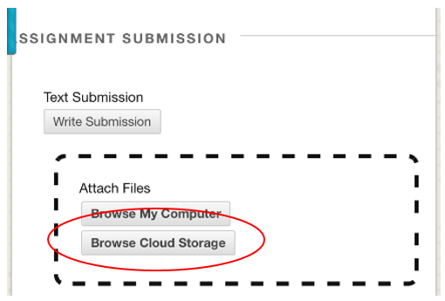

Select ‘OneDrive for Business’:

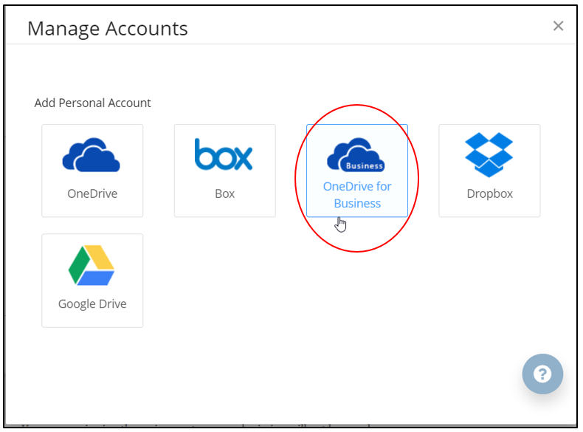

Follow the prompts to log into your University of Liverpool account. It is really important to log into the same account here that you used earlier so that you can access the file/s you have saved. Remember again to enter your username in the format username@liverpool.ac.uk.

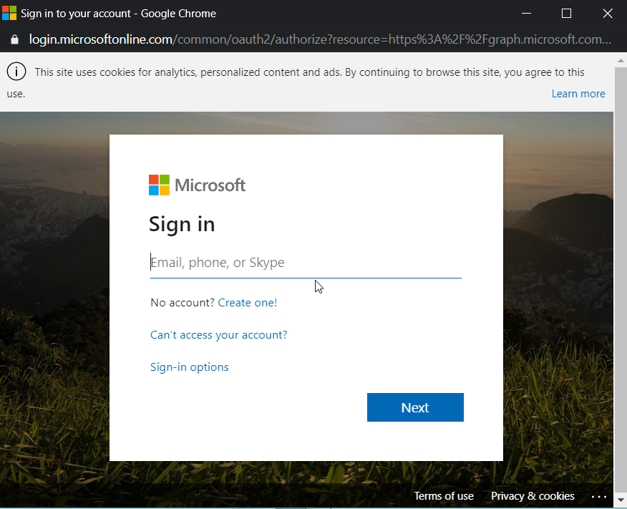

Once you are logged in, navigate to the folder you created and select files you wish to submit. Click on the file and then click ‘select’:

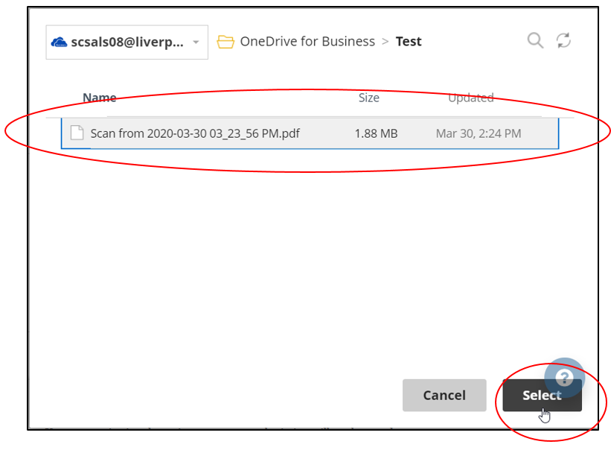

Once you have done this, your ‘Assignment Submission’ area in VITAL will be displayed.

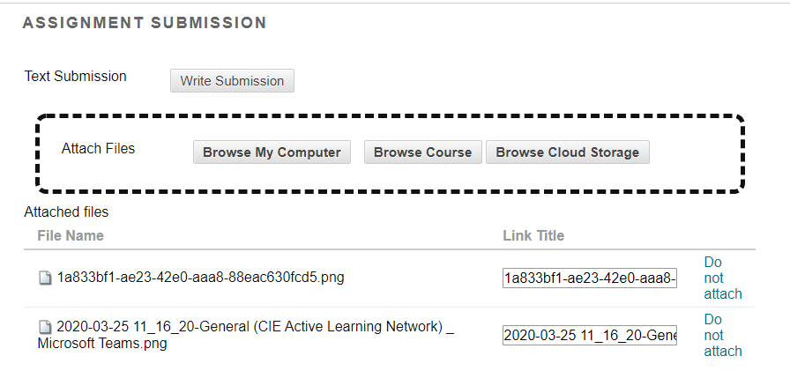

Make sure you have included all of the files you wish to submit for grading, before you move on to the next step.

Once you have completed your submission, click on ‘submit’:
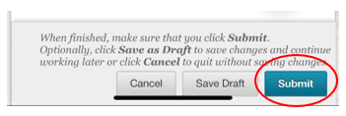

Make sure you get an email acknowledgement from VITAL. If you do not receive this automated email the upload may have encountered a problem. Contact the module leader so that VITAL can be reset.

Using a computer or laptop to upload your documents to VITAL
Log into OneDrive on your computer, laptop, Mac or similar device. You can do this by going to the Microsoft Office website and using your University of Liverpool login (with your username in the format username@liverpool.ac.uk). Once you’ve logged in, look for the OneDrive logo:

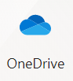

Find the folder you created when you were scanning your documents and use the Download files and folders from OneDrive or SharePoint guidance, to download the files:

Once you have the files saved on your desktop, or in a folder you can easily find and access, you can upload this to VITAL for submission.

Uploading your scanned file to VITAL
Navigate to the VITAL course where you are submitting your assignment.

To upload your file click on ‘Browse My Computer’:

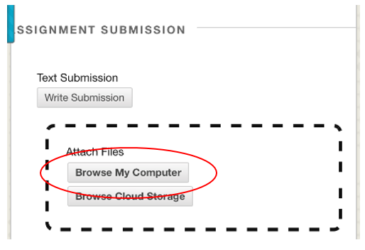

Navigate to the folder you have created on your desktop and select the file you wish to submit. Click on ‘Browse My Computer’, locating the file, and clicking ‘Open’. This will allow you to add the file to your submission. Alternatively, you should be able to drag and drop a file(s) into the checkered box area shown in the screenshot). Once you have done this, your ‘Assignment Submission’ area in VITAL will be displayed.

Make sure you have included all of the files you wish to submit for grading, before you move on to the next step.

Once you have completed your submission, click on ‘submit’:

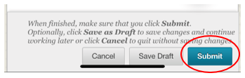

Make sure you get an email acknowledgement from VITAL. If you do not receive this automated email the upload may have encountered a problem. Contact the module leader so that VITAL can be reset or you can be provided with an alternative mode of submission.

Using your smartphone or tablet to upload your file to Canvas
In the Canvas app navigate to the relevant course, assignments and select the assignment. Click submit assignment and then select File upload.

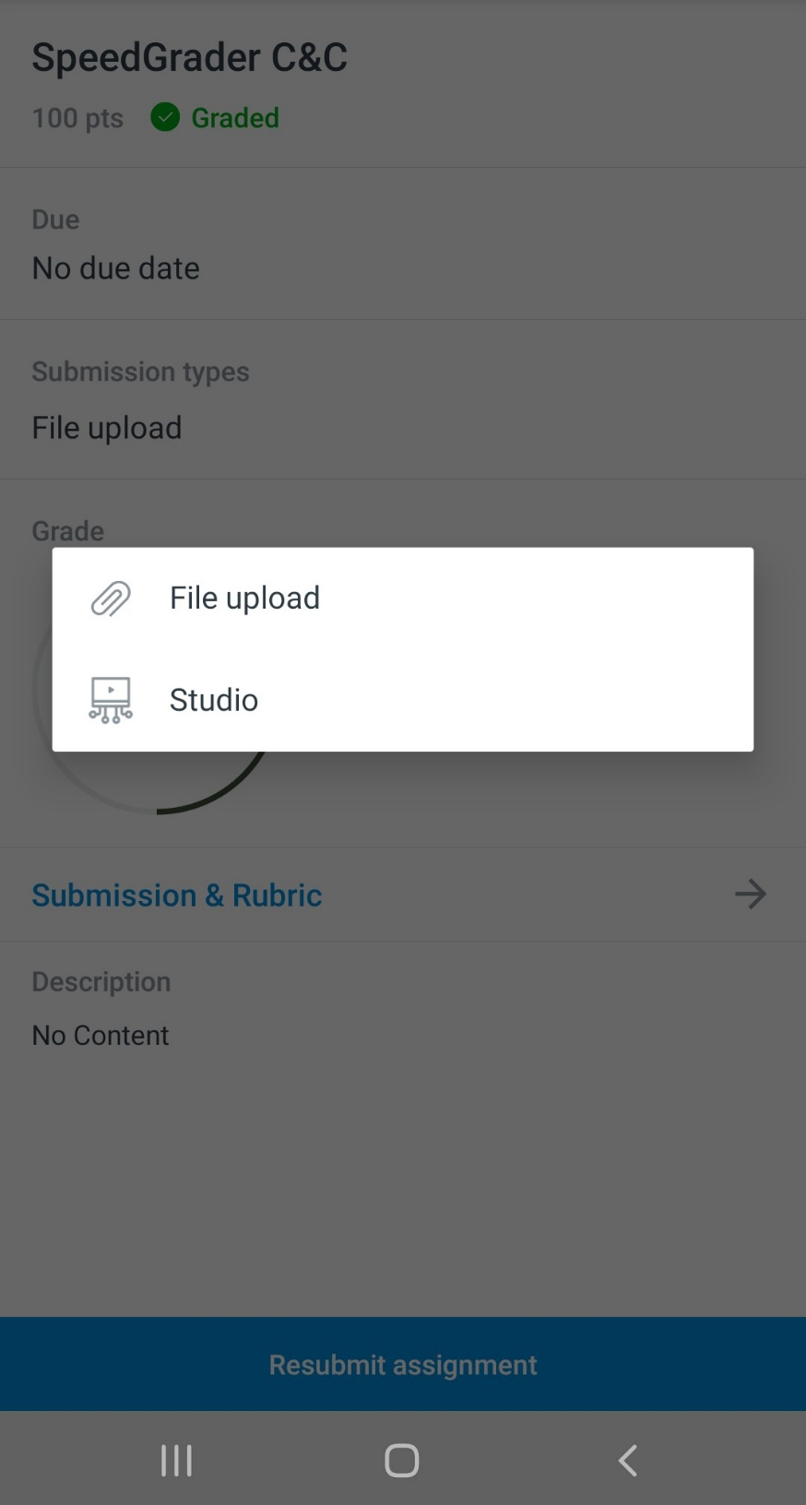
Select Device from the bottom right hand side of the app.

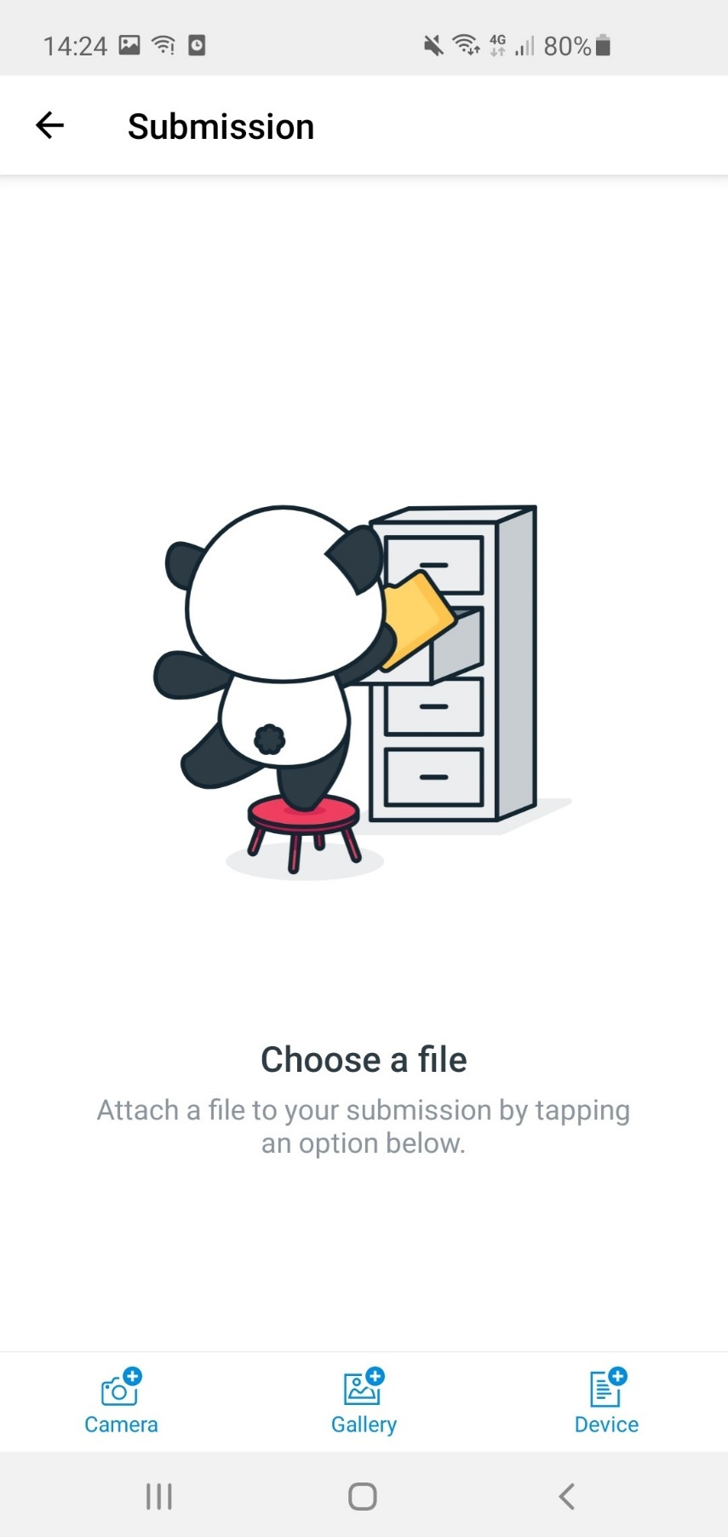
Using the 3 lines at the top left of the screen open up the Open from menu and scroll down to select OneDrive. Again, you’ll need to be signed into your University of Liverpool account in the OneDrive app.

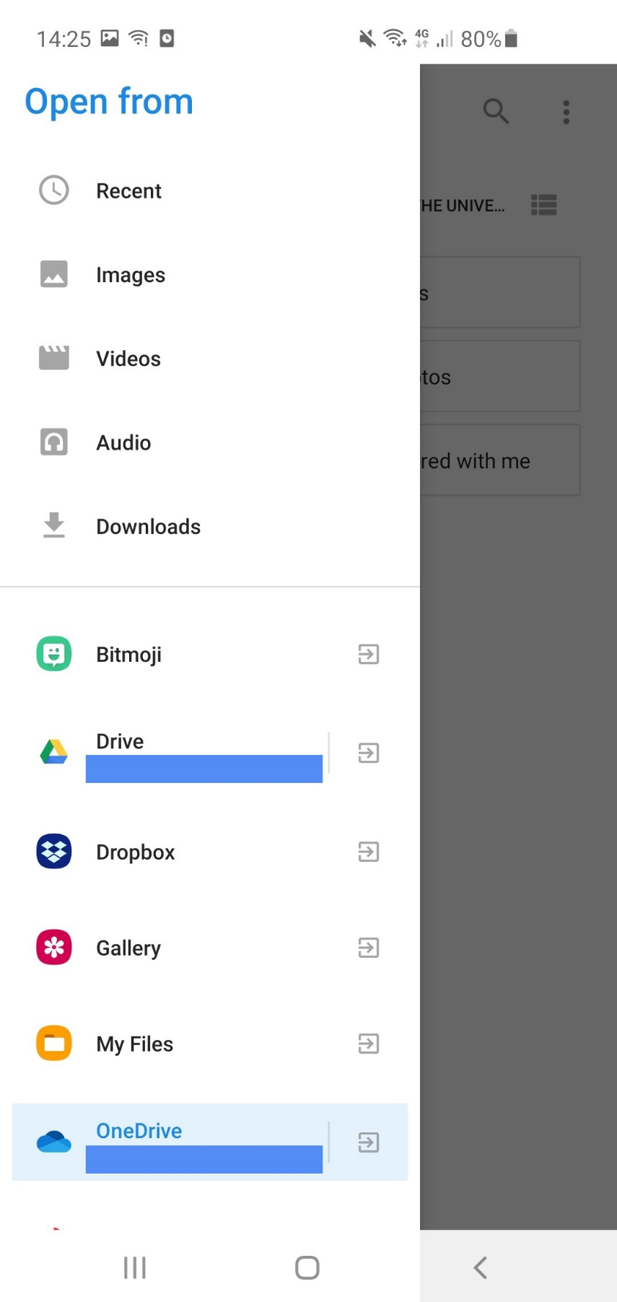
Select your file from your OneDrive folder, once selected ensure you click SUBMIT at the top right-hand side of the app screen.

Using a computer or laptop to upload your documents to Canvas
Navigate to the Canvas course where you are submitting your assignment. Select assignments from the left-hand menu and click on the relevant assignment to take you to the submission screen. By default, you’ll be taken to the File upload option, however you’ll need to select the Office 365 tab to access your scanned document within OneDrive.

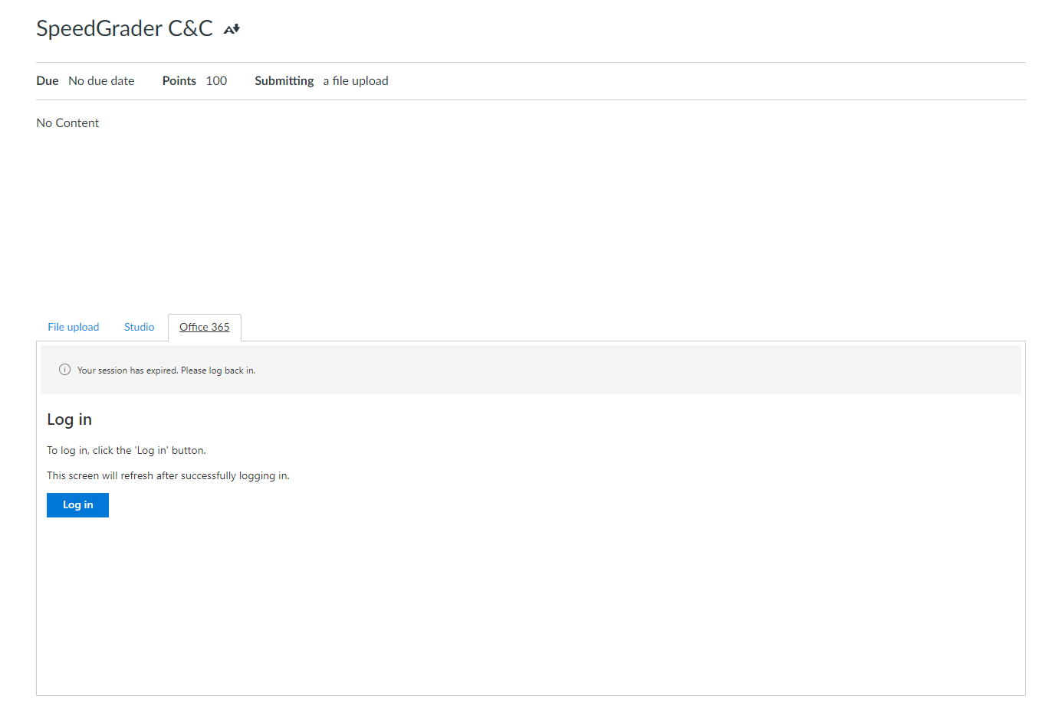

If you’re not already signed in to O365 you will see the screen above. Click Login in and be sure to sign in using your University of Liverpool login (with your username in the format username@liverpool.ac.uk)

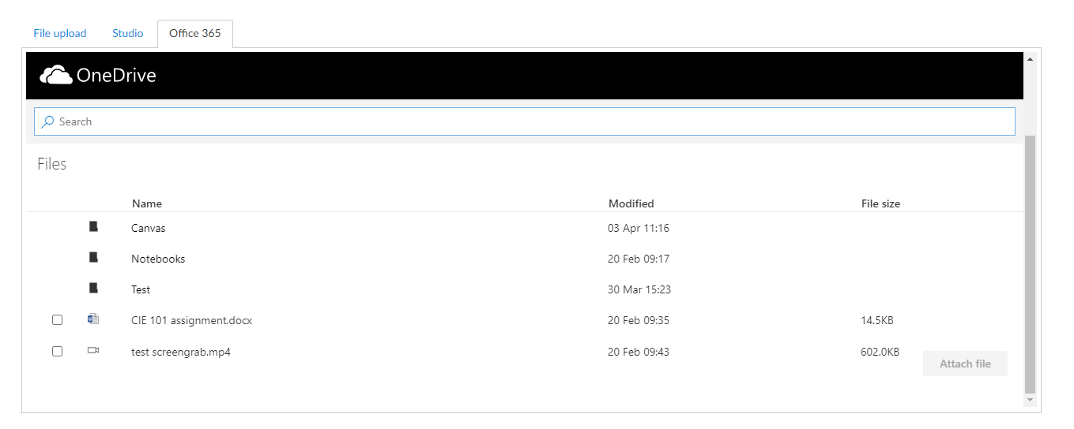
You can add additional comments for your marker if required. Ensure you click the Submit assignment button to complete.

© 2020 by the University of Liverpool, Centre for Innovation in Education.
How to support students in uploading scanned documents to the VLE is made available under a Creative Commons Attribution-NonCommercial 4.0 International License.

